

RECRUITMENT PACK

**Policy Manager**

**Location:** Remote working and occasional travel throughout Wales to include staff meetings at the Cardiff office

**Closing date:** 12.00pm**,** 8 September

**Stage 1 Interview (group assessment centre):** Thursday 18 September, 10.00am-12.00pm

**Stage 2 Interview (individual):** Thursday 25th September

**Fixed term until November 2026**

**Welcome**

Thank you for your interest in the Policy Manager role.



Tai Pawb is Wales’ leading organisation promoting equality and diversity in housing. We imagine a Wales where everyone has the right to a good home. We work with and influence policy makers and we support our

members and the wider housing sector to help them embed equality, diversity and inclusion into everything they do.

This is an exciting time to be joining Tai Pawb as we focus on influencing through our manifesto, next stages of our Back the Bill campaign, as well as a new 5 year strategy for the organisation.

In this role, we’re looking for someone with a genuine passion for equality and social justice, alongside experience supporting work to influence policy and an understanding of political processes. You’ll be a confident communicator and collaborative team player, keen to help us engage effectively with key policymakers, commentators, and stakeholders in Wales.

At Tai Pawb, we have ambitious plans for the future and need great people to help us achieve them. As a small, dynamic organisation, working with us means:

 Gaining varied experience and expanding your networks  Seeing the direct impact of your work

 Influencing our direction with quick decision-making

 Benefiting from our trailblazing 4-Day Week—100% of the work, in 80% of the time, for 100% pay

This is a fantastic opportunity to apply your skills, develop your potential, and be part of a team that truly makes a difference.

If you are not sure whether to apply or have any questions about the interview process –feel free to get in touch directly: [**alicja@taipawb.org**](mailto:alicja@taipawb.org)

I look forward to receiving your application. Alicja Zalesinska

Chief Executive Officer

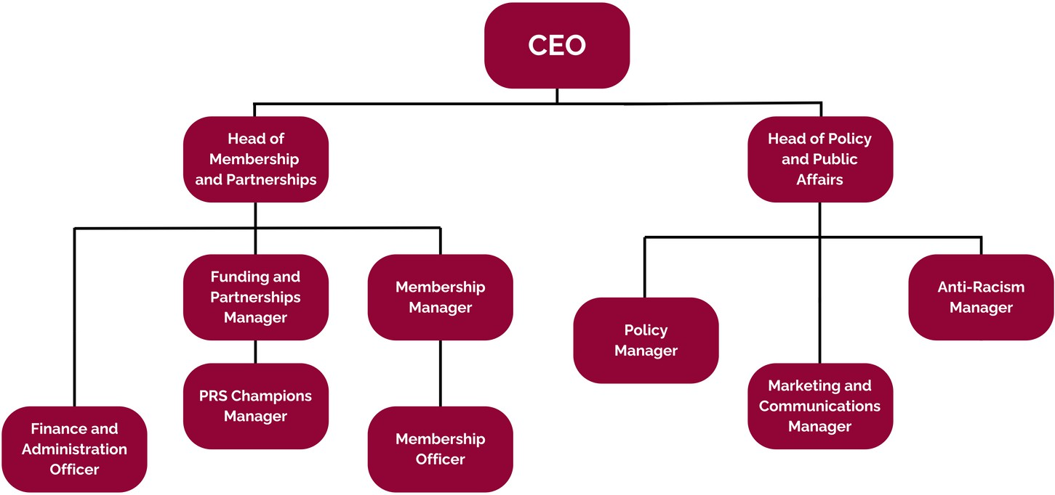

**About Us**

**Who We Are**

Tai Pawb is the leading national organisation promoting equality and diversity in housing. Our vision is Wales where everyone has the right to a good home. We support and work with our members to help them put ideas into practice, we influence policy makers to make housing policy fair and we are the thought leaders on equality, diversity and human rights issues for the housing sector and beyond.

**Our Team**

**Why work at Tai Pawb?**

**Benefits**

Why work at Tai Pawb?

# SALARY

**We offer a competitive salary. This is benchmarked regularly against industry standards.**

# PENSION

**A defined contribution pension scheme. Tai Pawb will contribute 5% to your pension.**

# 4 DAY WORKING WEEK

**Between April 2024 and March 2025 Tai Pawb is trialling a 4 day working week. The 4DW is based o**[**n a principle of del**](https://www.taipawb.org/news-story/tai-pawb-pilots-4-day-working-week/)**ivering 100% of the work, in 80% of the time, for 10**[**0% of salary (it doe**](https://www.taipawb.org/news-story/tai-pawb-pilots-4-day-working-week/)**sn’t mean compressed hoursor pro rata pay)** [**read more here**](https://www.taipawb.org/news-story/tai-pawb-pilots-4-day-working-week/#%3A~%3Atext%3DThe%204DW%20is%20based%20on%2Cand%20successfully%20implementing%20the%20policy)

**(Permanent adoption of this model will be decided by Trustees in April).**

# FLEXIBLE WORKING

**The successful candidate’s main base of work will be at home. We have an office base in Cardiff that can be used throughout the week according to staff members’ needs. There’s an expectation that you will meet at regular intervals with your line manager to discuss project work.**

# LEAVE

**Staff are entitled to 23 days of annual leave and 8 Bank Holidays. We also offer good maternity, paternity, adoption and shared parental pay.**

# SHAPE THE ORGANISATION AND OUR WORK

**Joining Tai Pawb gives you the chance to help shape our work as well as our responses to opportunities and challenges in the housing and equalities sector. We are a genuinely collegiate and collaborative organisation that values staff input and experience.**

**Job Description**

**Post:** Policy Manager

**Responsible to:** Head of Policy and Public Affairs

**Salary:** £37,874

**Hours:** Contracted to 35 hrs p/w (flexible approach to hours worked). We currently operate a 4-day week on a trial basis (100%salary for 80% hours and 100% outcomes). We do not work on Fridays.

**Contract:** Fixed term until November 2026

**Location:** Remote working and occasional travel throughout Wales to include staff meetings at the Cardiff office. Reasonable adjustments for the successful person if required.

**Travel:** Primarily at home with access to office, and at least monthly office sessions. May require occasional travel across Wales to partnership and membership meetings and events

**Key relationships:** Internal colleagues, Welsh Government, politicians, third sector, housing associations, local authorities

**Purpose of the post**

This post is funded via the Oak Foundation to support our influencing and campaigning activities.

The postholder will work close with the Head of Policy and Public Affairs on policy development, influencing and campaigning across a range of housing, equality and human rights issues. This will include in particular our joint ‘Back the Bill: the right to a good home campaign’ alongside Shelter Cymru and CIH Cymru.

The postholder will temporarily line manage the Policy coordinator (until the end of March 2026) .

**Job Description**

**Key Duties**

Coordinate the ‘Back the Bill: the right to a good home’ campaign, with strategic support from the Head of Policy and Public Affairs including: Lead partnership activities with Shelter Cymru and CIH Cymru, including meetings and joint outputs that support campaign delivery.

Use and promote the campaign’s evidence base—including research, case studies and stakeholder insights—to influence decision-makers and maintain campaign momentum.

Drive political engagement in the lead-up to the Senedd elections, including outreach to MSs, ministers, officials and committees.

Maintain and grow stakeholder support, ensuring campaign messaging is consistent, inclusive and empowering.

Support Tai Pawb’s policy work across key strategic areas including race, disability, LGBT+ and other equality issues.

Work with Welsh Government officials to shape and monitor housing-related policy, ensuring it promotes equality and human rights.

Develop policy papers, briefings, guidance and good practice resources, and influence stakeholders to adopt them.

Conduct research and engagement with members and partners to build a robust evidence base for Tai Pawb’s influencing work.

Monitor and communicate the impact of policy and influencing activities through surveys, feedback and stakeholder analysis.

Collaborate across the team to incorporate lived experience into policy development and contribute to the organisation’s wider strategic goals. Line manager Policy Coordinator until end of March 2026 (post end)

Undertake any other tasks as may be required from time to time as a member of a small team with a national remit

**Essential**

Person Specification

**Knowledge & Experience**

**Skills & competencies**

Qualified to degree level or equivalent.

Track record of developing effective, credible relationships with a wide range of stakeholders.

Understanding of housing, equality, diversity and inclusion issues, policy and practice.

Understanding of third and housing sectors

Experience of contributing to policy development and influencing work.

Understanding of Welsh Government and Senedd environments.

Excellent verbal and written communication skills for a variety of audiences and purposes, including public speaking.

Highly organised with project planning and research skills and the ability to work independently.

Advanced level IT skills including Excel, Word, PowerPoint, Co- pilot or similar software.

Ability to quickly gain a good level of understanding in different policy areas.

Demonstrable commitment to equality, diversity, inclusion and anti-racism.

**Desirable**

**Person Specification**

Lived experience of inequality

Experience in running a campaign aimed at influencing legislation. Ability to communicate in Welsh.

**Next Steps**

To apply for this position, please send application form and the equality monitoring form to

Person Specification

[andrea@taipawb.org](mailto:andrea@taipawb.org) by 12pm on 8 September 2025

Please note, we do not accept CVs as applications. You must complete our application form, and return it in Word format (if you have any trouble sending it in Word format, please email us: [info@taipawb.org](mailto:info@taipawb.org)).

Tai Pawb is committed to creating a diverse and inclusive environment. We actively encourage applications from individuals of all backgrounds. To help us with better representation of issues we work on and to remove barriers, all candidates from Black, Asian, and Ethnically Diverse backgrounds who meet the essential criteria, as well as all disabled candidates, will be guaranteed an interview at Stage 1 (group assessment).

Disabled candidates who meet the essential criteria have the option to proceed directly to Stage 2 (individual interview). If you require any reasonable adjustments, please specify this in the section provided on the application form. We will contact you to discuss this if you are selected for interview.



**Use of AI in Applications and Interviews**

At Tai Pawb, we value authenticity and lived experience. We know every applicant brings unique insights, and we want to hear about those in your own words.

While we understand that AI tools can help with structuring ideas or preparing for interviews, we encourage you to avoid relying too heavily on them to write your application. If you do use AI, please treat its suggestions as a starting point—not a finished product—and ensure everything you submit genuinely reflects your own experience.

If you progress to interview, you’re welcome to use AI to:

 Research sector trends or Tai Pawb’s work.

 Practice interview questions or improve your communication.  Organise your thoughts and responses.

Please don’t:

 Submit AI-generated answers as your own.

 Use AI to misrepresent your experience or skills.  Use AI tools during live interviews.

We’re interested in your voice, your values, and your perspective—so let them shine through.

