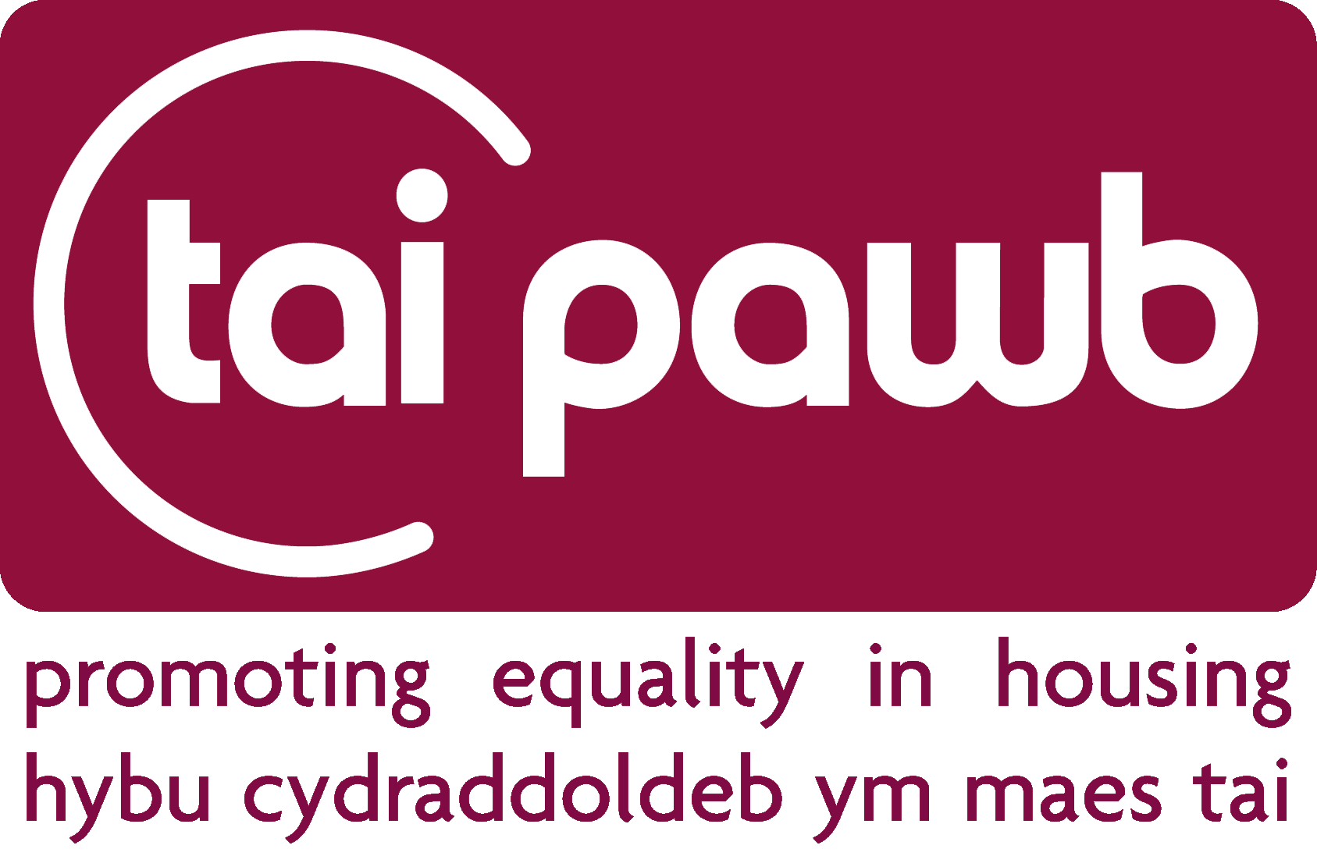
Training and Consultancy Services Agreement
Organisation
Membership status
Outline of services to be provided
Duration/Length of Services to be Provided (e.g. 1 day, 2 days etc)
Date(s) of training
Projected start and completion date of consultancy
(attach project plan, if relevant)
Membership benefits used for this service (e.g. discounts or free service)
Membership benefits remaining for the year
Estimated cost of service (to be invoiced by Tai Pawb)
Estimated Travel Costs
Total Estimated Cost

By printing my name in the signature box below, I authorise Tai Pawb to proceed with the provision of services as outlined in and on the terms and conditions of this agreement
Authorised by NAME on behalf of ORGANISATION | Signature:
Date: | Purchase Order No:

☐ Please tick here if you are willing for Tai Pawb to publicise that we are carrying out this training/piece of work with you
Terms and Conditions

1. Key Terms and Conditions
1.1 For a list of membership benefits relevant to each category of member, please see the Annex to this agreement.
1.2 The membership year runs from 1 April to 31 March (membership year).
1.3 Any membership benefit which is unused in a particular membership year cannot be carried forward to the following or any other membership year.
1.4 Any training or consultancy provided outside the membership benefits listed in the Annex is charged at a rate of £590 for each full day and £350 for each half day session plus travel (Member rate). Terms 4.1, 4.2, 4.3 and 4.4 will apply to any chargeable services provided to Members. Additional charges may apply if training or consultancy is provided by a Tai Pawb Associate. As these costs can vary, they will be estimated before the Training and Consultancy Services Agreement is signed.
1.5 Travel will be charged at 45p per mile for the first 100 miles and 15p per mile thereafter. An estimated quote for this cost will be provided in advance. No membership discounts will apply to travel expenses.
1.6 For the purposes of these terms and conditions, “full day” equates to between 4 and 7 hours and “half day” equates to 3.5 hours or less.
1.7 Where Tai Pawb services are provided by one of our Associates, the organisation contracting the service agrees not to directly commission the Associate for any further work without going through Tai Pawb, during the time the Associate is contracted by Tai Pawb and for at least 6 months following any termination of contract between Tai Pawb and the Associate. Organisations may contact Tai Pawb to request an exemption from this rule if they feel it is appropriate, for example if the service being contracted is not a service which Tai Pawb could otherwise provide.
2. Training
2.1 Bespoke training is available on request and can be tailored to suit the needs of the Member or non-Member. Where bespoke training is provided, an additional half day for the preparation of that training may be charged at the Member rate for Members and at the non-Member rate for non-Members.
2.2 Training should be booked at least 6 weeks in advance of the training date. If the training date falls during the month of March, bookings should be made at least 8 weeks in advance. If insufficient notice is given for a booking in March, the training may have to be delivered in the following membership year at the following years training cost.
2.3 The details of any training to be provided will be set out in the services agreement and sent to the Member or non-Member for approval. The training will not be provided until the services agreement has been authorised.
2.4 Tai Pawb will make reasonable efforts to provide training materials in an accessible format provided they are given sufficient advance notice of specific accessibility requirements. Members should ensure that any venue booked by them for training is fully accessible and that they have taken the accessibility needs of delegates into account.
2.5 The organisation contracting Tai Pawb’s services agrees to provide a suitable training room and facilities, including laptop, projector, screen, audio system, internet access, flipchart and beverages. You should inform Tai Pawb immediately if any of this cannot be provided. Lunch is not provided by Tai Pawb for any training course. In the case of full day training courses, the organisation contracting the training should inform Tai Pawb whether they will provide lunch for all delegates including the trainer, taking account of any dietary requirements, or whether the trainer and delegates will need to bring their own lunch.
3. Consultancy
3.1 The details of any consultancy to be provided will be set out in the services agreement and sent to the Member for approval. The consultancy will not be provided until the services agreement has been authorised.
4 Cancellations
4.1 Training cancellations: If training due to be provided is cancelled, the following consequences will apply:
(a) if cancellation is notified to Tai Pawb within 5 working days of the date of the training, the training fees will be charged in full;
(b) if cancellation is notified to Tai Pawb within 15 working days of the date of the training, 50% of the training fees will be charged;
(c) for the avoidance of doubt, if cancellation is notified to Tai Pawb more than 15 working days before the date of the training, no training fee will be charged.
4.2 Consultancy cancellations: If any consultancy work due to be provided is cancelled, the following consequences will apply:
(a) if cancellation is notified to Tai Pawb before any consultancy work is carried out, no consultancy fees will be payable;
(b) if cancellation is notified to Tai Pawb once the consultancy work has been commenced, fees equal to the time spent will be payable;
4.3 Expenses on cancellation: All travel and accommodation expenses incurred by Tai Pawb in connection with any training or cancellation will be charged in full irrespective of the period of the cancellation notice given.
4.4 For the avoidance of doubt, if a training date is rearranged, the training cancellation terms and conditions will apply unless there are exceptional circumstances.

5. General
5.1 All copyright and other intellectual property in all training and consultancy material including preparatory materials shall be and remains vested in Tai Pawb, unless expressly stated otherwise. Members and non-members shall not share Tai Pawb materials outside their own organisation or with anyone contracted by the organisation who is not a direct employee, unless with express permission of Tai Pawb.
5.2 Limitation of Liability
5.2.1 Tai Pawb does not accept any responsibility for any accident, injury or loss suffered by any person whilst attending a training session.
5.2.2 Delegates are responsible for taking care of their own property at all times during a training session.
5.2.3 Tai Pawb accepts no responsibility for any loss incurred as a consequence of using any material or information provided at a training session or as part of any consultancy or project work.
5.3 In relation to training and some consultancy work, Tai Pawb will send an invoice after the completion date. For consultancy projects, on occasion, 50% of the fee may be charged on receipt of this agreement and 50% on completion, depending on the nature of the consultancy and value of the agreement.
5.4 Invoices must be paid within 30 calendar days of receipt.

Annex – List of Membership Benefits
Supporters
- Free unlimited attendance at WHENetwork (Welsh Housing Equality Network)
More information on our website.
- Good Practice Briefings
E-copy of Tai Pawb’s popular Good Practice Briefings where we provide information, guidance and examples of good practice related to equality and diversity in housing across Wales.
- Equality and Housing Updates
Email updates on latest developments relevant to equality in housing including: research, guides, events, case law, policy, good practice and more.
- Access to Members area of the website (including resources)
- Membership discounts for training (30%) , consultancy (30%) and events (20%)

Commercial
- Free unlimited access to our Helpline
Helping you with any quick enquiries and requests for information or good practice. For more in-depth requests we may refer you to our consultancy service.
- Free unlimited attendance at WHENetwork (Welsh Housing Equality Network)
More information on our website.
- Good Practice Briefings
Unlimited e-copies of Tai Pawb’s popular Good Practice Briefings where we provide information, guidance and examples of good practice related to equality and diversity in housing across Wales. You will also be given an opportunity to showcase any good practice you may have undertaken.
- Equality and Housing Updates
Email updates on latest developments relevant to equality in housing including: research, guides, events, case law, policy, good practice and more.
- Access to Members area of the website (including resources)
- Listing on our new website
- Free advert on our new website (1st year of membership)
- Free advert in our conference guide (1st year of membership)
- Membership discounts for training (30%) , consultancy (30%) and events (20%) including but not limited to:
  - Contractor Equality Training (tailored for frontline staff or managers)
  - Equality Codes of Conduct, Handbooks and Do’s and Don’t Cards
  - Review/assistance with equality part of PQQ (or other part of tenders)
  - Contractor Equality Health Check (Basic or Advanced: See below)

Commercial Plus
- All the benefits of Commercial membership plus:
- Opportunity to use “Member of Tai Pawb” Logo
- Annual Free Contractor (or Commercial) Equality Health Check (Basic – 1 day)
A free review of your organisation highlighting areas of best practice and identifying areas of potential weakness with a view to helping you with fair employment and service delivery practices. Results in practical recommendations for action. Basic Health Check is a half-day desktop or face to face assessment and a short report/Advanced Healthcheck involves desktop review, interviews and evidence checks with an action plan at the end and takes on average 5 days).

In the years following your first Health Check, you will have the option for the Health Check to review:
  - Your progress towards addressing previous year’s recommendations and further suggestions across all business areas and equality topics
  - Progress within a specific business area and/or equality topic
Affiliate
- Free unlimited access to our Helpline
Helping you with any quick enquiries and requests for information or good practice. For more in-depth requests we may refer you to our consultancy service.
- Free unlimited attendance at WHENetwork (Welsh Housing Equality Network)
More information on our website.
- Good Practice Briefings
Unlimited e-copies of Tai Pawb’s popular Good Practice Briefings where we provide information, guidance and examples of good practice related to equality and diversity in housing across Wales. You will also be given an opportunity to showcase any good practice you may have undertaken.
- Equality and Housing Updates
Email updates on latest developments relevant to equality in housing including: research, guides, events, case law, policy, good practice and more.
- Access to Members area of the website (including resources)
- Membership discounts for training (30%) , consultancy (30%) and events (20%) including but not limited to:
  - Challenging Discrimination Training (for service users)
  - Reasonable Adjustments Training (for service users)
  - Tailored briefing/report on current issues/background information on equality and housing for your interest/beneficiary group (e.g. accessible housing or BME issues in housing, etc.)
  - Facilitated workshops on a topic of your choice for your staff/beneficiaries (e.g. housing options for BME older people or taking equality forward in your organisation)

Affiliate Plus
- All the benefits of Affiliate membership plus:
- Annual Tailored briefing/report on current issues/background information on equality and housing for your interest/beneficiary group (e.g. accessible housing or BME issues in housing, etc.) (half day)
OR
- Annual Facilitated workshop on a topic of your choice for your staff/beneficiaries (e.g. housing options for BME older people or taking equality forward in your organisation) (half day including preparation)
- 40% discount on one Equality and Diversity Awareness Training (half day)

Full membership
- Free Annual Equality Health Check (Basic) - 1 day
- And a choice of one of the following (0.5 day):
  - Free Policy/strategy/procedure/action plan review
  - Free Equality Impact Assessment Support
  - Free Facilitated Workshop on a topic of your choice
  - 40% discount on 1 half day Equality and Diversity Awareness Training

Additionally:
- Attendance at working groups, equality panels etc. (depending on availability)
- Free unlimited attendance at WHENetwork (Welsh Housing Equality Network)
More information on our website.
- Good Practice Briefings
Unlimited e-copies of Tai Pawb’s popular Good Practice Briefings where we provide information, guidance and examples of good practice related to equality and diversity in housing across Wales. You will also be given an opportunity to showcase any good practice you may have undertaken.
- Equality and Housing Updates
Email updates on latest developments relevant to equality in housing including: research, guides, events, case law, policy, good practice and more.
- Access to Members area of the website (including resources)
- Membership discounts for training (30%), tailored consultancy (30%) and events (20%), including , but not limited to:
  - Introduction to Equality and Diversity Training
  - Equality Impact Assessments Training
  - Hate Crime and Housing Training
  - Dealing with Discrimination Complaints Fairly Training
  - Developing Equal Outcomes for Self-Assessment Training
  - Equality and Diversity for Boards Training
  - Customer Profiling Training
  - Full facilitation of Equality Impact Assessments
  - Board Diversity Health Check
  - Equality Handbooks
  - Equality Policy/Scheme Development
  - Staff and Service User Workshops
  - Any other tailored solution you may be interested in

