·* Greater Gwent Health, Social Care a

..• Bwrdd Partncriacth

Well•betn8 Partnership

**,i'**

@'pawb

Rhanbarthot Gwent

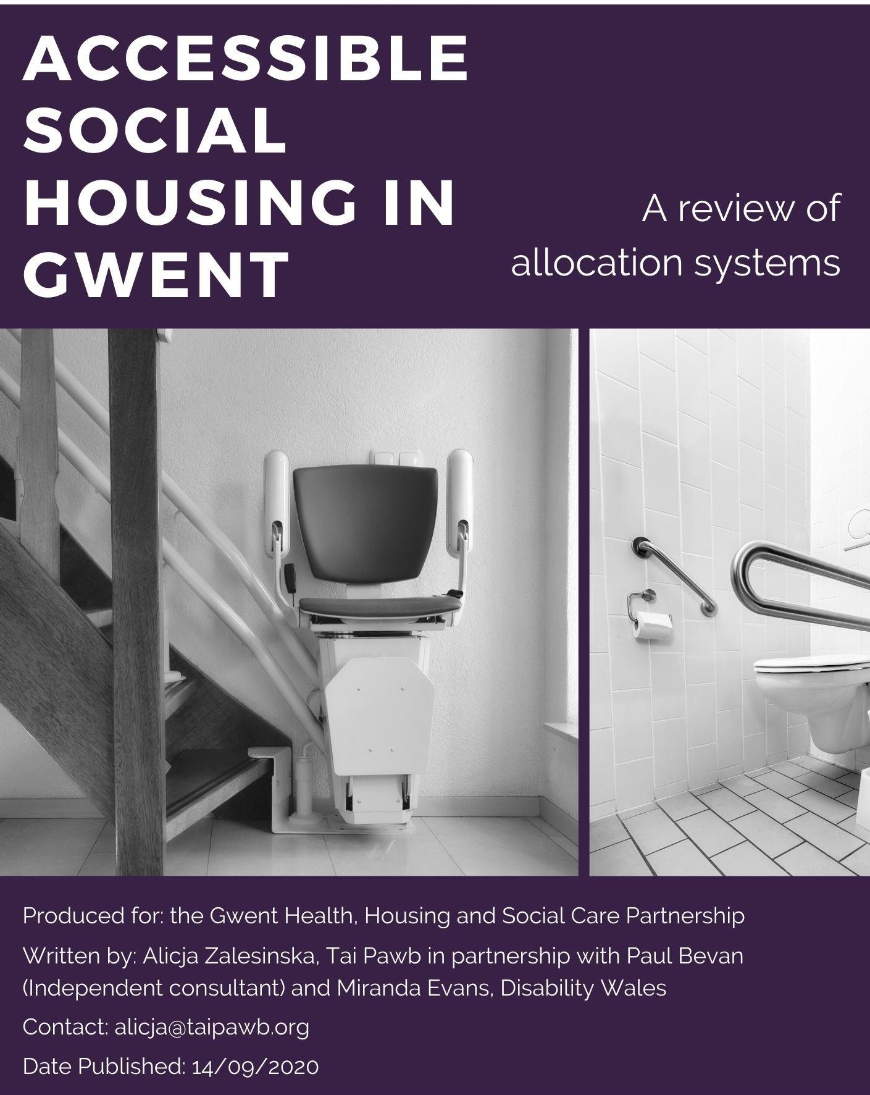1nl

Cymde,thasol Gwent Fwyaf

promoting equality in housing hybu cydraddoldeb ym maes tai

*1***f** Partnership Board

Partner aeth Lies, lecllyd a Gofal

* t Gwent Regional

**Contents**

Acknowledgments 4

* 1. Introduction 4
  2. Methodology and key terms 5
     1. Methodology 5
     2. Accessible housing allocation system vs. register 7
     3. Categorising and Banding 8
  3. Research and good practice review 8
     1. Context and research in Wales 8
     2. Housing and Disability: Equality and Human Rights Commission Toolkit 11
     3. Latest research in Scotland 12
     4. Cost and effectiveness research from England 16
     5. More on good practice 17
        1. Caerphilly accessible housing allocation system 17
        2. Cardiff Accessible Homes 19
        3. North Wales Regional Common Housing Register SARTH 22
        4. London Accessible Housing Register 22
        5. Home 2 Fit Scotland 25
        6. London accessible and specialist older persons housing locator 26
  4. Current allocation systems: baseline 27
     1. This section 27
     2. Newport County Council 27
        1. Allocation system 27
        2. Accessible housing allocation 28
     3. Monmouthshire County Council 29
        1. Allocation system 29
        2. Accessible housing allocation 29
     4. Torfaen County Borough Council 30
        1. Allocation system 30
        2. Accessible housing allocation 30
     5. Blaenau Gwent County Borough Council 31
        1. Allocation system 31
        2. Accessible housing allocation 31
     6. Caerphilly County Borough Council 32
        1. Allocations System 32
        2. Accessible housing allocation 33
  5. Findings – key themes, issues, good practice and gaps 34
     1. This section 34
     2. Application process 35
        1. Choice-based lettings (CBL) and Needs Based (NB) based systems 35
        2. Waiting times 37
     3. Assessing and categorising applicant’s accessibility requirements 39
        1. Early OT involvement 39
        2. Categorisation of applicants’ accessibility requirements 42
        3. Content of applicant accessibility assessments 43
     4. Assessing properties 43
        1. Adapted vs. accessible 43
        2. Categorising accessible properties and property information 44
     5. Matching and allocation 50
        1. Matching 50
        2. Finding the best match 53
        3. Prioritisation 56
        4. Direct lets 58
        5. Impact of void targets 60
        6. Offers and refusals 64
     6. Who is involved in accessible housing allocation system? 69
     7. The role of housing OT’s 77
     8. Joint working between housing, health and social care 79
        1. Joint working: operations 79
        2. Joint working: strategic level 86
        3. Hospital Discharge Processes and Accessible Housing 88
     9. Adaptations and allocation 94
        1. The links between adaptations and allocation of accessible housing 95
        2. Equity of adaptations systems 102
     10. Monitoring and oversight 104
         1. Performance and outcome monitoring 104
         2. Strategic oversight 106
     11. Applicant communication, engagement, and transparency 107
         1. Awareness of the process 107
         2. Application process & accessibility 107
         3. Assessment process 111
         4. Communication 112
         5. Support for applicants 113
         6. User engagement and awareness 115
     12. Accessible housing shortage 115
         1. Feeding into housing strategy and development 116
     13. The role of Private Rented Sector 122
         1. Age restrictions 123
     14. The benefits of an effective accessible housing allocation system 124
         1. Costs and benefits of a good accessible housing allocation system 126
  6. Recommendations 129
  7. APPENDICES 132

# Acknowledgments

For this research to come to fruition Tai Pawb needed disabled people who have or are applying for accessible social housing to engage in the research process. Talking about experiences is not always easy and we are extremely grateful to the disabled people who have contributed to this report and to Disability Wales who helped in the course of this engagement. We hope that the report is a true and accurate reflection of these experiences.

We also greatly appreciated the informative and useful input of the steering group who provided essential advice and guidance during the research. We thank representatives of: United Welsh (lead partner), Torfaen County Borough Council, Melin Homes, First Choice Housing Association, Aneurin Bevan University Health Board, Caerphilly County Borough Council and Newport City Homes. We are also thankful for the most helpful insight and assistance provided by the Regional Partnership Team.

Thank you to our two invaluable partners and researchers: Miranda Evans of Disability Wales and Paul Bevan, independent researcher.

# Introduction

This research aimed to review the effectiveness of social housing allocations policy practice in relation to accessible social housing in Gwent.

The study seeks to increase the understanding of processes and approaches towards meeting the needs of disabled people and other people with access requirements applying for social housing which meets their needs. The research also makes links between allocations practice and policy and two other areas relevant to meeting the housing needs of disabled people: adaptations and housing development as well as services offered by health and social care.

The study comprised of a comprehensive examination of five local authority areas from the point of view of applicants and practitioners across housing, health and social care.

The research considers the elements and processes involve in the allocation of accessible social housing including:

* + Application processes
  + Assessment of needs
  + Categorisation of applicants and properties
  + Matching and allocation processes
  + The role of practitioners across housing, health and social care
  + Partnerships and joint working
  + Links between allocation, adaptations, strategy and development
  + Applicant communication, engagement, transparency and support
  + Costs and benefits

This research was funded by ICF discretionary capital grant and commissioned by Gwent Health, Housing and Social Care Partnership.

# Methodology and key terms

## Methodology

The aim of this research was to examine the practices, policies and systems that enable effective allocation of adapted and accessible social housing. The research is a review and comparison of the operation of accessible housing allocation across the five Gwent local authority areas. The data obtained was used to identify efficient and effective practice, gaps and challenges as well as produce a set of local and regional recommendations.

Most of the field work for this research was carried out between October 2019 and March 2020.

The research team comprised of:

* + - Tai Pawb (lead organisation, third sector) – Alicja Zalesinska, Director
    - Partner: Independent Researcher (interview fieldwork and policy reviews) – Paul Bevan
    - Partner: Disability Wales (disabled people focus groups, survey and interviews) - Miranda Evans, Policy Manager

Oversight of the research was carried out by a steering group outlined in acknowledgements section with a lead partner being United Welsh.

The methodology for the research consisted of:

* + - Desktop research and good practice review

A summary of latest research and developments in the field of accessible housing allocation and examples of good practice from Wales and UK

* + - Policy reviews and a quick review of website information

Review of allocation policies which fed into our understanding of the differences between accessible housing allocation systems and their features. Website information to gauge the variety of information available to applicants with access needs and accessibility

* + - Practitioner Interviews

19 semi structured interviews were conducted with housing, health and social care staff in a variety of roles including: housing options staff, lettings and housing

managers from housing associations, Housing OT’s, Social Care OT’s, Hospital Discharge staff, Health OT’s and other health staff

* + - Practitioner surveys (quantitative and qualitative)
      * A survey of housing staff (local authority and housing association) – 23 respondents
      * A survey of social services staff – 15 respondents
      * A survey of healthcare staff – 7 respondents
    - Two focus groups with applicants for accessible housing

Current or allocated a house within the last 5 years. Attended by 6 people. Further 3 interviews were conducted to boost qualitative data

* + - A survey of applicants for accessible housing

Current of allocated a house within the last 5 years. 118 respondents. 103 respondents who met the qualifying criteria above. 53 respondents on the waiting list and 50 respondents who have been allocated a home in the past 5 years. The geographical distribution of respondents as per graph below.

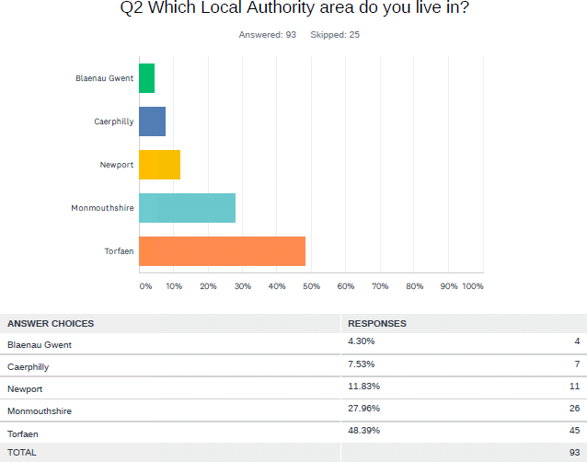

## Accessible housing allocation system vs. register

In this report we use the term accessible housing allocation system to refer to the processes involved in the allocation and the different elements of a functioning approach.

Whilst the term accessible housing register is widely used, we decided not to use it in this report. This is based on our experience of frequent differences in understanding of what constitutes an accessible housing register. For example, in the course of our policy, advice and consultancy work in this field we have come across practitioners who associated a register solely with a list of available properties, whilst others referred to a register of applicants. We are also aware that many practitioners understand a register to be a standalone register of accessible properties and applicants, including a separate matching system.

All accessible housing allocation systems across Gwent are embedded within the Common Housing Registers.

## Categorising and Banding

Categorising - some organisations considered in this research assign accessibility codes to properties and (in some organisations) people based on accessibility level of the property and corresponding accessibility requirements of applicants. For the purposes of this research we will refer to this process as categorising and to the different accessibility levels as categories, or accessibility categories.

Banding - all housing organisations considered in this research use a form banding process to assess and determine the level housing need and priority on the waiting list/register or in the process of bidding. We will refer to this process as banding and to the housing need levels as bands for clarity purposes.

# Research and good practice review

The aim of this section is to provide a policy context and a short research review on the subject of accessible housing allocation. Good practice examples are identified throughout this and other sections.

## Context and research in Wales

Recent reports related to disability and housing issues have been critical of slow progress in relation to accessible housing registers in Wales.

Homes for Wales White Paper 20121 contained a commitment from Welsh Government to ensure there is an Accessible Housing Register covering every local authority area, based on good practice and collaborative working. The same commitment was reflected in the Welsh Government Framework for Action on Independent Living (2013)2. The new iteration of the latter framework, Welsh Government Action on Disability Framework, contains a similar commitment, including the development of a national Accessible Housing Register standard, which will be undertaken by Tai Pawb on behalf of the WG Adaptations Steering Board.

In 2013, Welsh Government published a report entitled *Accessible social housing in Wales: a review of systems for assessment, recording and matching*3*.* The report was a result of comprehensive research carried out by Shelter Cymru, with a range of partners involved in the process and a diverse methodology. It found that all Local Authorities have a process for allocating housing to disabled people. However only 14 local authorities said that they had an accessible housing register, with the remaining reporting that:

1. their process has some elements of an Accessible Housing Register;
2. they are in the process of developing an Accessible Housing Register; or

1 https://gov.wales/betaconsultations/housing-and-regeneration/housewhitepaper/?lang=en

2 https://gov.wales/docs/dsjlg/publications/equality/130916frameworkactionen.pdf

*3* https://gov.wales/statistics-and-research/accessible-social-housing/?lang=en

1. they have their own internal matching process.

There was also an extensive variation between each of the Accessible Housing Registers and how they operated, as well as differences between matching systems of those local authorities that do not have an Accessible Housing Register operating in the area. The effectiveness of accessible housing registers researched also varied.

The research brought to the fore the fact that there was no industry standard or a definition of an accessible housing register, which would provide a benchmark against which an assessment could be made as to which registers should actually be classed as Accessible Housing Registers. A standard would also help assess the extent to which the Accessible Housing Registers were well-developed and effective. The research also demonstrated that monitoring of the effectiveness of individual AHR’s was also rather limited.

It meant that this and further research as to the number of accessible housing registers in Wales was mainly based on local authorities’ own perceptions of what they thought constituted an accessible housing register and what made it effective. This was acknowledged by the local authorities which engaged with Tai Pawb as part of our Accessible Housing Register Network, accessible housing events and other engagement.

In some local authorities, this lack of definition and, at times, awareness was evident when Tai Pawb began carrying out research into this area. For example, we came across local authorities where some staff members involved in allocations did not know whether they operated a register, others would confirm that a register was present whilst their colleagues reported having no accessible register present. This is not surprising, given the lack of accepted and well publicised definition, standard or guidance.

The review recommended that there is an accessible housing register developed in each local authority – a recommendation based on the views and wishes of frontline staff involved in accessible housing allocation and service users.

In 2015 Tai Pawb’s own research found that 15 local authorities had an Accessible Housing Register (5 of those were of a standard which we classed as good practice). Further 3 local authorities were developing an AHR and 4 had a more or less ad-hoc matching process. This short research exercise consisted of a concise phone questionnaire administered to all 22 local authorities, with questions based on a list of elements we considered to be in place for a good practice accessible housing register (based on our expertise in this subject developed via reviews of accessible housing registers we conducted for several local authorities and policy and practice elements of registers researched as part of Tai Pawb Good Practice Briefings, member seminars and Accessible Housing Register Network which was then facilitated by Tai Pawb).

In the course of this research we found, similarly to the Shelter Cymru research, that perceptions of what constitutes an accessible housing register varied and, on initial survey, were sometimes limited. Some staff referred to a list of adapted properties as an Accessible Housing Register (of properties), others defined an accessible housing register as the list of applicants (or the ability to identify them) with accessibility needs. In some places, little consideration was given to the specific processes governing the operation of an accessible housing register or allocation system as we started calling it – elements which this research explores in detail in the findings section.

In 2016, Welsh Government published *Local Authorities ‘Common Housing Registers’ and ‘Accessible Housing Registers’: A Report*4. Methodology was based on an online survey of local authority staff and their perceptions. 17 local authorities stated that they have an accessible housing register. The standards reported however were varied, e.g. only three local authorities stated that their registers were continually updated and involved disabled people in their development, only 5 had some dedicated staff, 2 reported not being very effective (although some of this might have been driven by factors such as general shortage of accessible housing in the area/low turnover etc.).

The extent to which the above research involved disabled people’s views, expectations or experiences was very limited. This would have provided a much fuller picture of the availability and effectiveness of accessible housing registers.

In 2018, Equality and Human Rights Commission Inquiry into Housing and Disabled People5 found that only half of local authorities in Wales use an Accessible Housing Register (although this was still much better than the UK level of 22% of local authorities). The methodology used was a survey.

The inquiry made the following recommendations:

* Local authorities and Registered Social Landlords to embed independent living principles into assessment and allocations policies for social housing, to ensure real choice and control.
* Local authorities to significantly increase their knowledge of existing accessible social housing stock, and develop specialist support and information services to facilitate suitable matching.
  + Local authorities to apply best practices on the use of Accessible Housing Registers, with the longer-term aim of the use of a standard methodology across all local authorities.
  + The Welsh Government to publish standards and monitor and publish effectiveness of Accessible Housing Registers

*In 2018 Wales Audit Office’s Review of Housing Adaptations*6*, referred to:*

*poor joint working practices between housing allocation staff and grants officers to improve use of already adapted homes. Policies are often property, rather than client focused, and rarely make the strategic link to other organisations and the wider needs of disabled and older people. This is despite the Welsh Government’s Framework for Action on Independent Living that commits to improving access to adapted and accessible housing for disabled people. The Framework identifies the Housing (Wales) Act 2014 and the use of Accessible Housing Registers as key opportunities to bring about improvements. Too often, matching applicants to adapted homes via accessible homes registers does not happen. Instead adaptation policies continue to be focused on the work of individual organisations, usually*

*4* https://gov.wales/statistics-and-research/local-authority-survey-accessible-housing-registers/?lang=en

5 https://[www.equalityhumanrights.com/sites/default/files/housing-and-disabled-people-wales-hidden-crisis.pdf](http://www.equalityhumanrights.com/sites/default/files/housing-and-disabled-people-wales-hidden-crisis.pdf)

*6* <http://www.audit.wales/publication/housing-adaptations>

*centred on processes for deciding on and managing grant applications, approvals and delivery or work to a social-housing landlord’s property.*

In this respect WAO recommended that local authorities work with partner agencies (health bodies, housing associations and Care and Repair) to strengthen their strategic focus for the provision of adaptations by (…) (amongst others) *linking the system for managing and delivering adaptations with adapted housing policies and registers to make best use of already adapted homes.*

## Housing and Disability: Equality and Human Rights Commission Toolkit

In October 2018, the Equality and Human Rights Commission published a toolkit7 for local authority councilors focusing on housing and disability, with the aim of enabling better scrutiny and leadership on housing and disability matters.

The toolkit focuses on a number of areas relevant to housing and disability, including planning, development, adaptation systems and allocation. The toolkit defines an Accessible Housing Register as the following:

**Accessible housing registers hold a detailed register of disabled people in need of accessible homes, together with a detailed register of accessible properties, their location and characteristics (or levels and types of accessibility). This enables effective matching of people and suitable homes. Some registers are separate to general waiting lists; others are embedded within waiting lists (categories are used to identify people with accessibility needs).**

The toolkit describes accessible housing registers as a great way of making the best use of available resources and letting adapted/accessible homes to people who need them in an effective way. They can minimise the need to:

* + - remove established adaptations which could benefit other applicants with accessibility needs
      * install adaptations in a non-adapted home (if this was let to a person with accessibility needs).
    - Enabling budget savings on Disabled Facilities Grants and Physical Adaptations Grants.

The toolkit further talks about the choices given to people registered for accessible housing allocation, stating that registration on the accessible housing register does not mean applicants can’t register on the general waiting list (where these are separate). Segregating applications from disabled people in this way limits their right to have a choice and can seriously prolong waiting times in areas with real accessibility shortage.

7 https://[www.equalityhumanrights.com/sites/default/files/housing-and-disabled-people-local-authorities-](http://www.equalityhumanrights.com/sites/default/files/housing-and-disabled-people-local-authorities-) toolkit-wales.pdf

EHRC toolkit further defines an Accessible Housing Register as having the following elements:

* Specialist staff or staff who are trained and have a level of expertise in relation to the access requirements of disabled people, in particular: disability equality training and inclusive design
* Open and easily accessible to apply
* Housing advice and information for applicants in relation to the availability of accessible housing and guidance on areas of choice
* Clear and transparent policies, procedures, and guidance covering the following areas:
* matching people and properties
* application, including process and criteria
* assessment and classification of need (housing, adaptation, and access)
* applicant prioritisation(preference)
* managing and reviewing waiting lists
* assessment of property (access and adaptations)
* classification of property (coding to denote accessibility level and adaptations)
* Clear standards, monitoring and review processes for: applicants’ waiting times (segmented into process e.g. application, assessment, waiting for a home)
* void times
* allocations
* complaints and appeals
* satisfaction (customer)

It further refers to good practice elements of an AHR as the following:

A best practice approach to accessible housing registers would encompass all of the above

elements, in addition to:

•

•

•

•

Clear and common process between all local housing providers on how they will

arrive at decisions to remove adaptations (in consultation with the accessible housing register).

Comprehensive housing advice for disabled applicants from specialist staff.

Housing needs data held by the register feeds into the housing strategy, LDP, LHMA, and other local planning and housing policy documents.

Outreach work to local hospitals (in particular with discharge teams) and general

promotion of the service.

## Latest research in Scotland

Recent research into accessible housing allocation in Scotland (*Match Me: What works for adapted social housing lettings?)* looked at the experiences of disabled people and systems in

three local authority areas. 8 This is the most recent and most detailed research on this topic, including extensive co-production with disabled people, therefore we afforded more space here to expand on its findings. *Match Me* looked into the allocation as a step by step process, starting with the application process.

*Applications*

The research describes methods of acquiring accessibility needs information from applicants and methods of information verification, including involving: housing staff only, housing staff with option to ask for help from OT and social workers and a panel consisting of housing, health and social work staff.

**Good practice: housing needs assessments**

The research highlighted the departure from questionnaires which are purely medical (i.e. asking for information on conditions/health problems/GP letters etc.) to questionnaires which focus on the functional ability of the individual in the current home and their potential needs – an approach more consistent with the social model of disability.

Disabled participants recommended that the assessments need to better reflect the needs of the whole household (not only the main applicant), especially where more than one applicant had housing need.

Disabled people also strongly favoured one name contact to support them through the application process.

Advice: each local authority identified the potential of the Housing Options approach to improve advice and solutions offered to disabled applicants. Importantly, many of the participants referred to the support and advice they received from a local Disabled Person’s Housing Service as invaluable, an example of such service is provided below:

**Good practice: Disabled persons housing service - Aberdeen**

The DPHS Aberdeen is a local charity offering housing advice, information and advocacy to

disabled people, their families and carers. If offers housing information and advice service, including:

•

•

•

•

Looking at all housing options – based on extensive local knowledge and good

relationships with housing providers.

Applications for social housing with Aberdeen City Council and Registered Social Landlords locally

Helping to ensure you give all the necessary information and evidence for your applications to be assessed appropriately

Support with requests for re-assessment or review if circumstances change

8 Match Me: What works for adapted social housing lettings? Action research to enhance independent living for disabled people. (2019)

•

•

•

•

•

Advice on how to access assessments for Occupational Therapy, care services or

telecare and other equipment.

Assistance with access adaptations to your current property to enable you to remain there

Signposting to money and welfare advice services Advice on housing law and rights

DPHS also providers a specific housing advice support service for disabled veterans

and to people over 65.

<http://www.dphsaberdeen.org/services/>

*Matching up applicants and vacancies*

**Good practice: property audits**

Property audits: The research was strongly in favour of a full audit and assessment of existing stock to determine accessibility level of stock as well as the potential to be adapted. This could be achieved during routine visits, rather than waiting for properties to become vacant: this shortens the matching process as well as informs future planning in terms of the pool of properties available to meet accessible housing need.

New built: Different methods of procurement of new build housing resulted in different standards of specification and therefore of adaptability, and in turn accessibility to, homes suitable for disabled people.

Rent loss targets: Practitioners discussed the housing management conflict between minimising rent lost on vacant properties, and acknowledging the extra time needed to successfully match vacant properties to disabled applicants.

In one local authority, pre-approval of adaptions required to make a home accessible to disabled applicants removed some of the factors that can lead to a delay in re-letting an adaptable home. The case was also made for flexibility in target letting times for adapted or accessibly designed vacancies.

Offers: A high proportion of participant home-seekers received inappropriate housing offers, or no offers at all, during the tracking study (12 months). There was some evidence of participants experiencing adverse emotional and mental distress.

Property Info: practitioners highlighted that having up to date property information helped minimise the number of unsuitable offers, which saved scarce resources and applicant frustration.

Suitability: the research stressed that it was crucial that suitability assessment included accessibility of the environment and support networks (as well as the property). It recommended strongly that access to a garden needs to be part of the criteria.

Management and review: the research favoured active management processes with applications reviewed at least every 6 to 8 months especially where there has been no offer of suitable housing. This helped with accuracy of information and reassurance.

**Good practice: Viewings**

Viewings: A potential area for future good practice was the increased use of new technologies to provide virtual property viewings for disabled housing applicants who are unable to leave their current unsuitable accommodation or unable to attend due to health or accessibility reasons.

It should be noted that the technology to offer virtual viewings has developed rapidly since March 2020 and many private lettings and estate agents started offering those due to the restrictions posed by Covid-19. Although we have not identified any examples of this being done in social housing yet, it is worth considering. Disability rights organizations, including Disability Wales, highlight that one of the potential positive aspects of the post Covid-19 new normal is the increased capacity of organizations to employ virtual technologies and flexible practices to employ and provide better services for disabled people. For an example of a virtual property viewing in the private sector, look here: <https://www.struttandparker.com/virtual-viewings>

Nominations & working together: The research recommended that all housing providers could develop more effective mechanisms to seek nominations for adapted/accessible vacancies from other housing providers, if they have an adapted/accessible vacancy but no suitable applicant. This could be extended to seeking nominations from hospital discharge units and relevant third- sector organisations (including from outside of the local area if there is no suitable applicant on their register).

Support and sustainment: There was evidence that some disabled tenants would benefit from support to move-in, settle-in and sustain their tenancies. Social housing providers should review their tenancy sustainment strategies, including better coordination between housing and support.

Good practice: The research identified good practice including involving disabled people and housing professionals, enhancing service user feedback mechanisms and developing strategic approaches to the provision of accessible/adapted social housing and accessible communities.

**Good practice: temporary step-down/accessible accommodation**

Participants from LA2 went on to explore a good practice example that illustrated the cross- tenure impact, flexible working and application of a Human Rights approach through using the Housing (Scotland) Act 2014 provisions to meet the needs of a disabled household. The case study involved home owners Mr & Mrs X and their 2 children. Mrs X became hospitalized, resulting in the need to use a wheelchair and when ready for discharge from hospital, realized that her own home was not suitable for adaptions. Mrs X moved in with her parents who had a more suitable home but this split the family and created tension. The

local authority adapted a Council home with temporary adaptations in order that the family could live together using a Shorthold Assured Tenancy. This enabled the family to take the necessary time to sell their inaccessible home and buy an accessible new place to stay.

## Cost and effectiveness research from England

*Costs and effectiveness of accessible housing registers in a choice-based lettings context*9, commissioned in 2011 by the UK Government, explored the effectiveness of 3 different types of accessible allocation systems within a choice-based lettings context in England:

* Open full accessible housing register

A comprehensive listing of accessible and adapted properties is compiled, and accessible homes are let via choice-based letting with bidders needing such properties given priority over all others.

* Closed accessible housing register

A comprehensive listing of accessible properties is compiled together with a companion listing of people needing accessible housing and seeking to move. Relevant properties becoming available for letting are matched by staff to the ‘most appropriate’ applicant with highest priority as registered on ‘companion listing’. Applicants on companion listing are also free to bid for ‘mainstream’ properties as advertised under choice-based letting.

* Open Partial accessible housing register

This model does not provide a full list of adapted properties. Instead it offers a ‘weekly’ list of such housing. That is to say properties becoming available for letting are assessed in terms of their ‘accessibility features’ in the course of initial void inspection and accessible/adapted properties are advertised within the choice-based letting system with a marker. Bidders with a need for such properties are given priority over all others. Arguably the only difference between this and the first system is the lack of comprehensive database of properties pre-advertisement.

The research investigates elements of processes involve in the allocation of accessible housing, analysing their effectiveness and cost effectiveness. It is a useful blueprint of how to approach any reviews of effectiveness and cost effectiveness of accessible housing allocation. Despite its focus on choice-based lettings, the breakdown of different processes involved, makes it possible for adapting this method for points-based systems.

The study, considers the following elements:

* Processes and costs of identifying households with special needs
* Assessment of housing stock suitable for accessible or adapted needs
* Other set up and running costs accessible housing register
* Scale and costs of adaptations

9 <http://www.housingcare.org/downloads/kbase/3134.pdf>

* Households with accessible/adaptive housing needs
* Matching of households and housing via accessible housing register
* Bid cycles and numbers of bids for lets involving accessible/adapted properties
* Duration of wait for priority households before rehousing in adapted housing
* Average letting times/void periods for lettings of accessible housing and for all lettings
* Links between adaptations and lettings
* Cost effectiveness

We discuss cost effectiveness element and conclusions in the findings section of this study, which considers benefits and cost analysis issues.

## More on good practice

## Caerphilly accessible housing allocation system

Caerphilly Common Housing Register has been operational since December 2016.

Caerphilly’s service deals with all types of tenures working closely with social services. Working with social services, they can deal with facilitating and assessing major and minor adaptations to owner occupiers and the private rented sector alike, as well as supporting allocations and relocations. The service uses specialist Housing Occupational Therapists (OTs), based within the housing team, to assess needs and resources across the borough. Having specialist OTs means a more holistic and efficient service can be provided to tenants and applicants.

The Common Housing Allocations policy is based on a banding system and applicants are placed into one of three bands depending on an assessment of their circumstances. Those with the greatest need are afforded the highest priority. It is a needs-based, time and date ordered system.

‘Home Search Caerphilly’ is a dedicated website aimed at providing information on the different housing options available in Caerphilly County Borough. This was Equality Impact Assessed before launch to ensure the service was as equitable as it could be and adheres to a single allocation policy. It is used for all CCBC properties as well as 6 local Housing Associations, and users can use the service to access all properties from these providers.

Applications are online based with information required about the applicants and their housing needs collected. Caerphilly also promote support with completing application if difficulties identified i.e., telephone application with allocations officer, support sessions in local Libraries through the Borough, customer service and home visits. The application includes information section with regards to an applicant/s health and physical accessibility requirements as well as applicant’s mental health.

Where housing application identifies accessibility requirements Housing OTs and / or Mental Health assessors work with the applicants to complete assessments to help determine requirements. These include desktop and/or home visits and joint working with other professionals including hospital / community professionals. Currently, the assessors work within

a 4-week time frame. Housing OT assessments determine level of accessibility required and priority band. Consideration of age dispensation is also part of the process. Assessments determine the level of accessibility required which is clearly categorised.

At the same time, all Caerphilly council properties that are void, are coded according to their level of accessibility, otherwise they cannot be allocated (see Appendix 1a for Caerphilly Accessibility Coding - Properties). These levels correspond to person classification categories (see Appendix 1b for Caerphilly Accessibility Coding - People)

In any allocation system, it is important that a clear process is developed for how the housing need Banding system interplays with the accessibility coding, i.e. on what basis are applicants with accessibility needs prioritised and shortlisted, should an adapted/accessible property become available. This process for Caerphilly is described in Appendix 1c.

Property coding is carried out by Estate Management Officers and Housing Officers in RSLs who have been trained by OTs and are advised by them. Although not all Council properties are currently categorised, Caerphilly have clear plans for achieving this. This will allow them not only to allocate, but also carry out a detailed analysis of available housing against the unmet need – feeding into planning and development of homes for the future.

Importantly, due to their clear classification system, Caerphilly Council are able to identify the profile of their properties by accessibility level as follows. It is clear that more than half of their properties are still not classified, however a clear plan on progressing this is in place and the ability to profile compares favourably to other local authorities. Please note the table below also represent council properties only.

|  |  |  |
| --- | --- | --- |
| **Accessibility Level** | **Total** | **%** |
| **A1 FULL WHEELCHAIR** | 274 | 2.5 |
| **A2 PARTIAL WHEELCHAIR** | 173 | 1.6 |
| **B1 LEVEL/RAMPED** | 1093 | 10.1 |
| **B2 LIMITED STEPS** | 573 | 5.3 |
| **C1 SINGLE LEVEL FAC** | 546 | 5.1 |
| **C2 HOUSE WC X 2** | 350 | 3.2 |
| **C3 LEVEL FAC GF ONLY** | 139 | 1.3 |
| **D NOT ADAPTABLE** | 1542 | 14.3 |
| **Not categorised** | 6112 | 56.6 |
| **Total** | **10802** | **100** |

Other features of the Caerphilly service:

* Housing OT assists with reassessments of hoists / lifts when not

Repairable

* Housing OT considers if existing adaptations need to be recycled

i.e. removed from property.

* Re-use of recycled lifts from private sector into public sector
* OT assessment works with the tenant to identify whether the provision of bathrooms,

kitchen, access etc. is suitable to need of tenant as part of WHQS improvements

* OT carry out assessments with all sheltered schemes across the borough
* Housing OTs works with colleagues when inappropriate housing /need to transfer is identified

Actions for the future identified by the Council include:

* Development of central repository for all CHR stock
* This will include type of property and the medical code, property information etc.
* Number of properties coded will increase showing a more accurate stock profile throughout Borough.
  + Ability to compare what exists against unmet need.
  + Highlight what properties are required moving forward – i.e. consider Enable funding, areas of high demand and new developments etc.

## Cardiff Accessible Homes

**Please note that there have recently been changes to the way Cardiff Accessible Homes operates. The housing OT’s running the service now operate within the council offices, however we are seeking confirmation whether the scheme has now been embedded within the general waiting list**

Cardiff Accessible Homes (CAH) provides a holistic housing service which includes managing a central disabled persons housing list, Occupational Therapist assessments, housing advice and support. This involves working in partnership with housing associations, agencies and voluntary organisations to find positive solutions and outcomes for disabled people regarding their housing issues. The project

became operational in 2002 and has since successfully rehoused over 2,500 clients.

CAH provides a similar service to Caerphilly in running an accessible housing register. CAH also manage the referral process for Physical Adaptation Grants (PAGs) ranging from extensions to grab-rails. This involves taking the referral from partner RSLs and arranging OT visits and assessments in order for clients to be able to have adaptations installed in their properties. The service has specialist housing OTs as part of its small team. The project also continues to work closely with its partners in identifying new sites for new build properties which is achieved by having a central register of disabled applicants and having the knowledge of each person’s disability, need to move and also the areas they are willing to move to.

CAH works closely with Child Health and Disability Team (CHAD) and Local Health Boards when dealing with Child and Delayed Transfer of Care cases and this has resulted in positive outcomes when locating these types of cases suitable adapted accommodation.

This is how CAH describes what they do:

* Manage a central waiting list of physically disabled people who require adapted / accessible housing
* Until recently (TBC) – CAH was a standalone Accessible Housing Register (as opposed to the Caerphilly register of properties and applicants, which is embedded into the Common Housing Register)
* Manage a central register of adapted / accessible properties
* Process that matches available properties to suitable clients
* Holistic approach – one stop shop - advice, info and support
* Work closely with several organisations and departments including social services, child services and health in order to provide suitable housing for applicants.
* Work in close partnership with our local authority (allocation and housing strategy departments) and partner Housing Associations
* Each partner organisation provides funding
* Each partner organisation agrees to refer all adapted/accessible stock to be used via the AHR
* Steering group consisting of partner representatives meet regularly
* Training and review meetings with partners

This is how they characterise accessible housing allocation prior to the introduction of AHR’s:

* Several different housing application forms
* Several different housing lists
* No way of identifying clients’ needs once adapted properties became available
* Local Authority and Housing Associations would contact each other in desperation trying to locate a suitable client
* Lengthy void times
* Removal of adaptations (further reducing adapted stock) - let via General needs housing

CAH states that the benefits of having the service are as follows:

* Re-use of adaptations
* Speedy process of identifying suitable clients to available properties
* Simple and effective process to suitable housing – Single application form, single housing list – single matching process
* Reduce void times on adapted properties
* Long term rental for social landlords
* Reduce the amount re-lets (due to successful matching process)
* One stop shop (consistent and concise approach)

CAH process is as follows:

* Anyone who is in need of accessible / adapted accommodation (each applicant would need to go through the normal local authority checks regarding criminal convictions, immigration status and tenancy arrears) before eligibility can be decided
* Apply by completing a Housing Application form (HUB centre or self-refer for a visit by CAH – visit within 7 days)
* OT assessment completed for applicants to obtain housing need (overview of need and adaptations required)
* If eligible – applicant will be placed on the AHR and will be considered for properties as and when they become available based on the property type, area, adaptations and accessibility of property

CAH uses the following classification criteria:

Each applicant is given a category of what they require:

F/A fully adapted –

* Wheelchair access at the front of the property. This may be level access, a ramp or a lift.
* Minimum 900mm door widths.
* Wheelchair turning/circulation space and full wheelchair access to all rooms and facilities.
* If there are internal stairs, a through- floor lift or stair-lift will be present.
* Bathroom to be fully wheelchair accessible with access to a level access shower or specialist bath.
* Wheelchair circulation space in the kitchen as a minimum requirement (kitchen units may be standard, partially adapted or fully wheelchair accessible).

P/A partially adapted

* Properties that have or have been adapted to provide a ground floor bedroom and shower-room/WC.
* Step free entry or could be adapted to include step free entry (consider using modular ramping).
* Other rooms such as additional bedrooms, bathroom or kitchen may not be wheelchair accessible or have step free entry.

E/A easy access

* Access may be step free or have one or two steps that have the potential to ramp.
* If flights of stairs/steps – lift access available (complexes etc.)
* This property type is likely to include ground floor flats, houses with a stair-lift and/or a level access shower, older style bungalows that are not wheelchair accessible but that have a ramp or shower.

CAH shortlisting process involves:

* Adapted/Accessible property referred to CAH
* Input details – F/A, P/A or E/A, location, size and type of property
* List of all CAH applicants eligible for property
* Go through list based on housing need
* Contact applicant – obtain interest
* Arrange viewing or record refusal (2 offers)
* View and let property or go to next applicant

CAH is also used for a partnership PAG assessment process. CAH manage a central referral process for Physical Adaptation Grants (PAG’s) on behalf of RSL partners.

* This involves CAH accepting PAG referrals and arranging OT visits to tenant homes
* OT’s visit tenants and recommend adaptations. Reports are completed and sent to

RSL’S who have the works installed

* CAH / OT’s deal with any queries regarding reports
* PAG service is funded by RSL partners

## North Wales Regional Common Housing Register SARTH

SARTH Common Housing Register system involves two local authority areas (Conwy and Denbighshire) and 6 Housing Associations. We weren’t able to carry out a detailed review of how the system operates in terms of accessible housing allocation however, the understanding is that it is a needs-based waiting list system with accessible housing options being embedded in the general waiting list.

Interestingly, one of the housing options managers told us that the partners on SARTH are developing a regional consistent approach to adaptations. They have set up a Strategic Adaptations Group including Social Services, Health, Local Authorities and RSL’s and which has considered Wales Audit Office report recommendations in relation to making adaptation systems more equitable and simpler. At the point of the short interview, conversations were being convened with the 2 local authorities in the area to see how a regional process for adaptations could be developed and administered. In addition to the research mentioned above, our report further demonstrates how the adaptation and allocation of accessible housing systems interact with each other and how different adaptation processes, policies and budgets can influence the operation of accessible housing allocation. It is recognised that for SARTH partners, who already have a regional system of allocation, regional conversations on adaptation systems and governance will be more straightforward that for Gwent – were 5 different allocation systems operate, however, as the SARTH approach develops – it would be useful to learn lessons from those developments.

## London Accessible Housing Register

The LAHR originated in 2004 when the Greater London Authority (GLA) carried out a feasibility study into setting up an accessible housing register. The study concluded that the development of an AHR should be integrated into choice based letting (CBL) schemes. Consultants carried out further work in 2006, on behalf of the Greater London Authority, to develop a model for the LAHR and a toolkit for assessing and categorising properties. The London Borough of Tower Hamlets and the Royal Borough of Kensington and Chelsea both piloted the toolkit, which includes a framework for categorising accessible homes. Both of these boroughs are now operating the LAHR on an ongoing basis.

The LAHR is now being rolled out across London with a project coordinator supporting social landlords to introduce the initiative locally.

**LAHR is a framework of allocating accessible housing within a choice-based lettings system –**

**not a standalone register.**

The LAHR has been developed to be an additional but integral component of choice-based lettings schemes. It is not a stand-alone register of accessible housing and people who require it, but a framework for collecting information on property access details and using this to assign a

category to the property. The framework is described in a guidance document developed for all London authorities.10 The LAHR framework approach, although based on choice-based lettings, is an important one to consider in this report. It offers a regional partnership approach to better accessible housing allocation and therefore it is relevant to this regional Gwent study.

The property categories have been developed and piloted for the LAHR and are based on national design guidance. The property categories used by LAHR are in Appendix 2 of this report. LAHR recommends that these property categories are used in all London CBL scheme adverts to inform home seekers about the accessibility features of a property.

LAHR offers a process for initiating the development of accessible housing register in each borough, presented below:

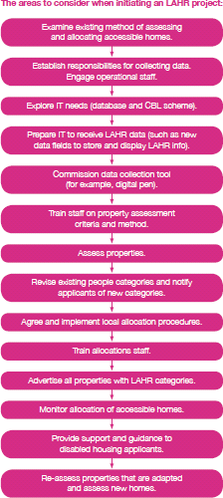

LAHR framework then offers information and advice on assessment of properties and data collection, IT requirements and prioritisation of applicants for accessible housing.

LAHR considers pros and cons of two ways of collecting property data (survey or during void inspections).

10 <https://www.london.gov.uk/file/2055>

It subsequently recommends the use of an electronic data collection tool to speed up the process. The information collected is then used to calculate the LAHR property category and transferred into a format that can be uploaded to a database. One example of a data collection tool is **a digital pen** that is used to complete a paper

checklist. The digital pen translates the information that is written on the form and creates a spreadsheet of information including the LAHR property category. (it’s important to note that the guidance was written in 2011 and more modern tools might be available now).

Interestingly, LAHR guidance, apart from providing a description of accessible property categories, also provides so called Business Rules – this is a set of rules which can be used by an electronic collection tool/software to calculate accessibility category automatically. While these criteria can be applied manually, it is most efficient to use a data collection tool that automatically works this out, thereby reducing the element of human error. It also facilitates the collection of large volumes of data and provides the information in a format that can be uploaded to housing databases or stored by each organisation.

LAHR recognises that this electronic means of collection requires certain assumptions to be made about properties in order to calculate rules for a majority of properties. There are countless variations of features of properties for which it is impossible to accurately capture all elements on the digital form. LAHR offers guidance on circumstances where further thought may be required to accurately obtain a property category.

LAHR framework advises that electronically collected data can be automatically uploaded to corresponding fields in electronic property databases used by councils, with specific fields chosen to be displayed automatically under property information when advertised. This of course depends on the systems used.

In London, each of the above CBL schemes has LAHR compatible data fields. Therefore, all properties can be advertised with data relating to their accessibility.

LAHR advises on the need for allocation and lettings systems and processes to prioritise disabled applicants (although does not set a specific process for this, due to possible local differences in banding/points awarded).

It further acknowledges the need for housing options to meet targets to allocate properties to given priority groups, such as homeless people or overcrowded

households. However, LAHR advises that, the shortage of accessible accommodation is such that boroughs may wish to consider initially making accessible accommodation available solely to those who are disabled/have accessibility requirements.

Whilst choice-based lettings systems leave the choice of property with the applicant, based on the information available and viewing, it recommends that advice is offered by an OT at viewing stage. No information is offered on how decisions are made in cases where an applicant with lower accessibility needs bids for a highly accessible/adapted property, e.g. whether the CBL systems would prevent this or whether part of the decision process sits with the local authority. It does state that usually it should be possible for applicants with higher requirements to bid for properties which are of lower accessibility level, however, similarly to the above situation, no information is offered as to how decisions are made if there is high disparity between the needs of the applicant and property accessibility (although this information is probably provided in separate allocation policies).

LAHR further providers a training manual for property assessors – a detailed guide to assessing properties and classifying them according to LAHR categories. 11 In addition – a standard property survey form is also provided.12

## Home 2 Fit Scotland

In 2007, Glasgow Centre for Independent Living launched Scotland's first on-line Accessible Housing Register in Glasgow. GCIL states that it works closely with Registered Social Landlords (RSLs) and national RSLs with accessible properties in Glasgow. Home2Fit is described as Scotland's Accessible Housing Register which has been developed and built on the success of Glasgow Centre for Inclusive Living's (GCIL) Glasgow-based Accessible Housing Register.13

In Scotland, similarly to other areas of UK, there is a well-documented shortage of accessible housing to meet the needs of disabled people. However, there is also evidence that accessible and adapted homes are being let to people who do not need them.

Home2Fit states that it provides an easy to use online system to match accessible properties with people who really need them. For the first time detailed information on the accessibility of homes across all tenures is available thus allowing disabled people more informed choices.

Home2Fit - Scotland's Accessible Housing Register is an online system designed to:

* enable disabled people seeking an accessible home to register and record the features they need. By registering, Home2Fit records information on housing circumstances; required property size, location and level of accessibility.
* enable landlords and housing providers to record information on their accessible properties by size, location and adaptations
* enable social housing providers and private landlords to find a match to allocate accessible housing to disabled people in housing need
* provide an advertising facility for owner-occupiers to market accessible and adapted housing to potential buyers looking for adapted accommodation; and to
* provide a comprehensive source of information for disabled people seeking more suitable accommodation

During 2014 'pilots' were established in Aberdeen, Fife and Glasgow. In addition, Horizon Housing Association have agreed to use Home2Fit to allocate their wheelchair accessible properties. GCIL acknowledges the engagement and commitment from a number of participants including the Disabled Person's Housing Services, local authorities, housing providers and the private housing sector in the pilot areas.

Home 2 Fit states that following the piloting phase, it will be rolled out in all 32 local authority areas in Scotland.

Home 2 Fit describes its aims as:

11 https://[www.london.gov.uk/sites/default/files/lahr_training_manual.pdf](http://www.london.gov.uk/sites/default/files/lahr_training_manual.pdf)

12 https://[www.london.gov.uk/sites/default/files/lahr_property_survey_form_sample.pdf](http://www.london.gov.uk/sites/default/files/lahr_property_survey_form_sample.pdf)

13 <http://www.home2fit.org.uk/about-us.aspx>

* To provide an easy to use online system which matches disabled people with housing which meets their needs
* To develop a comprehensive housing information resource covering housing options and accessible design
* To better coordinate the use of existing adapted and accessible housing
* To provide a consistent national framework for recording adaptations in Scotland

Whilst the idea behind Home 2 Fit is very innovative and certainly worth developing further, testing of the system by the researcher revealed that only 3 properties are advertised for sale and 2 properties are advertised for rent. This might be due to the fact that the register is in its infancy, although pilots for the system were carried out as far back as 2014. We will seek further clarification on any potential barriers and facilitators to the development of such a system.

We weren’t able to establish whether the system perhaps works better from the point of view of housing provider, e.g. how many disabled people actually registered on the website as being in need of accessible housing and whether providers use the website to identify such potential applicants, especially if they have longer term voids.

## London accessible and specialist older persons housing locator

This tool14 is separate to the London Accessible Housing Register Framework, nevertheless it represents an innovative way of providing disabled and older people with information on accessible housing being built in London. The locator tool aims to help people find out where in London accessible and/or specialist older persons housing is being built.

It provides searchable information on all developments that meet the search criteria, starting from 1 October 2015. Developments granted prior to this date do not feature in the tool. The tool is based on information obtained from the London Development Database which contains information on all new developments in London. The data on the LDD is supplied by the relevant planning authority. They are responsible for the quality and completeness of the data. The planning authorities are the definitive source of information on planning applications within their boundaries.

15

The locator tool pools information from the above database, allowing users to search properties by place, accessibility level (these are based on English building regulations, i.e. M4(2) and M4 (3), specialist older persons housing and affordable housing. It also allows to view the development status of homes.

An example search result is presented below:

14 https://[www.london.gov.uk/what-we-do/planning/accessible-housing](http://www.london.gov.uk/what-we-do/planning/accessible-housing)

15 https://[www.london.gov.uk/what-we-do/planning/london-plan/london-development-database](http://www.london.gov.uk/what-we-do/planning/london-plan/london-development-database)

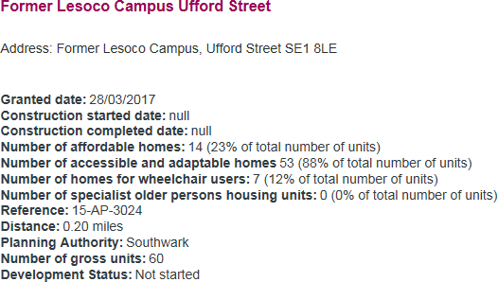

# Current allocation systems: baseline

## This section

In this section we describe the basic features of each of the 5 common housing registers across Gwent including how accessible and adapted housing is allocated. We do not describe the allocation systems and lettings processes used by each of the 9 housing associations/social housing providers which we interviewed and surveyed for the purposes of this research as this would make the section too lengthy, especially that most of the housing associations work across a number of local authority areas and their properties in a given local authority area would be allocated using the particular common allocation policy they subscribe to in those areas. The information and views obtained from RSLs however were invaluable in contributing to the subsequent section which focuses on thematic analysis, comparison, findings and gaps.

## Newport County Council

## Allocation system

Newport Council operates choice-based lettings via a common housing register (CHR) which is a partnership between Newport City Council and the RSLs in Newport. CHR has a common policy, common application form and common advertising process. The local authority

administers it on behalf of the RSLs (Newport Council does not have any housing stock). The RSL’s involved are: Aelwyd Housing Association, Charter Housing (part of POBL), Derwen Cymru (part of POBL), Elim Housing Association, Seren Living (part of POBL), Hafod Housing Association, Linc Cymru, Melin Homes, Newport City Homes, United Welsh Group.

The RSLs allocate the properties. The policy is both band and points based. The local authority assesses all applications and awards a level of housing need which determines a band. Bands are ordered from A to D, with A being the highest band and D the lowest.

Within each band 10 points are attributed to each level of need within that band; e.g. if someone is privately renting, they would get Band C with 10 points for insecurity of tenure and if they have a medical need, they would get another 10 points on Health and Welfare Grounds. It is cumulative – so for example 20 points in Band C.

Newport use a quota system to allocate properties i.e. they apportion properties and give preference to certain bands for each advert placed - 30% each for Bands A, B and C and 5% for Band D and 5% for move on from supported housing. The quota system is based on property area and property size. So, if a property of a certain size in an area is advertised in Band A, the next time a property of that size comes up it will be advertised in Band B and so on. It doesn’t exclude anyone applying, but people in that band will get first choice. The system will order the shortlist of applicants in order of applying.

Adverts run weekly from one minute past midnight on Friday to midnight the following Wednesday. People can bid at any time during that time. The shortlist will then be automatically produced for the RSL’s and they will allocate. The system gives an indicative position to people of their place on the shortlist. This can help them decide if they want to withdraw their bid and use it for something else. Applicants can bid for up to 4 properties each week.

## Accessible housing allocation

Applicants for housing can complete a supplementary health and welfare needs form based on their current living circumstances. The form asks about health and welfare needs, medication, treatment and whether they have an OT already assigned. The form is used for both – level of banding awarded and accessibility category which will be assigned to the applicant. There are 3 categories:

Adapted Level 1 – someone who is a wheelchair user, someone who would need a wet room, low level units, full ramp access – i.e. full adaptations

Adapted Level 2 – someone who needs ground floor housing, wheelchair access externally but not necessarily internally, provision for a wet room.

Adapted Level 3 – someone who needs ground floor housing, could manage up to 4 steps with a grab rail and may need a wet room or walk in shower.

Allocation and adverts are done in the same way as other properties.

Properties are assigned a category corresponding to the applicant accessibility categories, based on RSL’s assessment of the property. RSL’s have different ways of assessing their properties, including internal databases, assessment at inspection, information from previous tenants etc.

The property is assessed when it is advertised and categorised into the 3 levels above. People within that particular accessibility category will be given preference for the corresponding accessible properties. Property and applicant categories are not in the public domain – they are used operationally. Applicants will find out their accessibility category via a letter.

Occupational Therapist from social care may be involved in the assessment of accessibility requirements at the point of shortlisting on an ad hoc basis. This is generally done if an applicant already had contact with an OT or they have other needs than housing.

Newport is currently changing the accessibility category levels to 5 different levels to better reflect the variety of properties and people’s accessibility requirements.

## Monmouthshire County Council

## Allocation system

Monmouthshire uses a choice-based lettings system which is also part of a common housing register which is partnership between the council, Monmouthshire Housing Association, Melin Homes, United Welsh Housing Association and Charter Housing (part of POBL). The system is administered by the Monmouthshire Housing Association and is currently being reviewed. Similarly to Newport, all applicants are assigned a Band based on their housing

need. RSL’s would allocate the properties. When property is advertised, the shortlist of applicants who bid for it is sorted according to band with the highest Band, Band 1 given a preference over others (this interplays with the accessibility categories described below).

## Accessible housing allocation

At the point of registration, applicants are asked about their mobility levels and what impairments they have. They are given a definition of each mobility level. There are 3 levels:

Mobility 1 is someone who uses a wheelchair all the time; Mobility 2 is someone who may need a wheelchair outside and sometimes inside; Mobility 3 is someone who struggles with steps (they may be able to manage 2 or 3 steps). When accessible/adapted properties are advertised, they will be advertised as suitable for Mobility 1, 2 or 3. That comes in the form of an icon with a wheelchair on it – with 1, 2 or 3 on it. RSL’s will assess the mobility level of their properties based on their own knowledge of properties and policies.

Everybody can bid for all properties. The advert will state however that priority will be given to someone who needs adaptations. So, if it has a hoisting system and level access,

the RSL will be looking for the first person on the shortlist (according to the housing bands) who needs those adaptations.

The shortlisted applicant with accessibility needs who is considered for a specific adapted property will also be assessed by an OT from the social care team at this point.

## Torfaen County Borough Council

## Allocation system

Torfaen operates a choice based letting system via a Common Housing Register operated by Torfaen Council on behalf of a partnership between the local authority and 6 RSL’s: Bron Afon Community Housing, Charter Housing, Hafod Housing Association, Melin Homes, Linc Cymru and United Welsh Housing Association.

Applicants join the register and are expected to bid for properties that are advertised. The level of priority is determined by a banding system. There are three main bands: Gold, Silver and Bronze. There is also a Platinum level which is very niche and was developed in response to spare room subsidy issues, but is likely to be reviewed.

When applicants register, for determining need and level of priority, they are asked about their current housing to determine to what extent it is suitable to meet their needs.

Similarly to Newport, there is a quota system which determines what percentage of properties will be advertised for what bands. There is a separate quota of applicants who need adapted housing against what is likely to be advertised.

Allocations are carried out by the RSL’s once applicants have been shortlisted.

## Accessible housing allocation

All applicants are asked via a form whether they believe they require housing that is adapted or accessible in future and what types of adaptations they may need. Additional information is asked later on in relation to accessibility needs and all applicants who can provide a summary of diagnosis from a GP are also referred as early as possible to the social care OT. The OT provides a report via an agreed template which highlights what the

applicant’s future housing needs are, identifies the type of property they require, and assesses suitability of their current home. OT reports are attached to applications. Ca 80% of stock is Bron Afon’s who will use their own OT’s to determine suitability at allocation stage. The Social Care OT’s can also carry out a further assessment at allocation stage although it is not clear to what extent this is used.

The assessments do not categorise people into specific accessibility categories.

The RSLs will identify their properties as being for someone who is disabled and it is advertised as adapted. Only applicants who have been assessed to require adaptations can

bid on adapted properties. The properties are currently not categorised into accessibility categories but they will be starting this process in a few months.

## Blaenau Gwent County Borough Council

## Allocation system

Blaenau Gwent operate a Common Housing Register with a bands-based waiting list. Matching of applicants on the waiting list to the properties available is carried out by the housing providers based on a shortlist of applicants in the given area and their banding. It is a partnership between the local authority, who administer and monitor the waiting list and 4 RSL’s: Tai Calon, United Welsh Housing Association, Linc Cymru and Melin Homes.

Based on housing need, applicants are assigned one of 4 bands: Emergency, Gold, Silver and Bronze. In terms of accessibility Emergency banding usually includes people who need palliative care or are experiencing delayed transfer of care. Emergency banding applications are reviewed every three months by a panel.

Applicants with health requirements complete a medical form which contributes to the decision on the Band awarded. If applicants are not happy with the banding, an additional extra information form is sent which goes into greater detail about the suitability of the current property. If applicants are still not happy with the banding, the housing OT support worker will refer to social care OT and will visit the applicant.

RSL’s can access the waiting list and shortlist once they have a property available. RSL’s carry out the allocation with the highest bands being given priority. The process is monitored and regularly audited by the local authority housing options. The housing options also provide continual training on the allocations policy and process.

## Accessible housing allocation

Blaenau Gwent have an OT support worker employed by social services with a responsibility for housing. The support officer is based in Tai Calon (the largest provider) 2 days a week and works with the OT team in the local authority for the remainder. The OT support officer is also involved in allocations.

All applicants who indicate that they have medical needs on their application are sent a medical form to complete. The OT support officer reviews their application at this point and assigns a Band based on housing need as well as the category of property they require. The OT support officer has access to the social services database, so if the applicant is known to the services, or had an OT assessment – this information is used to assign a band and

category. If the applicant isn’t known to the services and have a certain level of accessibility need, the OT support officer refers them for an OT assessment and carries out the assessment, by visiting them. The OT support worker hasn’t got the capacity to assess everyone hence the system of using a mixture of medical forms, access to the social services

database and visits if they are needed. Applicants will always be re-assessed if they ask for this.

The OT support officer will assign a category of accessibility to applicants. These go from A to F (and are similar to the Caerphilly model although we could not establish whether they are exactly the same). The below categories have been outlined to us in the course of an interview however we are aware that they party describe applicants needs and partly categorise properties. Property and applicant accessibility categories are not outlined in the allocation policy. RSL’s have also been asked to categorise their properties in the following way (with the OT support worker and housing access officer having trained them).

A – wheelchair users internally and externally

B – wheelchair user externally (but the property needs to be adaptable)

C –one level bungalow or flat (or a property that can be adapted to be level access)

D –houses which have been adapted with through floor lift or stair lift or with a potential to fit this adaptation (it is unclear how the person’s functionality level is categorised here as the categories provided to us via interview

E – could accommodate a stairlift inside but has 3 or 4 steps F – general needs properties.

RSL’s allocate their properties based on a shortlist from the common waiting list. When an adapted property becomes available for allocation the relevant housing officer from the RSL will identify applicants requiring an adapted property, which are at the top of the relevant band.

Although the OT support officer is based with the council and with Tai Calon several days a

week, she is also used by other RSL’s housing officers when advice is needed.

## Caerphilly County Borough Council

## Allocations System

Caerphilly operates a common housing register and a waiting list. Matching is carried out by the housing provider. The common housing register is a partnership between the council which is also a social housing provider and the following RSL’s. Aelwyd Housing Association, Cadwyn Housing Association, Linc Cymru, Pobl Group (including Charter Housing & Derwen Cymru), United Welsh Housing Association and Wales & West Housing. Applicants are assigned one of three bands depending on their housing need.

As part of the application process all applicants are asked a series of questions to establish if they or a member of their prospective household has a medical condition and/or disability and whether their existing accommodation affects their independence and wellbeing.

Where a medical condition or disability is disclosed by the applicant, their application will be referred to the occupational therapist (Housing) for assessment.

The role of the occupational therapist (Housing) is to establish the extent to which the

current housing situation effects the individual’s ability to live independently and their overall wellbeing. The occupational therapist (Housing) will recommend the preferred type of accommodation needed together with an indication of the level of urgency and, where applicable, whether an award of reasonable or additional preference should be made which feeds into the banding the applicant will be awarded.

Matching of applicants on the waiting list to the properties available is carried out by the housing providers based on a shortlist of applicants in the given area and their banding.

## Accessible housing allocation

Caerphilly Council benefits from a team of OT’s specific to housing. There is a senior OT who manages a team of 3 other OT’s and a Technical Officer and WHQS OT staff. All are

embedded in the housing department. The OT’s are part of a team which includes Environmental Health Officers, Technical Officers, Allocation Officers and Housing Strategy. OT’s work cross tenure including dealing with adaptations. The Senior OT role is partly funded via the Common Housing Register and partly through Private Sector Housing. The OT is based with allocations team a few days a week and the plan is to have an OT in the team every day.

People who may have access needs complete the medical section of the application form, which has been developed by the Senior OT. The form asks about medical conditions, impairments, medication, current access within home and the effect on the applicant.

The OT’s assess everyone at the point of application. The method of assessment depends on the quality of the information. The OT has access to social services database where details can be obtained or the OT can obtain further information from social care colleagues. They can ask for additional information. For many Category A people – a visit will be undertaken.

All those applicants will be assigned an accessibility category from A to D. Category A and B is also split into A1, A2 and B1, B2 – which altogether gives 6 categories (with D being general needs). All properties will also be assigned corresponding categories. (the categories have been outlined in Appendix 1a and 1b). Properties of the council as well as those of housing associations are loaded on to the system. It is our understanding that all Caeprhilly Council properties have been loaded on to the system and more than half have been assigned accessibility category (others are assessed at shortlisting). RSL’s would load their properties onto the system, together with the corresponding category, when property becomes available.

Those applicants who are awaiting assessment will be categorised as U (unclassified) – this has been brought in recently to ensure applicants don’t miss out on an adapted property which might be available. The categories are clearly listed in the common allocations policy.

Housing providers allocate their properties based on a shortlist from the common waiting list. When an adapted property becomes available for allocation the relevant housing officer will use the property category to identify applicants on a shortlist who match the category. Applicants with category matching the property will be allocated the property using the band and the accessibility category (see Appendix 1c for outline of shortlisting process from Caerphilly’s common allocation policy).

The OT also works closely with housing associations which are part of common housing registers. This involves joint visits and viewings with a focus on category A applicants.

Offering advice if housing officers are not sure of a category of property in the process of matching.

# Findings – key themes, issues, good practice and gaps

## This section

In this section we attempt to analyse all the information and views obtained in the process of the research via interviews with and surveys of staff in housing, health and social care as well as the survey of applicants and former applicants for accessible housing and focus groups with this cohort.

In the course of the research it became evident that the work of the staff involved in the allocation of social housing in general and specifically accessible housing is demanding and a lot of effort goes into balancing the needs and choices of applicants against a backdrop of a very scarce resource that is accessible and adapted housing and an ever increasing need for social housing in general. Small teams of people will often make very complex and quick decisions in the context of options which are not only limited by the evident shortage of accessible housing stock but also by time and business constraints which are reflective of the wider housing crisis facing Wales.

*For us, accessibility isn’t just about the individual and giving them the best outcome, it is strategically looking at everybody’s needs and making best use of the stock – so we can’t give everybody ‘perfect’, but need to give something that meets everybody’s needs.’*

Housing Options Manager

In this context it was clear that allocation decisions will often have a substantial and positive impact on the independence, quality of life and wellbeing of people in need of accessible

housing. We have been told about examples of people where the lives and mental wellbeing of whole families have improved immensely since being supported to be able to live in a home which meets their needs:

*One woman moved after waiting for 18 months. She had access to a toilet, living room, the youngest child had stopped being suicidal, another stopped self-harming. She said moving had a massive impact on all of the family.*

Occupational Therapist

*The OT assessed my accessibility requirements. She was brilliant, second to none and fully took my own views on board. I moved into my home in 2011. It was adapted to accommodate wheelchair, doors widened, bathroom and kitchen adapted. It is now suited to my accessibility requirements.*

Disabled tenant

However, the shortage of housing, resource constraints, complexity of big systems and, at times, lack of awareness, will also inevitably mean that there are people for whom the outcomes won’t be as positive and in the course of this research we have also seen the frustration and impact that this can lead to.

*I’m left feeling afraid and down, I’m housebound as I can’t get in or out of my house, I sleep in a chair downstairs, I can’t use the stairs*

Disabled applicant

*I was assessed by an Occupational Therapist but had to wait 3 months for an assessment. I felt this was too long & I continued to struggle living in my old home while waiting for this assessment. Once assessed the OT supported my application & my rating improved so housing was offered sooner. My property is much better than the old one & I am able to manage tasks in my home much easier than in the old one.”*

Disabled applicant

## Application process

## Choice-based lettings (CBL) and Needs Based (NB) based systems

As outlined above three local authorities in Gwent operate choice-based lettings schemes whilst two operate a waiting list system. Much research has been carried out into both systems and some local authorities are considering whether to change from one to the other. Clearly there are pros and cons of both systems. Below we outline what we found in terms of their interaction with accessible housing application.

Staff outlined that choice-based lettings provide applicants with more choice as to the properties they would like to get.

*One downside of a needs-based system is that the applicants just wait for something to come up in the area they want but it may not be the street they want. Sometimes that can lead to more refusals because people are offered properties they don’t really want. In a choice-based system people can chose whether they want to live there. It is more in their hands and they are in control.*

Housing Manager

We could not establish whether in needs-based systems there are more refusals for adapted properties. Several participants from both CBL and NB systems told us that in their area refusals are not as common for accessible housing as for general needs, probably as accessible homes are few and far between.

We found that in some areas, the choice provided through CBL does not necessarily result in a better outcome (allocation of unsuitable housing happened in both types of system). This could be both due to the nature of the system but more so due to the incomplete

information on applicants’ needs and property features, accessibility assessments and allocation processes (which we talk about later) – which can be a feature in both types of systems. This highlights that in the process of allocating accessible properties there are many pieces of the puzzle, which need to fit together to match people to the best properties they can get.

It was clear in the course of the research that in areas with choice based systems those applicants that were very familiar with the system and able to navigate it (some struggled to use it) had better awareness of where the accessible properties were, how often they would come up and consequently had more of an idea of their chances of getting a property.

However, some systems seemed too complex to navigate or inaccessible to some people with accessibility needs despite the support offered. We heard this from both housing provider and social care staff as well as applicants. We talk about this in the section on accessibility.

The quota systems could at times lead to difficulties. Housing managers told us about applicants with accessibility requirements who couldn’t bid on the house they thought would suit their needs as they were in a different band than what the quota was for. Some choice based lettings operators told us that if they couldn’t find a suitable applicant in the corresponding access category in the advertised band they would proactively look for people on the register in the lower band – although it is not clear to what extent this is the practice across the region and it was clear this is not always possible due to time constraints. It was often unclear whether the housing provider would first look for an applicant within the same band but with lower accessibility category or whether they would look for an applicant with the same category but in a lower band.

It was clear however that applicants with the correct accessibility categories were prioritised for adapted properties within the different systems over those that did not need accessible homes – the extent to which this was done might differ though as seen by examples above. Most allocation policies did not specify this level of detail although it is possible that this was clear in training and guidelines provided to staff. An example of where this type of prioritisation is specified is the Caerphilly policy (Appendix 1c).

## Waiting times

It was difficult to establish how waiting times for adapted/accessible stock compared to general needs. Some staff indicated that they are more or less the same. This is because, despite the shortage of accessible housing, people with accessibility needs get prioritised for accessible properties. This is clearly dependent on a whole variety of factors including availability of accessible stock.

There were some indications that people with more complex requirements, for example bariatric, or families with several members who are disabled, will often wait longer as properties are rare. We were given examples however of how local authorities try to overcome this issue. First Choice Housing often works with local authorities or housing providers whose tenants or applicants are facing this issue.

*I have had a large family with a disabled son with physical and learning disabilities who used a wheelchair. They were in a HA property that was too small. A through floor lift was impractical. We had nothing in our stock that would suit them – so they would be waiting on the register for nothing. So, the Housing Strategy Officer approached First Choice Housing, and we found a suitable property in the same area because their children were in the middle of GCSEs and A Levels. We couldn’t go out of the catchment area. We could adapt the property. First Choice Housing bought it, adapted it and rented it to the family.*

*Housing OT*

Many local authorities and housing providers will in these circumstances carry out Direct Lets or Emergency Lets – we discuss these in subsequent sections.

The graph below shows the time breakdown for how long applicant survey respondents had been on the waiting list for accessible social housing. Of respondents who have been allocated a home, 58 per cent waited between 6 months and 2 years before moving into their accessible home, with 20% stating they waited over 3 years. Many respondents stated that the long waiting times have had a detrimental impact on their mental health and standard of living. Overall, just under 50 percent of applicants were allocated an accessible home in less than 12 months, with the highest proportion in Monmouthshire (53.3%).

The waiting times obviously depend on a large number of factors and it would be useful for local authorities to monitor the waiting times for accessible housing, especially where they

are making changes or improvements to their allocation and adaptation systems and/or developing more accessible housing. Whilst local authorities told us that they sometimes compare the allocations data to census data to check whether diverse communities apply proportionally, we were not made aware of any local authority analysing the waiting times.

Some disabled people also mentioned waiting times for further adaptation assessments once they moved in to partially adapted home:

*Some of the items I needed for my disability were considered before they direct matched me for a more suitable property, however there are some things put in place in my old property which were not put into place for my new property. I moved in August and am still awaiting an OT assessment regarding further adaptations I require for my conditions. (survey completed in January 2020)*

*Disabled tenant*

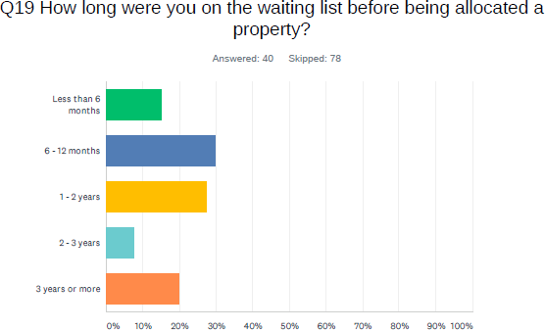

There were big variations in waiting times for OT housing related assessments, usually related to at what stage of the application they were carried out. Monmouthshire in particular reported a quick process of up to a week, of assessing all shortlisted applicants with an accessibility need. In other local authorities this varied.

One local authority reported that OT’s waiting time is usually 8 weeks for a personal assessment at application stage. However, if property needed to be checked pre-allocation to see if it is suitable it would be 7 days and if it was allocated it would be a couple of days.

Another local authority had a target of 4 weeks to do a full assessment – this was at application stage.

Generally, OT assessments at shortlisting stage tend to be quick although in some local authorities many applicants will not be assessed at all and the matching/suitability assessment will be done by the housing officers.

## Assessing and categorising applicant’s accessibility requirements

## Early OT involvement

Section 5 discussed at what stage OT assessments are carried out in different local authorities. In three local authorities, OT’s carry out assessments at application stage. In one of these local authorities, an RSL’s with the majority of stock and a team of OT’s, will carry out assessments for their own tenants who might be transferring whilst a team of social care OT’s will carry out other assessments. In the remaining two local authorities, the assessments are carried out at allocation stage although in one of them the system is more ad-hoc with assessments carried out for some applicants but not others, and at times, not carried out at all or post allocation – especially where further adaptations are needed.

*They come to us at the point of allocation, but rarely do we see them before they move in. We often pick it up when they move in and the property isn’t suitable.*

*OT*

Most staff in both local authorities and RSL’s expressed the need for an OT assessment early on at the registration/application stage. One or two interviewees thought that earlier assessments would be very useful but this carried obvious resource implications.

Some disabled people expressed clear frustration that assessments were carried out at later stages, perhaps without an understanding that this was the policy or sometimes due to ad hoc nature of assessments – with some people being assessed early on, mostly due to having had contact with social services already and others having to wait or having no assessment at all.

*The OT came out to assess my husband only after we had been on the waiting list for 3+ years and only after we had chased up the housing dept a number of times.*

*Disabled applicant*

Many disabled people clearly appreciated the input from OT’s and were complementary of the service, although we also heard of perceived mistakes being made by the OT’s. It was clear that many service users saw an OT report as a document which could help not only to match them to a suitable property but also

increase their priority banding. One social care OT member told us that there is a lack of awareness of how the OT assessment interacts with re-housing:

*When people register for rehousing and it says about having an OT assessment, we do have people asking for an OT assessment as I am applying for rehousing. What people don’t realise when they sign on to the register is that the Terms and Conditions say that if your current property can be adapted then you aren’t applicable for rehousing. So, people may want to be in Band B but with adaptations they should remain in Band D as they are suitably housed with adaptations to their home. But people don’t read the small print.*

*We are trying to tell them when they first contact us that they are entitled to an assessment and we will look at aids and equipment but if we recommend re- housing and you decline you could go down in band – because that is the housing policy. People aren’t being told about the Terms and Conditions*

*Social care OT*

Both housing, social care staff and tenants clearly saw the benefits of early OT involvement. This included RSL’s who work across various local authority areas and staff who oversaw or worker through a change from ad hoc assessments or later assessments to early assessments. The benefits of early OT involvement identified by staff can be summarised as follows:

* OT can raise awareness of housing options. Those that work closely with housing, will have a good understanding of housing options and will be able to advise on e.g. widening search options, how the allocation system works etc. It was highlighted that housing options staff will often have no time for this sort of engagement and housing support staff may not have a good knowledge of how often properties of certain types become available. OT’s can help manage expectations based on the knowledge of accessibility needs and oversight of accessible properties.
* OT’s can help the applicant fully realise what type of property they need which can result in a better match. Although many disabled people are experts in their functional ability and know what they need, we have been told by some applicants that they weren’t fully aware of their conditions, and the limitations they might have in their environment in the nearest future. Staff told us that this was particularly the case for people who have been disabled recently or for people who might have endured extremely difficult living conditions and simply got used to it, particularly where vulnerability was involved.
* OT can recommend adaptations, if these are viable and practical and help people stay in their own homes (it was mentioned that some people are not aware that their house can be adapted, or don’t consider it enough)
* Early OT involvement (accompanied by good property accessibility information) can lead to better matching of people’s needs against available accessible properties as more information is available on people’s accessibility needs. Examples were given of people’s needs being incorrectly categorised as housing options officers have no expertise in assessing the functional ability of applicants. Earlier assessments can reduce the number of refusals where applicants bid or are offered properties without full knowledge of their accessibility needs.
* Early OT involvement can help housing options assign the correct level of priority to applicants with accessibility needs as more is understood on their housing needs – whether they can or cannot manage certain tasks due to the housing situation and to what extent.

*It would have been easier for me if the OT assessment was done on application not allocation*

Disabled Tenant

* OT’s can advise on who is the best match for a particular property from a

shortlist

* Early assessments can reduce time needed to fill in a void (as opposed to assessments carried out at shortlisting stage) which results in loss of rent. Some people indicated that that can be more accurate as there is no rush associated with the allocation stage.

*OTs are involved when the person applies to join the register which is the fundamental change that is being made. Landlords know that this is good for their business. People were previously being assessed when they were being offered a property – and there was a lot of work to be done very quickly.*

Housing options manager

* OT’s can help assess not only current but also future need. Although matching people to properties that take into account future need is not always possible due to shortage of accessible housing, there are instances where nobody bids

or is offered an adapted property as they don’t directly ‘fit’ into the specific

accessibility category.

## Categorisation of applicants’ accessibility requirements

Below is the summary of accessibility categorisation of applicants across Gwent (more details on each category in Section 5).

|  |  |
| --- | --- |
| **Local Authority Area** | **Applicant Access Categorisation** |
| Torfaen | not currently categorised. OT report is attached to the  application. Currently developing categorisation system. |
| Caerphilly | 6 categories directly corresponding to property categories. Additional category U – for those who haven’t yet been assessed and are unclassified. |
| Blaenau Gwent | 6 categories directly corresponding to property categories.  Similar to Caerphilly |
| Monmouthshire | 3 categories directly corresponding to property accessibility level. |
| Newport | 3 categories corresponding to property accessibility level.  Currently expanding into 5 accessible categories |

It is clear from the above table that there are differences between different local authorities with some using just 3 levels whilst others are using 6 and one local authority not using categorisation (but developing a system).

Where 6 categories are being used, or developed, it is difficult to say whether they are exactly the same across different areas. Some local authorities mentioned that they looked into systems used by other local authorities but we could not establish to what extent this comparison was carried out by officers responsible across Gwent.

Those local authorities using 6 categories (or developing this system) explained that a system with more categories allows for better reflection of not only the adaptations installed in the house but also its attributes, e.g.

*The policy has extended those Adapted Level Needs levels to make best use of the properties. We were having instances where we had upper floor flats with wet rooms or houses with wheelchair access internally and wet rooms, but steps to the front. So, they were partly adapted which meant you couldn’t directly match people to properties. The 5 levels try to capture characteristics as well as adaptations, including grab rails, wet rooms, or provision for a wet room.*

*Housing Options Manager*

In the course of the research we also considered with participants, whether there is a need for a regional standard categorisation of accessibility requirements to be adopted by all local authorities. The findings reflect those related to a standard regional approach to property categorisation – see **section 6.4.2.4.**

## Content of applicant accessibility assessments

In general, in the process of our research, it transpired that OT involvement can result in or signify a move away from the more medical model of disability to a social. It seems that, at least some processes have stopped relying solely on medical information to decide what type of house is needed or what house people can bid for. Medical information would involve GP letters, information on medication or specific conditions. There is some recognition that this information is only party useful as two people with similar conditions may have totally different barriers to independent living. Functional assessments and questions are more in line with the social model of disability in which it is not the impairment which disables individuals, it is the environment which creates barriers to functioning and living. Some disabled people will not necessarily see themselves as being ill or having health problems and may not respond to ‘medical’ questions in the same way as others.

In Caerphilly, the Senior Housing OT told us that she had the opportunity to design the ‘medical’ application form to ask specific and detailed questions about functioning in and around the house.

## Assessing properties

## Adapted vs. accessible

Assessment of properties in terms of their accessibility levels was problematic in many ways.

Firstly, many staff members, from all types of organisations, highlighted the differences there are between adapted and accessible properties and how this can lead to issues in the course of application, bidding and allocation and, at times, different outcomes for people.

It was highlighted to us on many occasions that adapted doesn’t necessarily mean accessible.

In some areas properties weren’t categorised by their accessibility level, they were simply classed as adapted or not. There were many instances were a property is classed as adapted and advertised as such but it could be a third floor flat with a walk-in shower – and as such be generally inaccessible.

This wasn’t only the case in systems where accessibility level categorisation wasn’t carried out. In areas where properties were categorised, we were told about several issues connected to the level of detail available on properties.

A house may be accessible for one person in a specific category but not accessible to another. This could be due to e.g. different types of stairlifts and wheelchair sizes. Where there is a housing OT or good links between RSL’s with social care OT’s to access advice or to

visit a property, these issues are easier to deal with to assess what is suitable and what adaptations can be made (especially where OT’s have technical knowledge or quick access to technical officers). This risk can be further alleviated by detailed information on the attributes of the property. This is rarely available to the level of detail needed. Resources can be an issue here, lack of coordination and leadership can also play a role, lack of access to property which hasn’t been pre-categorised couple with quick turnaround times will also play a role.

Another issue at the application stage can be lack of detail and functionality in CBL systems for applicants and support workers to help applicants to bid for the right properties with only limited pictures and a list of basic attributes or adaptations.

There are many factors at play here and some of these are further discussed below

It was recognised however that finding a house that is a perfect match is not that often possible due to the varied needs of people and a huge range of accessibility needs. It is recognised that there will always be a need to adapt to some extent.

## Categorising accessible properties and property information

* + - 1. **Proactive categorisation and register of properties**

Having the correct accessibility information and using this to categorise properties according to accessibility level remains an issue across Gwent (as in the rest of Wales). At times it was difficult to ascertain whether problems were caused by incomplete property information, lack of awareness of applicant’s needs (one RSL staff member told us it is common in their area for applicants not to identify their accessibility needs at application, accept an unsuitable house and ask for adaptations later), shortage of ‘perfect match’ properties or lack of communication. It is likely that various factors are at play, property information and categorisation or matching process being some of them.

We have heard of numerous examples of where this caused problems for applicants, OT’s and RSL’s. Here is one example of applicant talking about their assessment of needs and house information:

*It was generally good, but the house we now live in was deemed unsuitable as there was steps to access the house!? This we knew was wrong as we had looked at the house from the outside, we then disputed this with the RSL, who eventually believed us and we were awarded the house (unnecessary stress and hassle was caused by this.*

*Disabled applicant*

*The RSL won’t adapt a property unless it has been recommended by an OT. So,*

*we get a referral to say I have just moved into a property and it doesn’t meet*

*my needs. I need to be able to bathe for pain or for skin conditions; I need to be able to bathe; or I was told it has a stair lift and the property has never had a stair lift, but when they went for the property they were given a house without a stair lift even though they needed a stair lift. And then we go in and have to make recommendations for adaptations.*

*OT*

*I was offered properties that were not accessible, the stairs was ridiculous, told it could be changed and a stair lift could be fitted. After having to go to a board to get the points I needed to be housed I was told I would only be offered a property that could be adapted as my health get worse. The property I was offered, after we had lived there one year became too difficult to get upstairs so I slept in the living room for over a year while waiting for another property after being told the property could not be adapted. Many silly houses were offered to me before finally an adapted bungalow came up.*

*Disabled applicant*

In those areas and organisations were properties were being categorised proactively according to accessibility level, (before short listing or allocation) staff highlighted benefits of this approach.

*That is very important. That is where the property information comes in – if the person has very selected areas, I can visit to say whether we have got that type of property in the areas they want. And if we haven’t, I can tell them what properties we do have in other areas and encourage them to widen their area or the type of property they are asking for; for example, if they are only asking for a bungalow but I know there are houses that have been adapted we can use our housing stock knowledge to give them the best opportunity to be housed.*

*(...) I would rather be truthful. What is the point of sitting on the register for nothing? This is where my link with Housing Strategy comes in. I can tell Housing Strategy that we can’t house a family from our current stock and we can look at other options.*

*Housing OT*

*Some RSLs do an exit survey and ask the person what is in the property. For transfers they try to go into the property. Melin have very good success rate of doing end of tenancy inspections – others that we work with seem to have an issue of getting access to properties. There is only a few days to get access before the property is advertised. Perhaps allowing access needs to be incentivised in some way.*

*Housing Options Staff member*

*The knowledge I would want would be at the time of advertising the properties. They may not need to do it for all of their properties. We are asking RSLs to sign up to a categorisation of properties (we are asking them to sign up to a principle which could cause delays in advertising and so potential loss of rent) – ideally we would like to know what adaptations are in the home, as there are a lot of mistakes there – sometimes people go to a view a property thinking there is a level access shower in it, but when they view it there is a bath. There are real gaps in the quality of information because landlords advertise their properties so quickly after having notice from the current tenant.*

*Housing Options staff member*

*The central repository (i.e. list) is starting to work well – when someone says what do we need in that area I base it on who is on the register and what current stock we have got. We are building up a repository and the Council and HAs are coding all of their properties. So, I can run a stock profile of what we have got in a particular area but it won’t be correct – it will only give the properties that have been coded. I want a full list – so I can tell Housing Strategy what we have got in an area and what we need.*

*Housing OT*

The above views are just examples of some of the issues and benefits mentioned to us of early assessment and categorisation of properties. Some staff mentioned to us that categorising all of their properties according to accessibility levels would be unmanageable. Especially where an RSL works across 4 or 5 areas with each using different accessibility categories – RSL’s in general were keen on adopting a regional property categorisation standard for that reason. Where there are practical barriers to categorising all properties, it would be advisable to adopt an approach where at least some properties are categorised early and placed on a council register/repository and those that could not be categorised are coded at inspection, housing visits etc. and added to the register, which can be used in the ways outlined below.

The benefits of proactive/early categorisation which were communicated to us are as follows:

* Quicker and more efficient allocations and better suitability outcomes for applicants, therefore more sustainable tenancies (due to avoiding rush at turnaround period)
* Ability to better inform applicants and better manage their expectations – especially where someone has good awareness of accessible stock based on a database/register/repository
* Ability to better feed into housing strategy and housing development as gaps are more easily identified)

Although we did not access any performance measures in terms of quicker allocations, *Costs and effectiveness of accessible housing registers in a choice-based lettings context16,* researcher commissioned by the UK Government, compared two different local authorities – one with a full register of accessible properties and one with a partial register/repository. It concluded:

*In the London borough which operates a full accessible housing register only about 20% of occupational therapists’ time is spent assessing the adaptability or accessibility of properties because of the comprehensive nature of the accessible housing register stock data held. In comparison in the mixed urban authority that applies a partial accessible housing register approach which lacks stock data on adaptations, it is estimated that 96% of occupational therapists’ time is spent on this activity.*

Those organisations having their own OT’s identified the benefits of the roles in terms of

appropriate categorisation of properties, e.g.

*I can tell (the organisation) a lot about their properties because one of our team has probably been in their properties. I was talking to an RSL officer this week who was putting a bungalow into Category F because they thought it had steps to it – I told her that it had steps but also had a ramp and you could use a wheelchair in it, and so it should be in B or C. If it had been put into Category F anyone could have moved into it. It is about educating all the time.*

*Housing OT*

## Methods of property accessibility assessment

We looked at methods used for categorising properties and a mixture of methods was used

* whether this was done early or at voids stage. Below is a list:
  + Categorisation is done by a range of people including housing officers, estate managers, voids inspectors, technical officers, WHQS staff etc (any staff visiting the properties). In some RSL’s this was following training by an OT and using a template form (please see Appendix for a form used in London)
  + Property surveys (we aren’t aware whether this was used in Gwent but came across this method through research above)
  + RSL’s databases – some RSL’s will have databases with property information

outlining e.g. adaptations present in the house and this will be used to access

16 <http://www.housingcare.org/downloads/kbase/3134.pdf>

information quickly. The extent to which this has been done in different RSL’s and

councils varies.

* + Void inspections
  + Tenancy completion surveys (with outgoing tenants)
  + Social Services databases – in some places these are accessed by housing OT’s which may outline the features of properties
  + Lists of newer properties built to DQR standards – DQR uses a Lifetime Home standard therefore some accessible and adaptability features are known through this
  + Cloning of access data for similar properties (e.g. rows of terraced houses)

In Caerphilly – much of this work was done as a condition of joining the Common Housing Register although there are still many councils and RSL properties which are uncategorised or where information is incomplete. The register is however being developed as time progresses, coordinate by the Senior Housing OT. All available properties and their coding are uploaded onto the council database.

Some participants told us that in their organisations, not all officers involved ‘bought into’ the benefits of assessing and categorising properties in advance and that the process requires a certain level of buy-in and leadership. Whilst many staff members told us about the benefits of early categorisation and having a depository of properties, some told us that they came across lack of will from some officers who could help with categorisation when they carry out their visits.

## Embedded allocation versus stand-alone accessible housing registers

In the course of the research, we also looked into the matter of running separate accessible housing registers and allocation systems rather than systems which are embedded into the current allocation structures. Most people we interviewed, including those that previously worked within or with a separate register in other areas, thought that both types of systems can work well – provided they are appropriately resourced and this would be our conclusion. Embedded systems can additionally provide greater flexibility to use properties which might be partly accessible and adapt them on allocation to increase accessible stock. (although, without appropriate systems there is also a greater risk of taking adaptations out of accessible properties to be used for general needs). Separate accessible housing registers also offer this opportunity but individuals may have to register twice – once for general register and once for the accessible one.

Some disabled people expressed the need to know more about where the accessible properties are – to better inform their choices on application. We noted that applicants are mostly informed about this by housing OT’s or OT’s who work very closely with housing, as well as various housing support workers who have a good awareness of how housing works. Some gain a better understanding through closely following properties advertised on CBL. It

would be a useful to consider whether more information could be provided on this matter to applicants through information on website or other means.

## Regional standard categorisation?

As previously mentioned, and as outlined in Section 5 – all local authorities categorise their applicants and properties using different accessibility categories – albeit with some similarities. The categories have been described in Section 5 therefore we will not be repeating the classifications here. We considered with all staff whether a regional common way of categorising properties (and applicants) would be beneficial.

* + - * + RSL’s – vast majority were in favour of a standard or more standardised property accessibility categorisation. Many noted that it would make their work much easier and quicker and would therefore lead to better outcomes for applicants.
        + Health – health professionals saw clear benefits of having a standardised coding system. Some stressed that housing allocation systems and the differences between them are difficult to understand and navigate, if your man role is not housing, therefore increased standardisation would be helpful for health professionals and patients alike
        + Strategy – standardised categorisation would enable more effective regional working and analysis of accessible housing allocation, adaptations and accessible housing needs and gaps. This is particularly pertinent as Welsh Government is currently working towards developing a Strategic Regional Governance Framework on Adaptations with plans to ask housing, health and social care to adopt it in local and/or regional areas. Standardised data would also be more effective in feeding

into Population Needs Assessment’s under Social Services and Well-being (Wales) Act 2014 and health strategies, such as Building a Healthier Gwent17

* + - * + Applicants and tenants – standardised property categorisation across Gwent could lead to joint, Gwent wide work on increasing awareness of accessible housing allocation amongst potential applicants for accessible housing. It could lead to better understanding of how allocation systems work, increased transparency and the ability of applicants to make more informed choices. Some tenants made us aware that it was currently difficult to understand what the categories meant and how they impacted on decisions made, e.g.

*Language used often inaccessible and not user friendly e.g. B12 category etc. –*

*what does it mean??!! Disabled applicant*

17[http://www.wales.nhs.uk/sitesplus/documents/866/Aneurin%20Bevan%20DPH%20Annual%20Report%2020](http://www.wales.nhs.uk/sitesplus/documents/866/Aneurin%20Bevan%20DPH%20Annual%20Report%202019%20English%20%28Final2%29_compressed.pdf)

[19%20English%20%28Final2%29_compressed.pdf](http://www.wales.nhs.uk/sitesplus/documents/866/Aneurin%20Bevan%20DPH%20Annual%20Report%202019%20English%20%28Final2%29_compressed.pdf)

* + - * + Training and Skills –some research participants also suggested that a standardised accessibility categorisation system could also enable pooling of resources for Gwent wide work and training on improving categorisation skills of the varied staff members involved in this process. It is undoubtedly a process which requires a good level of knowledge of accessibility features and how they correspond to the needs of applicants (considering that it seems that in many organisations OT’s are not involved in all accessible housing allocations, especially those at lower level of accessibility). This would improve applicant experience and outcomes. In the course of research, we were given many examples, by housing, health and social care professionals, as well as tenants, of properties being ‘mis-categorised’, which at times resulted in unsuitable allocation. (we talk about skills and organisational confidence later in this report)
        + Practice exchange – some participants identified that common categorisation would enable more effective knowledge and practice exchange between local authority areas.

## Matching and allocation

In this section we consider the implications of approaches to matching and allocation of accessible properties, including flexibility, prioritisation, direct lets, void targets and refusals.

## Matching

There are differences in how different RSL’s and stock holding local authorities allocate their properties. The process clearly requires some expertise in being able to assess the extent to which a property will match person’s accessibility requirements and good communication and partnership working between different housing roles is important. This has been recognised by some RSL’s and LA’s which invested in OT, who are involved not only in the need’s assessment process but also in allocation - during and post-shortlisting.

In some cases, OT’s will be working very closely with allocations teams or are even part of allocation process post-shortlisting, for example taking part in viewings. In other cases, there might be no OT involvement and the process is handled solely by officers responsible for allocation – many participants highlighted that this might lead to unsuitable properties being allocated. Below is an example of how allocations team works with OT’s:

*When I first arrived, the OTs weren’t based in housing and I couldn’t get a grip on how the allocations worked. I was getting 100s of emails every day from the allocations team. I realised I needed to be immersed in the allocations team for 3 days a week. I became part of the team, understood the processes, how they worked. We were more on top of things – if people were unhappy with something they could easily link in with me or they could refer directly to me. So, we are based in allocations a few days per week. The Homelessness Team are there as well, and so they can also come direct to us if someone has medical needs.*

*The plan is that there will be OTs based in allocations on every day of the week The Area Housing Officer is also there which helps us to make links with other staff (e.g. estate managers, housing inspectors). So, we know straightaway when voids happen – and we can view them straightaway. The Housing Inspectors will ask us directly whether a stair lift or other equipment needs to be taken out. We build up great communication and links by being based with the allocations team.*

The example above shows clear benefits of having OT involvement at allocation stage to advise and assist with a number of issues, including further assessing the suitability of the property. This will of course be a smoother process if the needs of the applicant have been thoroughly assessed, categorised and where property information is available beforehand (and the London cost benefit assessment proved that it saves costs long term). Many organisations however acknowledged that assessment of accessibility needs and property information, whilst facilitating a smoother and quicker process, are only one element of effective accessible housing allocation and OT involvement is still needed albeit not to the same extent.

In some housing provider’s cases, housing or social services OT’s will always be involved in viewings – especially where the property is in the highest accessibility category, whilst in others this will be dependent on whether an applicant already had contact with OT team. In some areas OT’s will be contacted for advice (if they have already carried out assessment of accessibility needs) in relation to specific properties, in other cases still they might access property databases (especially if needs are not deemed as complex of properties are at lower accessibility levels), in some local authority areas/RSL’s there is no involvement of OT’s beyond assessment of needs or if an adaptation needs to be made. Housing

professionals highlighted that social care OT’s have little capacity to be involved in allocation post-shortlisting stage (e.g. to match or to carry out joint viewings) although it did happen on an ad hoc basis in some areas – usually when there were complex needs involved or an applicant was already on an OT ‘caseload’.

Some RSL’s will also have their own OT’s whilst others will contract them in when needed or use housing OT’s funded through common housing register. Quotes below illustrate some of the benefits of partnership work/resource pooling when it comes to allocating and matching homes to accessibility needs.

*We would do joint visits of all of our Category A people as I wouldn’t want anyone to turn down an accessible property if one door isn’t wide enough or there is a bath not a shower. So, we are involved in viewings of these to ensure that if I can make it suitable I will*

Housing OT

*Once they go through the shortlist, we will send the shortlist to the lettings*

*team and say that this property is suitable for this person (or isn’t for that*

*person) and the lettings team contact them. We then go to the viewings with them to make sure the property is suitable.*

### *Researcher: Do you do a second OT assessment at the viewing stage (as you* did one at the application stage)?

*Housing OT: Yes. We take the first assessment with us to the viewing and we review it to see if anything has changed - we don’t do a whole new assessment. But the person is in the actual property to see what they are able to do. We used to find that shortlisting was very very difficult when there was a lack of evidence. You are relying on people to put the information in their applications and relying on it to be the truth.*

*We were going out to viewings and we weren’t needed, or we were wondering where have you been/why haven’t we seen you before (because the person has significant mobility issues). It just didn’t work at all.*

Housing OT

*According to adverts they have never had a wheelchair accessible property, but as OTs we know that most properties were not ‘building registered’ as wheelchair accessible because the doors are narrower than a wheelchair accessible house would be. However, a very slight person in a wheelchair would probably manage in that property, but they wouldn’t list that as wheelchair accessible because it is specific to an individual to move into that property*

*Social Care OT*

*In some LAs the Home Option staff are trusted assessors so they are able to assess for minor rails and have that basic level of understanding of how arthritis may impact on a person’s day to day functioning ability, but when it becomes slightly more complex than that with 2 or 3 medical conditions it is being able to understand how they interact with each other and impact on the person. On paper they are administrative staff, not clinical staff. It is a completely different role – to ask them to match properties to the person’s functional ability they would have had to have seen that person, or read a report to know it. I think that is exactly what they need – for someone to sit with them and say that with minor adaptations that property would be suitable. We are recycling old houses which aren’t built for purpose and so we have to think slightly outside of the box*

*Would we love everyone to have a full turning circle in every house – yes. But if I need a wheelchair in my house when it isn’t wheelchair accessible - that is where the discrepancies between home options come in. They don’t have those skills. It is perfectly reasonable as they are not employed to do that job.*

Social Care OT

## Finding the best match

It was clear that it was often difficult to match people to a ‘perfect match’ which met all their accessibility needs. Small to medium adaptations would sometimes have to be made to ensure suitability of the new home. This was more often the case where housing stock was predominantly older (newer, DQR compliant stock is not only more accessible but also easier to adapt).

Particular issues were identified with properties which have been adapted or highly adapted but have other features which make them inaccessible to most people with accessibility requirements (e.g. located on a hill with no transport links). In some cases, such stock would not be re-let as accessible or highly accessible and the accessibility category would be downgraded. (We talk further about the interaction between allocation policies and adaptations in forthcoming sections)

Knowledge of the exact needs of the applicant and a detailed knowledge of property features was particularly valued and the organisations which carried out early applicant and property assessments (pre-void) highlighted that this facilitated a more effective matching process.

*Some properties are small terraced houses in steep streets, and there may be a stair lift in the property because the tenant didn’t go out that much or needs to go upstairs to the bathroom. But if we re-let it, we wouldn’t say it is suitable for someone with severe mobility issues because of the layout of the property. We think about the property and who is going to be matched to it to give people the best chance of moving in and succeeding*

It was clear that housing staff, OTs and applicants often have to make a difficult choices between waiting longer for a property which could be near perfect or being housed/choosing a property which might not match all the needs of the applicant. It was also evident that this choice should be informed by a good knowledge of properties available and how often they ‘come up’ – housing options staff in some cases had a good knowledge of accessible stock and its availability (based on frequency of advertising) but it

was evidence that, due to capacity, many struggled to communicate this to tenants. Housing OT’s or social care OT’s working closely with housing in some places had that knowledge and often passed it on to tenants, this was seen as valuable in informing choices and matching decisions.

*I assessed someone a couple of weeks ago. She was in a 2-storey property. The front wasn’t accessible. There was a stair lift but she had lost her mobility. She was transferring from bed to commode to bed for months. She had become depressed, her relationship was breaking down, her family didn’t know what to do best. I knew of a property that had come in that had been ramped to the*

*front, in her area – but the back wasn’t ramped. The ramp didn’t fall into the 1 in 12 gradient – it was quite steep. The property wasn’t the best match but it would make a huge difference to this lady. Her husband could manage pushing the wheelchair up the ramp. It had everything on one floor – bedroom, wet room. She could get into the kitchen and living room and be involved in every day family things. I linked with the Community OT and we visited together and agreed the impact would be very significant. It wasn’t an ideal property but they have moved in. They are absolutely over the moon. They don’t mind about not being able to help her into the back garden. They can get her out of the front of the property, into the car. She is showering, having physio. She is feeling much better mentally.*

Thus, flexibility in the matching process and communication between allocations officers, OT’s and the tenant were seen as important. In the course of the research we found that this flexibility was difficult to achieve and there were different levels of ‘flexibility’ in terms of tenants with higher accessibility needs bidding or being allocated to a property with lower level of accessibility. It would often be a balancing act between the availability of adaptation budget and the assessment of the extent to which an applicant was deemed to be able to ‘manage’ within their current environment. These were often very difficult choices and would lead to some frustration amongst both applicants, tenants and OT’s in both: cases where tenants were happy to accept lower access categories but were refused and in cases where such an allocation was made, but the tenant found it hard to function. Some tenants felt that their other needs, e.g. mental health, safety, access to transport etc were not considered equally with their physical needs. Many OT’s stressed that environmental factors would always be considered but that, at times, it was difficult to find a property that matched all of those needs.

*It is flexible based on people’s needs and property levels; e.g. if the RSLs shortlist on an adapted level 2 property and there is nobody with a level 2 need they will look at adapted level 3. And vice versa – if the property is borderline between level 1 and 2 the RSL will look at level 1 people knowing that the property could be adapted in future.*

*Housing Options Manager*

*I have been turned down by otherwise suitable ground floor properties because they don’t have walk in showers, yet I am expected to carry on living in an upstairs flat and climb into a bath to take a shower.*

Disabled Applicant

*Accessibility requirements were assessed but not met when awarded a property, my partner is unable to use her wheelchair inside because doorways are too narrow*

Family member of disabled tenant

*It would have needed a ramp to be installed and there was no available budget to do this.*

Disabled tenant about a property they bid for

*It wasn't suitable based on my son's needs & it being located on a busy & potentially dangerous road which would cause a safety issue if he was to run out of the property as he has ASD*

Parent of a disabled child

Balancing of current and future needs was also a complex area. Where people had known deteriorating conditions, OT’s told us that they would try to match to future need (and appropriate banding would be assigned). But this was not always possible, especially where stock was scarce. We were given a few examples of cases where a person thought they could manage in lower category property but they faced difficulties within a few years and had to move. This can be clearly a difficult decision where a person is in high need of re- housing now.

*Sometimes landlords want to take the decision away from the person. A person may be able to manage in a property now, but may not be able to in the near future. But the person feels they can manage, but the OT and landlord feel different – we have to balance the person’s view, OT’s and landlord’s view.*

*Housing Options Manager*

*I worried that some people might be missed if we just put them in one category. So, some people can be in Category C with the medical condition they have, but they have the potential to end up using a wheelchair and so you put them in Categories A and B. But at the moment they only need a Category C.*

Housing OT

*I just did a house allocation. Even though it has steps to the front access I asked a colleague if it could be ramped in the future, in case the person needed to use a wheelchair in the future – it has a toilet downstairs and upstairs. I said we could move a gate and get a straighter run in for a ramp if we needed a ramp. I knew a ramp could be put in – it isn’t needed at the moment but it could be done if it was needed in the future.*

*Housing OT*

Two local authorities also told us that flexibility in categorising properties was also important as opportunities to meet needs and make the best use of stock could be missed, e.g.

*We found that when we started on accessible properties, we were quite rigid in our approach in categorising them to one alphabetical letter, but we found that some properties can be adapted or may fall into other categories. So, we can say what the property is now and what we could do in the future.*

*Housing Options Officer*

In some areas we were told of difficulties in managing and meeting the needs and expectations of applicants who were assessed by OT’s without close links to housing. Some OT’s stressed that the Social Services and Well-Being (Wales) Act 2014 required them to work to the expectations of tenants and what mattered to them – which is a very person-centred way of working. Some housing staff told us that at times OT assessments, in their view, did not reflect the reality of accessible stock available – therefore it was felt that there is sometimes a mismatch between two different ways of working.

## Prioritisation

In all areas both, local authorities and housing associations told us that people with accessibility needs would always be prioritised for accessible properties. This wasn’t always the case however, especially in for applicants from the lower access need categories and in many places the banding of general needs applicant would take precedent over the accessibility needs of applicant in one of the lower access categories. In some areas, the managers were clear that at the shortlisting stage, the allocation officer will be flexible and might go up or down the accessibility level to allocate the property – as long as the property is matched to a person with accessibility needs.

In Caerphilly, the shortlisting/accessibility prioritisation criteria are clearly described in the policy (see Appendix 1c.) and it is clear that applicants with a higher level of accessibility needs with always be shortlisted first for higher accessibility homes (even if lower banding than general needs applicants) however, this changes once the shortlist reaches applicants at lower levels of accessibility and with lower bandings. At certain threshold, the applicants from general needs list could be allocated an accessible property.

There are clear benefits of giving preference to applicants with accessibility requirements where accessible properties are available – staff were clear that there is a shortage of accessible properties and the preference system ensures equal outcomes for disabled or older people. It also allows for a better use of accessible stock by preventing the removal of costly adaptations.

*It makes best use of properties that have certain characteristics or adaptations in situ already. So, preference is given to applicants who need the adaptations already – e.g. a single person with moderate level of mobility issues would wait years for a general allocation; if they need ground floor housing or adaptations by giving them preference for any such properties, they wait much less time*

*Housing Options Manager*

*We will advertise the property, run a shortlist of applicants. If we have 200 bids when the bidding closes, they will be based in order of priority. We can apply a filter which will only show people who need an adapted property type – it doesn’t stop people bidding for it. But we say in the advert that the property is likely to go to someone who requires a wet room, or stair lift etc. We apply the filter which knocks out anyone who doesn’t have an adapted requirement. So, people with adapted requirements will be top of that list regardless of their banding. They don’t have to wait as long for properties, because adapted properties aren’t as common as non-adapted properties. So, there is an enhancement there to make sure that properties that are suitable for people with mobility problems are matched to people.*

*Housing Manager*

Some officers highlighted specific examples where the preference system, in their view, did not work ideally, e.g.

*Manager: We had a tenant who lived in a bungalow in that area that was adapted specifically for him. It had hoists, a level access shower, was in the area he wanted - but because he registered to move, he received a low banding because his needs were adequately met. He wanted to move rather than needed to move. Because of his medical needs he was straight away categorised as Category 1. So, if we had a bungalow at Adapted Level 1, he would be allocated it – despite that his needs were already met. So, it is difficult to work through that*

### *Researcher: Is there flexibility?*

*Manager: Yes – in that example, we may look at Category Level 1 (although we have very few) and the LA would probably support us in looking at people in Category Level 2 to see if anyone needs the property. So, if there is a person who needs it and is homeless for example, the LA would probably support us in offering it to the person in Level 2 who is in greater housing need. There is a flexible approach. If you are strict with the policy, we may not make best use of stock and not to best for applicants in more difficult circumstances. We don’t readily come against this problem.*

*RSL Housing Manager*

As previously mentioned, despite preference in shortlisting for accessible properties being given to applicants with accessibility requirements, the quota systems used by some local authorities were seen by some as preventing people with accessibility needs in even slightly lower or higher banding from bidding for accessible properties which might match their accessibility needs. We also had several comments from applicants who said they were only ‘allowed’ to bid on certain properties, despite all CBL systems highlighting that anyone can bid on any properties (but of course applicants would be filtered by accessibility need). This could be based on advice from OT, housing options or other information they received, rather than the IT system itself. This was seen as problematic by some applicants, especially in cases where they thought their choices were being narrowed e.g.

*I need to keep using stairs as long as possible and I'm not being allowed to bid on anything but ground floor one bed properties*

We were given an example of a tenant of a housing association who was in second band but had high accessibility category. He could not bid for bungalows which he said were perfect for him, because his band was not the band that the property was advertised for.

Professionals told us that people with accessibility needs tend to be in higher banding therefore accessible properties tend to be advertised for higher bands, however several tenants and housing associations told us that this is not always the case.

This is an issue worth some consideration as not only are the applicants’ needs not met, but the local authorities might not be making the best use of accessible and adapted stock, especially if there are no applicants with accessibility needs in the specific band and accessible properties end up allocated to people with no accessibility needs.

## Direct lets

In many organisations there are positive partnerships which separately consider people with need for accessible housing in special circumstances. It is our understanding that in some areas this will be done solely for Delayed Discharge of Care whilst in others the process will include people in ‘extreme accessible housing need’.

Most local authorities and RSL’s will carry out so called direct lets or emergency lets for

those people with urgent and high or complex accessibility needs.

Some local authorities and housing associations will work proactively with health and social care to search for potential applicants when there is no one on their list or no one bidding for highly adapted properties, e.g.

*We will usually let OTs and social services know we have the property and see if they have anybody who may need it, even if they haven’t registered. We don’t want to miss anyone – we don’t want to give a property to someone who doesn’t need all the adaptations, when there may be someone who does.*

### *Researcher: So, you proactively search for people?*

*HA Head of housing: Yes, when we have properties like that. We have about 10- 20 of those properties. They are all occupied*

*HA Head of Housing*

Some local authorities will also work with health, social care and housing associations on Delayed Discharge of Care (DTOC) cases where individuals are unable to leave hospital due to unsuitable housing which cannot be adapted. In some areas this will be dealt with via emergency banding and in others, individuals will be held on a common list (or cases will be considered as they come in) which are considered proactively by a cross sector/department panel.

*There are exceptional cases in the policy. So, for Delayed Transfer of Care we would potentially work outside of the normal process. That has been agreed by the partnership, and so a panel of representatives would look at exceptional cases and determine if the person’s needs outweigh other people’s needs who would be applying. This would be a ‘direct match’.*

Housing Options Manager

*If we had a bungalow in ... (local authority area mentioned here), we would ask the council if they have anyone who requires it. So, we wouldn’t use the list. We are part of the partnership group which discusses direct lets and so we would go straight to that group – it would be that Mr X is a wheelchair user and needs a 2-bedroom ground floor flat in this and this area. They would provide evidence why he needs it and the panel would agree that the next 2 bed ground floor flat in that area will be matched to that applicant. There is a direct matching system so that those in highest need are not going to miss out.*

*At any one time there are probably between 5 and 15 people on the ‘direct list’ who need specific property types – so if the property comes up one of those people is the most in need of it. Those in the highest need will get the property that best matches their need. One RSL have their own OT who brings applications to the panel – I think that is excellent.*

HA Housing Manager

Our understanding is that within some of the practices above account is taken of people who are already on the waiting list/housing register but this is compared against people who might be in much higher or urgent need who may be not registered. However, in some areas, the process will be carried out before a property is actually shortlisted. The manager above also clearly recognised the value of a housing OT employed specifically by a housing association in bringing cases forward.

*If at any time there is anything exceptional to the rules it has to be agreed by all partners. We have an Assessment Panel if it is exceptional – this is for people in*

*extreme difficulties. All partners are at the panel and we can agree or disagree. We can agree a direct let – the council has a list of people who may need to be prioritised, so before a property is short listed, we will see if anyone has extreme circumstances and needs to be housed. But that must be agreed by all partners.*

*HA Lettings Manager*

*A register of all accessible properties in our local authority area would be useful for the properties which have more extensive adaptations – e.g. family houses with through lifts, low level units, because those are the ones we have most difficulty finding for families. When we have families needing that sort of housing, we have a provision in our policy to make a direct let rather than the bidding process. That is because the properties are so rare – we would match the person to the property.*

Housing Options Manager

The above examples demonstrate that despite there being no separate accessible housing register as such in any of the areas, there are some separate practices, which take account of the people with highest needs. Such processes might also take away the stress and complexity of bidding for housing when an applicant might be in a very difficult life situation.

## Impact of void targets

All housing associations we spoke to had some form of target timescales in which an allocation had to be made. In some organisations it was clear that there is a lot of flexibility in relation to the voids targets, with lettings officers obviously being aware of them but expressing that they focused more on suitable and sustainable allocation. In other organisations it seemed that voids targets were more stringent than in others. This is to be expected with different organisations and different areas experiencing very different housing pressures, with business model often reflecting that, e.g.

*Not targets – our mantra is the right person for the right home. The pressure on the team is to make sustainable lettings. The target is to have properties offered or allocated to people during the 28-day notice that current tenants give. Then the new person moves in when the property is ready. We make sure any repair work is done as quickly as possible. We can prioritise repair work in certain properties (e.g. for households who would become homeless). We are willing to let things slide to meet people’s needs. But generally, I like homes to be let within two weeks of a person moving out. The team don’t make a decision on the speed of allocations, rather than appropriateness. The problem with targets is that people work to that at the expense of sustainability.*

*HA Housing Manager*

*We aim to offer the property on the notice stage, so we have a definite 4 weeks to play with. When the keys come in (i.e. the tenancy has ended) we are in the void period. We need to know by that stage that we have someone ready to move in. So, if we let everyone view as many properties as they wanted it is unrealistic. Two years ago, we had at least 280 voids out of 5,500 properties. Our target this year is 40 voids by the end of March 2020. Since the summer we have had a lot of voids for some reason. It is currently 77 voids. From the lettings stage I have 11 actual days (not working days) for someone to move in.*

*HA Lettings manager talking about link between refusal policy and voids*

Whilst many professionals highlighted that they would allow more time for an accessible housing allocation, e.g. to liaise with OT’s, carry out assessments, adaptations etc. we did find that voids targets did have some impact on effective accessible housing allocation. We found that several factors facilitated a smoother, swifter and effective allocation despite often quick turnaround times.

In general, many professionals told us that the more work was done at application and pre- shortlisting stage, the quicker and more effective the process of allocation was. It needs to be acknowledged however, that for some people with accessibility needs, the process might take more time due to a number of factors: the need to adapt the property pre-moving date if the match is not an ‘ideal case’ scenario and it would be unsafe or inappropriate for the tenant to move in, the need to involve OT’s, health and social care at various stages, the

need to liaise with both children’s and social care OT’s where families are involved and multiple other factors.

Whilst it is understood that there need to be timescales due to overall business needs, it is not always possible to meet these timescales and it is worth considering whether void turnaround targets should be longer for certain categories of clients and accessible properties. A good monitoring information specifically on void times for accessible housing (or certain categories within that) would aid that process. Some staff described the longer turnaround times for accessible properties as ‘acceptable fails’ – which is probably the language used for monitoring the targets (similar to WHQS terms). Describing what is often a successful allocation in terms of outcomes for the applicant as ‘acceptable fail’ may be counterproductive in how it influences the perception amongst letting officers of what is a ‘job well done’ and what isn’t. None of the organisations we surveyed and spoken to had different void turnaround times for accessible housing, although, as mentioned, some seemed more flexible than others.

In general, proactive OT assessments at application stage generally meant that there was more comprehensive information available for allocation teams without OT’s or that OT’s were doing ‘quicker’ or ‘less in-depth’ assessments at allocation stage. The same is true of

having a comprehensive property information pre-shortlisting – this helps to avoid the rush of having to assess the property when the previous tenant gives notice, e.g.

*Some RSLs do an exit survey and ask the person what is in the property. For transfers they try to go into the property (specific RSL mentioned) have very*

*good success rate of doing end of tenancy inspections – others (e.g another*

*RSL mentioned) seem to have an issue of getting access to properties. There are only a few days to get access before the property is advertised. Perhaps allowing access needs to be incentivised in some way.*

*Housing Options Manager*

*We have good links with our lettings team. If we have a property becoming available that we know has adaptations we will visit it – to see what adaptations it has and what potential it has (for adaptations) and we advertise it accordingly if it is going onto the register. We put all the features that it has on the website.*

*Housing OT*

As previously mentioned, Costs and effectiveness of accessible housing registers in a choice based lettings context18 study, showed that where a local authority had full information on the accessibility of properties, the housing OT working for the local authority spent only 20% of their time assessing the accessibility or adaptability of the property, whilst when this information was only partially available, it took 96% of the housing OT time. In one of our surveys, an RSL housing manager commented that they noticed that a good accessible allocation system helped them reduce voids in general. Good information on accessible properties, although highlighted as entailing a substantial amount of work, was seen by many as a good investment, e.g.

*Researcher: What agreements are in place in relation to timescales from notification of a void property to supplying a match?*

*Housing Options Manager: I don’t know – but it comes down to properly understanding the property characteristics before advertising it. When we will start asking landlords to categorise their properties this should help.*

*Housing Options Manager*

Some staff highlighted that short void turnaround times sometimes mean that an accessible property is allocated to a person without an accessible need, e.g.

*If somebody bids on a property which has a level access shower, but nobody who needs it bids for it – it may go to a person on the register who doesn’t need*

18 <http://www.housingcare.org/downloads/kbase/3134.pdf>

*it, and they ask for a bath to be put in. That is a waste of the shower and the*

*£3,500 - £5,000 it cost to put in. And it may be taken out for a bath to be put in.*

*And the HAs tend not to re-advertise properties if no-one suitable bids initially – as it sits void and they are losing money because rent isn’t coming in. But if they kept the bidding open for another 2-3 weeks, they could get someone who needs the adaptations and save £3,500-£5,000 on adaptations.*

*I guarantee that there will be someone who needs it. People forget to bid or aren’t well or have busy lives. If people were phoned, we could find someone I’m sure.*

*Social care OT*

Good partnership working with social care OT’s can also facilitate a better outcome in terms of void targets, e.g.

*Researcher: Does the process work well with OTs – is there room for improvement?*

*Housing Manager: We have been looking at this. Our housing options manager has been to an OT meeting to explain what we do and our time pressures on voids. We are trying to build on our relationships with OTs as we need to work together. They are really good. We don’t need to buy private OT visits (approx.*

*£300 per visit) as we aren’t losing that much on voids. HA Housing Manager*

Some tenants and support workers who responded to our surveys highlighted that support with moving was important especially due to the quick turnaround times. For some disabled people the physical, administrative, financial and emotional effort associated with moving home proved very difficult, e.g.

*No offer of support was made, had to move within a week or at risk of paying rent for both properties, had to wait 6 weeks after moved in for adaptations to be finished or risk waiting a further 6 weeks if we didn’t accept that before moving into the property.*

*Disabled tenant*

*Support wasn’t needed, but when I emailed the OT they always responded.*

Disabled tenant

*Would have been useful to have been offered assistance with moving processes,*

*it’s very scary as a vulnerable person*

Disabled Tenant

We talk further about support needs in the section on working with applicants.

## Offers and refusals

In the course of the research we considered how offers and refusal policies and practice interact with accessible housing allocation. Both disabled participants and practitioners often highlighted that the perception of what is and isn’t a suitable can differ widely between staff and applicants.

It was evident that staff are not only driven by the requirements of the applicant but also balancing this against the needs of the wider service and other applicants. Staff had a more comprehensive knowledge of availability of properties and often had to work to very short timescales (as highlighted in section above).

Disabled participants on the other hand, were driven by their own requirements and the requirements of the entire household (which was considered to varying degrees in the examples we were given), including accessibility of the home, the garden, external environment, access to their support networks, access to schools and others. Evidence from disabled people and practitioners showed that both internal and external requirements were taken into account with varying success. Many disabled applicants showed understanding of the scarcity of accessible housing and despite not finding or being allocated an ‘ideal home’ they were accepting of the constraints within which allocations were made.

*I was assessed by an Occupational Therapist but had to wait approx. 3 months for assessment. I felt this was too long & I continued to struggle living in my old home while waiting for this assessment. Once assessed the OT supported my application & my rating improved so housing was offered sooner. I am young with a young family & needed a level access property close to family & the children's schools in the West of ...(area). Despite there being lots of new*

*housing building built, there doesn't seem to be any social housing in the new developments that met my needs. I have therefore had to move to an area that isn't exactly where I would like to be, meaning my family aren't as close & it is more difficult to get the children to school & adds effort & time to our morning routine which is difficult with my disability. My property is much better than the old one & I am able to manage tasks in my home much more easily than in the old one. But I just wish my social needs could have been met in a better way.*

Disabled applicant

Overall, out of the applicants who were allocated a home, 50% stated that their home meets all of the access requirements, 32.5% stated they were partly met, with 17.5% stating that their needs were not met.

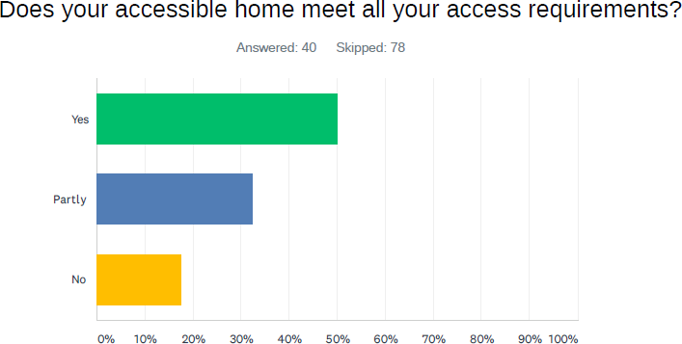

Whilst the numbers of people who answered this question was small, it was notable that none of the tenants in Caerphilly area, which seems to have the most comprehensive system and a

team of housing OT’s answered that their needs weren’t met, whilst in other places the figures were between 17% and 33%. Figures tended to be higher were OT assessments were carried out at later stages and/or where there was less of a proactive system for recording property information.

For those who said their needs were partly met, the main reason was the need for further adaptations, other reasons mentioned accessibility of the environment, access to family networks, doctors, accessible parking and size of the property.

*Still find it very difficult to access the rear of the property e.g. back garden as for wheelchair user there is a step and the back garden is on the side of the property so have to go out the back/side door down the alley trough another gate to get into the garden and which being In a wheelchair accessibility is very difficult we’re as the front door we have access via a ramp*

*I would like to get up to my grass area but I would need a ramp that the council won’t do. I also had to pay again for the new drop curb for my wheelchair, we had already had a driveway put into the property they gave us by mistake costing us thousands of pounds*

*Still awaiting the OT assessment for additional grab rails out the front and an intercom system as I struggle to get to the door*

*There are wooden strips between the doorways which are trip hazards as I use a walker or stick around the house.*

*I have to put ramps down to get my wheelchair in.*

## Disabled tenants

Our survey of tenants asked whether they were offered any unsuitable properties whilst on the waiting list. The patterns here were different than in the above question and differences between local authority areas were quite big (from ca 20% in Monmouthshire, which was the lowest percentage of unsuitable offers to nearly 80% in other areas). Interestingly, there was also no clear difference between choice-based systems and needs based systems with main reasons being stairs and inaccessible bathrooms.

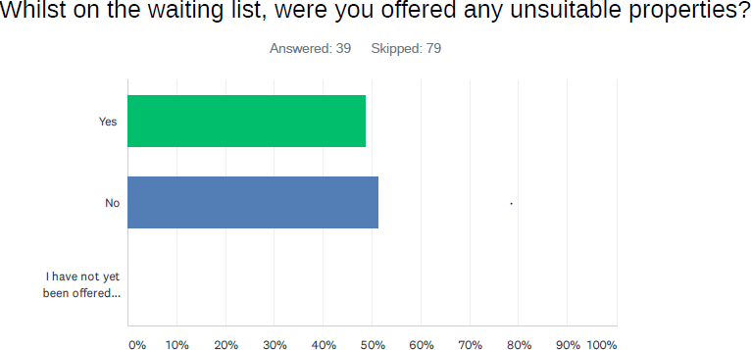

helped to minimize the number of unsuitable offers of adapted/accessible social housing. This not only saved scarce resources for housing providers, but prevented causing unnecessary frustration for disabled housing applicants.

We also asked those who are still on the waiting list, whether they were offered any homes which did not meet their access requirements. Here there were much fewer people who had been offered unsuitable properties (under 30%), this might be due to the fact that some were simply not offered any yet.

*Location of the property, or being a First, Second or Twelve floor property, but I have put forward many times that this type of property is not suitable*

*Disabled applicant*

*It would have needed a ramp to be installed and there was no available budget to do this.*

*Disabled applicant*

Interestingly, the first example above is from a choice-based lettings area. Similarly, to the above question, those who thought they were offered unsuitable properties, mainly referred to physical accessibility features like stairs (although one or two referred to location, pet bans)). Once again, there were no real differences between choice and needs based systems.

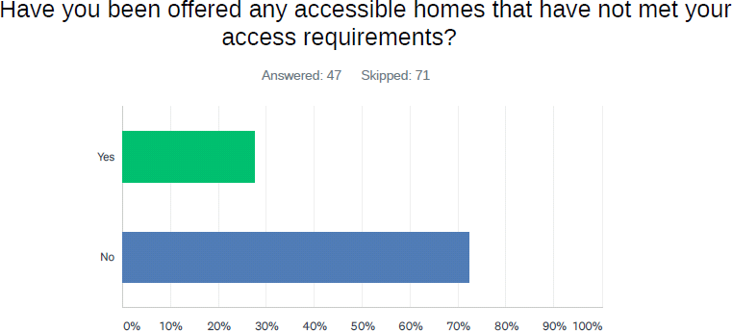

Some of the comments from participants on the above two questions provide an interesting insight into choice-based lettings systems. Stairs and inaccessible bathrooms were quite often mentioned as features not expected by the applicants who bid for properties which highlights the need for a more comprehensive property information (including photos).

Staff told us that in such cases, rejecting an offer would not be counted as refusal. In some cases, staff told us that applicants with accessible housing needs would bid on unsuitable properties, as they were encouraged to be actively bidding so as not to lose their ‘welfare points’. This was clearly frustrating for both staff having to deal with bids and applicants, some of whom mentioned that they could not bid if there was nothing matching their access needs.

*We were gold band dropped down to silver now bronze as above unsuitable accommodation we were not applying for.*

Other examples of ‘unsuitability’ reasons provided by applicants from choice-based lettings systems were location, safety of the area, access to transport/parking and size.

It was difficult to ascertain to what extent a refusal due to the latter aspects would be classed as reasonable although many practitioners highlighted that rejecting an offer just because someone did not like the property, even if it was deemed suitable by the housing

provider, would count as refusal. Some staff working through a CBL system highlighted that applicants bidding for properties ‘know what they are bidding for’, however some of the

examples provided above show that the ‘choice’ is not often as straightforward as it seems: information might be missing on the advert, tenants feel compelled to bid for properties they see as unsuitable so as not to lose their points or they simply struggle to use the system (although equally as many found it easy).

Some OT’s referred to the accessibility of the environment, access to transport, local amenities and support networks as being part of their assessments of suitability of new properties but this varied across the board. It is important to what extent these factors are considered when dealing with a refusal from a disabled person – as factors which may seem unreasonable for a non-disabled person might have a big impact on the health, wellbeing, quality of life and functioning of disabled people, despite being ‘non-medical’ – this is what disabled people told us at focus groups. These decisions are often difficult to make for practitioners.

Policies on the number of refusals allowed also differed between areas. Some were harsher than others although it was difficult to establish the reasons for this. Many staff highlighted business needs and lack of capacity to deal with too many refusals with high volume of applications and quick turnaround times. In some areas 2 or 3 refusals were allowed after which the person would ‘go down’ in band, in other areas, applicants would go down to the bottom band, in others still, they would initially go down in band and, after second refusal, they would be taken off the register and would need to re-register again (in which case they would also lose time points).

In general, many providers told us that their aim is to allocate a suitable property so that the tenant is happy and it results in sustained tenancy. However, several housing, social care and health professionals acknowledged that in their areas there may be more refusals than they would like. This was mainly due to the need for additional OT resource (housing options and lettings staff are not experts in accessibility and there is a need for additional OT resource and better partnership working). One health practitioner working in patient flow also highlighted that they regularly come across discharge patients who refuse accommodation but are not aware of the consequences, which highlights the need for better information and support for patients who are in need of accessible housing.

Whilst it was clear that the experience and perceptions of many of the participants in the research weren’t as positive, there were also others, who appreciated the service and housing that they were provided with:

*I bid for a bungalow, was assessed then offered the property which I viewed & accepted. I consider myself very lucky.*

*Disabled Tenant*

Some practitioners told us that refusals from disabled people are rare – they attributed this to the shortage of accessible properties. Ultimately this is the underlying factor which has a great impact on disabled people’s lives.

## Who is involved in accessible housing allocation system?

Naturally, in each organisation and local authority there would be different structures, teams and roles involved in the allocation of accessible housing, or more broadly, roles contributing to successful outcomes for disabled applicants and tenants. Multiple roles were mentioned during our research, with each of them having some impact on the applicant journey and/or outcome:

* Housing Options Officers
* Housing OT’s (based in Local Authorities or in RSL’s)
* Lettings officers
* Housing Officers
* Voids Inspectors
* Technical Officers
* Housing support staff
* Adaptations officers (grants and technical)
* Social care OT’s
* Health staff including OT’s, Patient Flow Coordinators, Rehabilitation Teams etc.
* Third sector organisations offering support and advocacy (e.g. Disability Advice Project)
* Care and Repair Agencies and Hospital to a Healthier Home Team
* Lighthouse Project
* Applicants and tenants in need of accessible housing

Each role required some level of understanding of disability, accessibility and health issues impacting on applicants or tenants. Below is only some of the knowledge and skills required as gleaned from our conversations with participants:

* Medical knowledge and/or understanding of functional ability of applicants and the impact of housing barriers and enablers
* Technical knowledge of accessible housing design, construction, aids and adaptations
* Knowledge and overview of accessible housing stock available or being built
* Knowledge of adaptation systems and grants
* Knowledge of allocation systems and how they interplay with accessible housing allocation
* Knowledge of planning systems
* Knowledge of wider housing, health and social care strategies
* Ability to analyse complex performance, monitoring and outcome data
* Knowledge of social model of disability and the barriers that disabled people are facing
* Knowledge of welfare and financial systems linked to housing
* Accessible communication skills and engagement with disabled people
* Knowledge and awareness of housing support and wider third sector support organisations assisting disabled people from various groups
* Knowledge of health and social care systems governing treatment, discharge and care of disabled people
* Skills in relationship building, communication and negotiation across multiple departments, priorities, policies and processes
* Strategic skills in building alliances, partnership working and strategic partnerships aimed at improving health and wellbeing outcomes for communities

Amongst RSL’s, the level of confidence in some of the skills and knowledge mentioned

above was quite high, as demonstrated in the survey answers below:

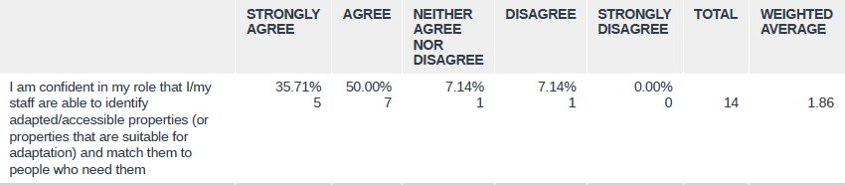

Our survey of housing practitioners also asked participants to rate the level at which they thought they had specialist or trained staff with a level of expertise in access requirements of disabled people, in particular: disability equality training and inclusive design. Local authorities gave their systems higher ratings that RSL’s in this case, with a weighted average of 4.22 for the former and 3.43 for the latter (the caveat being that only 2 local authorities answered the survey (albeit multiple staff members).

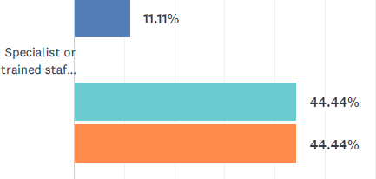

LA’s – specialist/trained staff & expertise

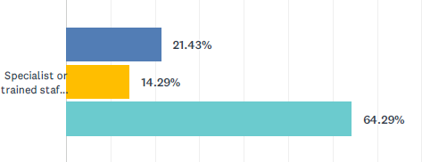

RSL’s – specialist/trained staff & expertise



Overall, it was clear that staff involved directly in allocations need to have a high level of general skills and knowledge to be able to deal with a range of applicants with very different and varying levels of housing need. Staff from RSL’s working across many areas were able to give us comprehensive overviews of how different allocation systems worked, the differences between them and how they were negotiated – this was clearly complex and multifaceted.

In the course of the research it also became apparent that the effectiveness and successes of accessible housing allocation systems and meeting wider housing needs of disabled people were driven by leadership from key individuals or teams, who were able to secure wider organisational buy-in and ‘make the case’ for accessible housing. This required a certain level of resilience and support from senior leadership in order to influence and change wider systems of working, practices and behaviours in teams dealing with multiple priorities. It is certainly an area worth further reflection, consideration and investment.

Our survey also asked about training on specific areas related to accessible housing. The results for local authorities and housing associations are shown below.

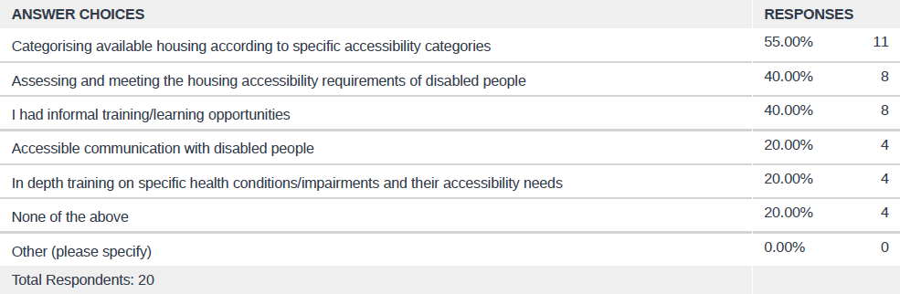

The results show that the highest percentage of staff received training on categorising properties and assessing and meeting housing access requirements, although this was only at 40%. 40% of staff received informal training and learning opportunities which are also important. In depth training on specific health conditions/accessibility needs was low and probably answered by housing OT’s. Interestingly 20% of participants felt that they did not receive any training – formal or informal.

Majority of the participants acknowledged that staff responsible for housing applications and allocation – be it housing options or allocation/lettings officers - do not necessarily have the in-depth knowledge needed to appropriately assess and allocate a property to disabled people, hence the close working with OT’s in many areas. Vast majority of participants, in housing and social care also acknowledge that there is a need for more closer working and

investment in housing OT’s, so that the expertise accessed through the OT service is not short-term or reduced to specific ‘contact points’. We talk about this in the next section.

It is also important to acknowledge that disabled people are often the experts in relation to their own impairments, they know what they can do and what they are prevented from doing due to physical and environmental barriers and how to overcome them. As one OT told us:

*We will look at the information we have in the assessment, how they have presented, and have a conversation with them. Is it a good day or a bad day for them? It is easy for us to do a snapshot assessment but people live with these conditions 24/7 – they are the experts.*

*Housing OT*

This does not de-value the role of the OT however in that their role is often to focus on the

person’s needs, identify the barriers that they are facing, the impact of those on the

person’s life and advise on and help identify solutions. This is clearly an expert field which can make a huge contribution to improving disabled people’s quality of life and it was without a doubt valued by the disabled people we spoke to. This also included people with newly acquired conditions or impairments including deteriorating conditions – where the OT

was able to advise on the future barriers that people might be facing and how to overcome them.

We also asked whether staff thought that the training they received was sufficient and 30% of respondents thought it was not sufficient.

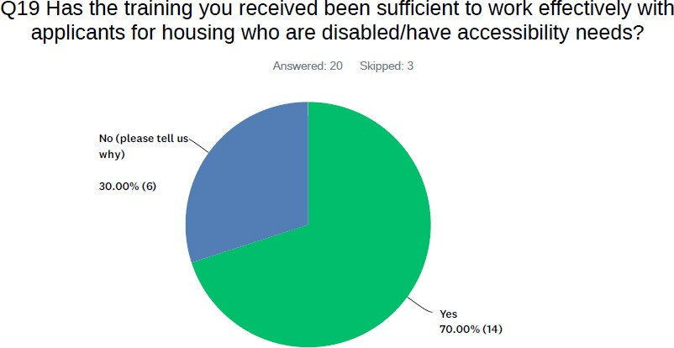

Those who thought that their training was not sufficient provided further comments. One person thought that it was not needed in their role, one thought there was always room for more training. Our general impression is that this is perhaps an area which organisations did not consider in-depth when it comes to learning and development and it is certainly worth reflecting on and investing in.

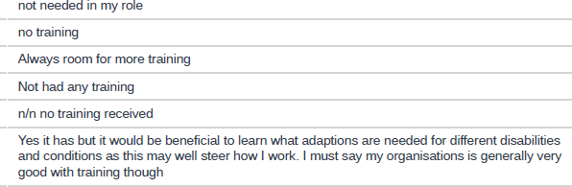

Finally, we also asked professionals across all services whether they received training on the social model of disability.

The model acknowledges that disadvantage and social exclusion stem from the

barriers disabled people face rather than from individuals’ impairments and is universally supported by disabled people’s rights organisations.

The recently published Welsh Government framework ‘Action on Disability’19 describes the model in the following way:

*Social model of disability is well-established and enshrined in the UNCRDP (United Nations Convention on the Rights of Disabled People). The National Assembly adopted the model in 2002, making Wales one of the first countries in the world to do so. This framework signals a renewed commitment to the model: our aim is to embed the model visibly and effectively across all areas of work, including as an employer, and to encourage Welsh public services and other agencies to do the same. The Social Model makes an important distinction*

*between ‘****impairment’*** *and* ***‘disability’****.* ***It recognises that people with impairments are disabled by barriers that commonly exist in society.*** *These barriers include negative attitudes, and physical and organisational barriers, which can prevent disabled people’s inclusion and participation in all walks of life.*

*Impairments are functional limitations experienced by a person. They may or may not be*

*lifelong and they may or may not arise from illness or injury. They may affect a person’s appearance and / or the way they function or communicate and / or they may cause a range of difficulties including pain and fatigue.*

* *According to the Social Model of Disability****, impairment*** *is what has historically been referred to as a “disability” or a health condition. For many (but not all) disabled people, their impairment is a significant part of their life and may form part of their personal identity. For some people, their impairment may require considerable management and they may need ongoing medical support. Experience of impairment is personal. Everyone’s experience is different. That experience is always valid and always important.*
* *Disability, by contrast, is the inequality, disadvantage, disempowerment or discrimination which may affect people with impairments as a result of barriers to access and inclusion. For example, a staircase is a barrier to a wheelchair user; providing a lift removes that barrier. Just a few other examples of barriers include the lack of British Sign Language (BSL) interpretation facilities or a loop system, the lack of braille, large print or audio information, the lack of flexible and part time working opportunities, the lack of appropriate social support or lack of understanding of mental health issues or autistic spectrum condition. Disability is therefore something which affects people with impairments but is different from impairment. Disability is*

19 [https://gov.wales/sites/default/files/publications/2019-09/action-on-disability-the-right-](https://gov.wales/sites/default/files/publications/2019-09/action-on-disability-the-right-to-independent-living-framework-and-action-plan.pdf) [to-independent-living-framework-and-action-plan.pdf](https://gov.wales/sites/default/files/publications/2019-09/action-on-disability-the-right-to-independent-living-framework-and-action-plan.pdf)

*something which disables someone with an impairment. Barriers can be removed. If you remove the barrier then you remove the disability.*

*The UNCRDP states that “disability results from the interaction between persons with impairments and attitudinal and environmental barriers that hinders their full and effective participation in society on an equal basis with others”. If fully realised, the Social Model would transform society, removing barriers and meaning that disabled people would be able to participate fully in society.*

*The historic approach to disability in the UK has been based on the Medical Model of*

*Disability (in which a person’s impairment is seen to be the thing which disables them). This means adopting the Social Model of Disability requires a fundamental shift in our attitude, culture and how we work. By adopting an approach based on barrier removal – and working with disabled people to identify solutions – we can create better policy and better services for everyone.*

Further information on the social model of disability can be accessed on Disability Wales’ [website.](http://www.disabilitywales.org/social-model/#%3A~%3Atext%3DThe%20Social%20Model%20of%20Disability%3A%2Cout%20by%20disabled%20people%20themselves.%26text%3DThese%20barriers%20include%20people%27s%20attitudes%2Cand%20physical%20and%20organisational%20barriers) Scope has also produced a useful [video](https://www.youtube.com/watch?v=0e24rfTZ2CQ) on what the model means for disabled people.

The model is widely adopted by the Welsh Government which encourages its adoption by all public services and functions. It is also the model adopted by disability rights organisations and many disabled people.

Our survey results demonstrate that only about a **quarter** of housing practitioners thought that they received training on the model. The proportion is much higher for social care practitioners with j**ust under half** reporting that they have received training, and for health professionals – with ca **43%** having received the training.

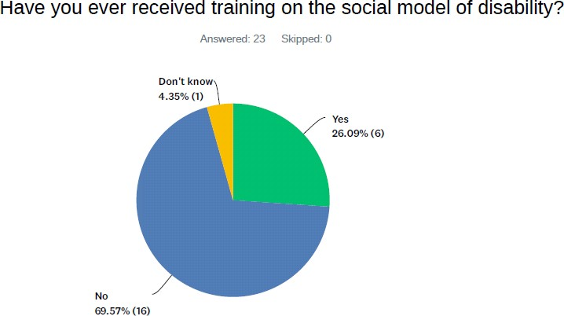

**Housing practitioners**

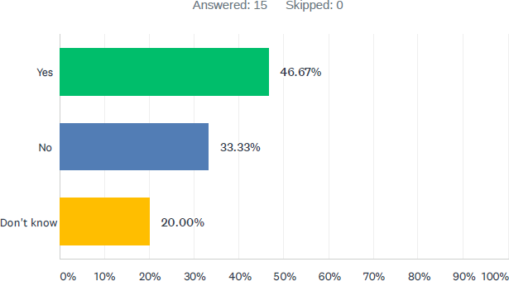

**Social care practitioners**

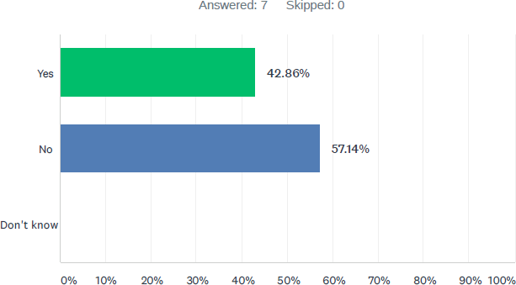

**Health practitioners**

Overall, the numbers of people who have received this training are rather low. Terms such as ‘bed-blocking’, which was used by a number of practitioners in the course of the research, are seen to be incompatible with the social model (it is not the person that is blocking the bed, it is the system and environmental barriers that prevent timely discharge from hospitals).

Considering this is the official model promoted and required by the Welsh Government, it would be advisable to invest in this type of training and awareness raising amongst staff. The ultimate aim of the model in the context of public services and functions is to transform the way they are delivered.

## The role of housing OT’s

All of the previous sections of this report have to some extent highlighted the role that occupational therapists employed by and based in housing teams can play. Contributions from vast majority of our practitioner participants leave little doubt that an investment in OT’s specific to housing has a positive impact on the service and outcomes for disabled people and others with access requirements.

Naturally, the involvement of social care and health OT’s is much needed and is invaluable in ensuring a comprehensive assessment of needs and often allocation, however almost every housing and social care practitioner we spoke to acknowledged that this involvement is often limited to specific touch points which reduces the impact of the service on the wider housing outcomes and services.

Those touch points have been outlined in section 5 where we provided an overview of the accessible housing allocation systems. Other sections of this report have already highlighted many of the contributions that housing OT’s bring into their respective housing services.

Housing OT’s and staff from local authorities and RSL’s were also able to highlight the improvements that were made due to the investment in these housing-specific roles. There was wide-spread support for greater investment in housing OT’s – especially pooling of

resources and investment in OT’s linked to housing options teams.

*It would be good to have an OT for housing – but we wouldn’t need one exclusively for us. But I think we would need more than one for across the whole city.*

HA lettings manager

*Having OTs specifically for housing would be a great recommendation.*

*HA Housing Manager*

*They need an OT. If you are issuing adapted housing for someone with functional difficulties you need somebody who can assess their functional ability… I think the local authority needs someone to match people to properties who have quite a high level of need. This doesn’t happen.*

*Social Care OT*

*We need more interaction with the OT service. It is dealt with on an ad hoc basis at the moment. If we have a household that needs adapted housing, we would ask an OT to assess suitability at the point of shortlisting. It would be more beneficial if we had an OT who could assess applications for housing in the first place and make recommendations. It would be better if we were able to be more proactive on assessing needs.*

*It would definitely be useful to have a housing OT. Somebody who has a good knowledge of how we operate would be useful so they know what the restrictions and issues are of allocating and finding properties. At present we have a team of housing options officers who are not medically trained, are not from an OT background. So, they can make decisions based on their judgement but they don’t have any specialist knowledge of medical or welfare needs.*

Housing Options Manager

*It would be absolutely fantastic if an OT could be available to assess all applications and provide that level of detail. In some LAs that is taking place e.g. Caerphilly.*

*HA housing managers*

*One of our RSL’s has an OT but a dedicated ‘Housing OT’ across the local authority area would be welcomed; e.g. we can’t easily get OT involvement in a few days. Having an OT who knows the applicant and what they need, and for them to look at the property – that is the ideal scenario. I would ideally like social services to nominate one or two OTs who would do housing assessments*

* *more than anything to build the relationship and understanding of how housing works. The current situation is an improvement but it is still not where I would like it to be.*

*Housing Options Manager*

These are just some of the comments made by practitioners we have spoken to but it was evident that the value of a good investment in a team of housing OT’s linked to housing options across the local authority area, goes far beyond that of an additional resource for

assessments and suitable allocations. Below is a summary of all the benefits we were able to identify, based on participant contributions:

* + Additional resource for early assessments of housing need and accessibility need

– making the process quicker and easier

* + Additional resource for ensuring suitable housing is allocated (including viewings and source of advice for housing allocations officers based at housing providers); making the process quicker and easier
  + Central source of extensive knowledge of adapted and accessible housing and the probability of getting suitable adapted properties in various areas
  + Ability to see the potential of un-adapted properties, so that they can be adapted or made more accessible for people
  + Enabling coordinated, proactive and regular review and overview of the accessible housing need in the area (including monitoring of the waiting times of people in need of accessible housing on the waiting list
  + Leadership and advocacy for an effective reflection of accessible housing need in housing strategy and development
  + Enabling better coordination, communication and referrals between housing, health and social care
  + Enabling quicker discharge from hospitals
  + Early engagement with applicants requiring accessible housing which raises awareness of accessible housing availability, location and helps manage expectations
  + Extensive knowledge of housing adaptations systems, grants and budgets and how they interplay with allocations
  + Central resource for both: adaptations assessments and accessible allocation
  + Training for and skills sharing with other housing staff in relation to accessible housing allocation (e.g. on appropriate categorisation of properties)
  + Coordination of processes involved in more effective and proactive categorisation of existing properties according to access levels.

We also spoke to two housing associations who have their own OT’s. It was evident that their role in their organisations was substantial and they performed some of the functions outlined above, albeit only for the tenants of their housing associations. Our impression was that the investment in housing association specific OT’s was based on the profile of stock and the proportions of communities/tenants with accessibility or health requirements. This was clearly appreciated by some tenants.

## Joint working between housing, health and social care

## Joint working: operations

We came across many examples of good practice across Gwent when it comes to joint working between housing, health and social care. Applicants for accessible social housing rarely access only one public service, and joint working is necessary to achieve coherent and good outcomes for people with access requirements.

Nevertheless, our survey and interviews also revealed significant gaps identified by practitioners across services.

In one of our surveys, we asked housing professionals to rate their joint working across services and departments (graph below).

Based on the weighted average, the lowest scores were achieved for joint working with

social services, children’s health and third sector organisations.

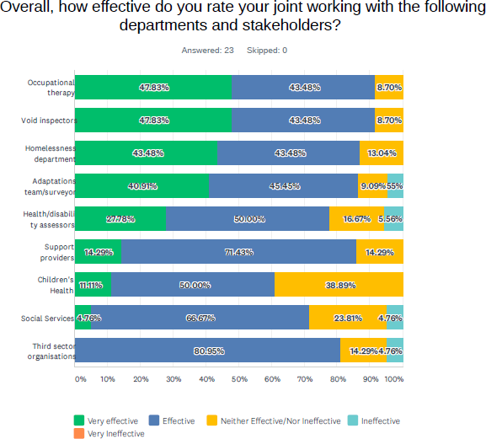

Graph: Partnership working effectiveness, housing practitioner views Some participants provided further comments on their views, including:

*We need to know more about our own stock so we can in turn match the right people to the right properties*

*Closer working relationship and having all stakeholders sat round a table from the beginning then properly plan a development rather than doing it piecemeal as the process drives it along*

*Improved channels of communication. I find social services (in particular) slow to respond to enquiries the switchboard system is lengthy and off-putting.*

*Different agendas within services sometimes create obstacles We need regular training and engagement events*

Housing practitioners

Health and social care practitioners were also asked to rate the effectiveness of joint working between health, social care and housing.

As seen on the below graphs, large proportion of health practitioners disagreed that there are effective referral mechanisms and communication between health and housing (42% and 57% respectively) with vast majority expressing that current resources to enable effective discharge are insufficient (over 85% disagree or strognly disagree that resources are sufficient).

*If patients are in the process of bidding there is at times a breakdown in communication with regards to what the patient wants and what the patient needs and this can extend their length of stay*

*Health practitioner*

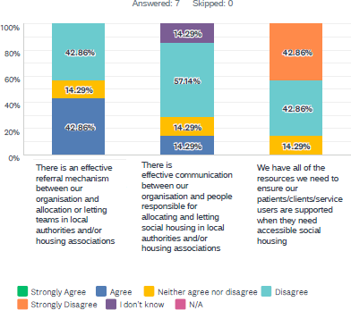

Graph: Referrals and communication: Health views

Views on referrals and communication with housing allocations staff were more mixed amongst social services (see graph below). While more people strongly agreed that communication and referral were good there were also more people who strongly disagreed. This might reflect the fact that there were more practitioners here from different local authority areas, with differing practices.

*Unless I am involved with a service user then I wouldn’t be made aware if a property was allocated to them and whether it would meet their long-term needs in relation to their disability.*

*It is usually myself who does the contacting for advice/support from housing colleagues*

*There needs to be a clearer referral path into housing and clearer guidance on financial support i.e. housing benefit / universal credit.*

*Partnership working and communication between agencies needs to be reinforced for effective referral process, awareness of service within the borough and effective location of suitable housing for the users*

Social services practitioners

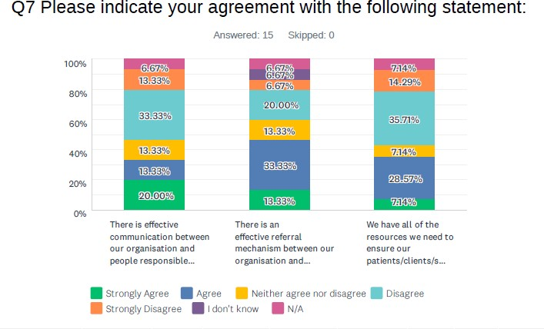

Graph: Referrals and communication: Social services views

The general view from health pracitioners on the effectiveness of joint working with housing colleagues responsible for accessible housing allocation echoed the above perceptions with only ca. 14% rating joint working as effective and ca.28.5% rating it as ineffective or very ineffective.

*Through networking I have always worked well with housing colleagues such as Housing OT leads to ensure appropriate and timely discussions are held for patients. These though can vary in length and process before they reach me*

*Health practitioner*

This differed however for social service practitioners, where nearly 50% rated joint working with social housing colleagues responsible for allocation as effective or very effective. However, in comparison to health, more social services practitioners thought join working was ineffective or very ineffective – ca. 35.5%. Once again – this might reflect the disparities in joint working between the five different local authority areas. Regional knowledge and practice sharing could help to identify these differences and share good practice.

Additional survey comments from social services practitioners as to the effectiveness of joint working included:

*At present there is no joint working between social housing and occupational therapy.*

*More joint working in partnership needed to reinforce robust follow ups and*

*suitable allocation of housing according to the user’s need*

*Better communication and openness*

*It could be better in some areas - referrals made earlier for involvement which needed -understanding of each other’s role and when department cannot intervene*

*At operational levels there are good working relationships and a willingness to support each other, but often it is more strategic, systemic issues that put in red tape.*

Social services practitioners

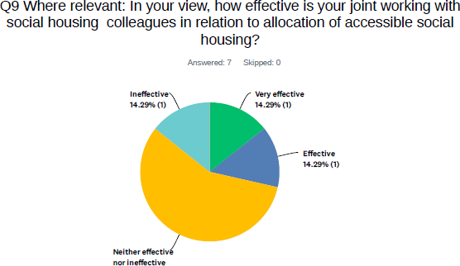

Graph: effective joint working: views from health

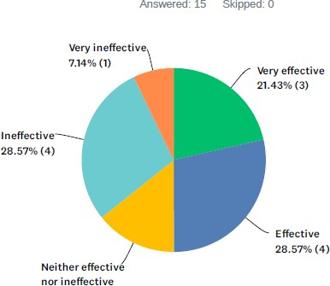

Graph: effective joint working: view from social services

Housing practitioners had a slightly more positive view of their work with hospitals than health colleagues when asked about outreach and general promotion of housing services, with just over 22.5% assessing this work as poor or very poor and 45.5% rating it as good/very good (although it must be appreciated that the format of the question is different).

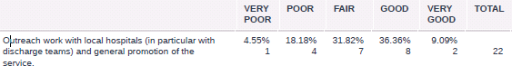

Table: Housing practitioners views on work with hospitals

*There are good links with OTs and social workers when the applicant has an OT or social worker. It becomes more difficult when they don’t. With hospital discharge there is not sufficient awareness of the system – people can have unrealistic expectations that we have a lot of properties available. When someone in hospital needs adapted housing, the link is between the hospital and the LA Housing Team who then disseminate information to the RSL. There could be some improvement in this.*

Housing Association Manager

Overall, it was clear that both: health and housing identified a strong need to improve joint operational working relating to hospital discharge.

Throughout the survey and interviews, two local authority housing option teams have been mentioned by healthcare practitioners as having a particularly good working relationships and communication channels in relation to discharge and allocation: Caerphilly and Monmouthshire. Bron Afon OT team was also mentioned as working closely with hospital staff.

A number of themes were identified through interviews in relation to joint operational working, some of which provide more context for the above statistics:

* There is a need to hold regular partnership meetings to discuss applicants on the register with the higher level of accessibility need. Other sections already mention partnership approaches to direct/emergency lets – some practitioners identified a need to include other ‘higher level’ need cases in this approach, including those cases which might have been waiting for a longer period with no successful allocation (in some places we were told these used to happen but were stopped). An example of such meeting is a Torfaen monthly Complex Case panel which involves housing, adult and children social services.
* There is a need for one point of contact in social housing providers for social care and health OT’s (we were given examples of good relationships with e.g. experienced technical surveyors who could advise on adaptability in some places, whilst in others changeover of staff meant social services found it hard to find the right contacts)
* There is a need to include OT’s and other relevant social services staff in housing options management/operational meetings to discuss performance and issues related to accessible housing allocation.
* There were some good examples of joint working on allocations to Extra Care schemes were social services had 100% nomination rights and where allocations were carried out regularly in partnership between social care and housing, e.g. in Torfaen.
* We have not come across any regular regional examples of joint working on accessible housing allocation. Some participants stated that these would be useful as a means of driving developments, improvements and exchange of good practice as well as making better use of scarce resource regionally whilst others did not see them as particularly useful and preferred to focus locally. We’ve heard of regional Housing Strategy Officers meetings where accessible housing need and good practice would come up.
* There is a need to involve social care OT’s and health in housing development meetings. Whilst there were many good examples of this happening, the practice certainly wasn’t uniform (we talk about this in a forthcoming section)
* There is a need to maintain other forms of regular communication and engagement between housing, health and social care to discuss priorities, issues, policy changes that might affect both services etc. Housing options managers were generally keen on building a greater understanding amongst social services of the way allocation of accessible housing worked, the various pressures of the system and the interplay between adaptations and allocation. Social care staff were generally keen on better and earlier referral pathways, communication at various points of allocation and an opportunity to feed into wider housing strategy. Inequitable adaptations systems were also identified as an issue.
* Good relationships and networks were crucial to effective joint working, e.g.

*I know a lot of people and so the links with community OTs, physical disability teams, hospital discharge team etc. is very good. This is half the battle – if they know there is a housing issue, they will ring me or our team.*

Housing OT

## Joint working: strategic level

We asked housing, health and social care practitioners to provide their views on whether there was a sufficient level of consideration of accessible housing allocation and accessible housing need at joint strategic meetings between health, housing and social care (be in local or regional).

The graphs below show clear differences in perceptions between the three. Overall ca.40% of housing practitioners agreed that there was sufficient consideration of both areas (although 20-25% disagreed/strongly disagreed which might account for local differences). This is compared to 100% of healthcare practitioners who disagreed that the level of consideration is sufficient. Amongst social services practitioners, vast majority neither agreed/nor disagreed.

The above answers indicate a strong level of support for more or better strategic consideration of accessible housing need and allocation, the impact of gaps on service users and on the three services. A regional framework on accessible housing allocation in the future could help in strategic analysis of outcomes and pressure points and enable better joint working in addressing gaps and improving disabled people’s health and wellbeing.

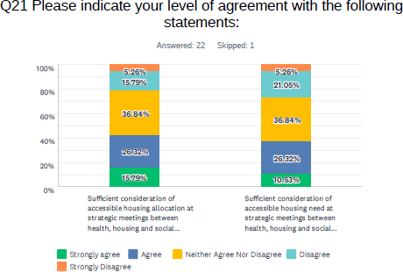

Graph: strategic level meetings: housing practitioners’ views

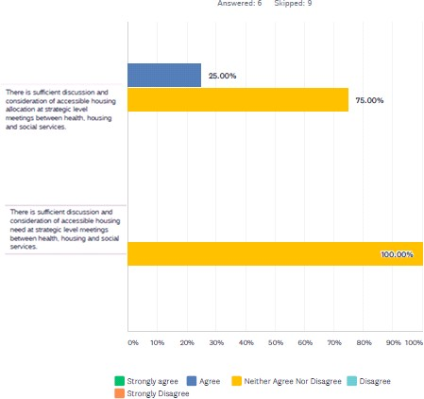

Graph: strategic level meetings: health practitioners’ views

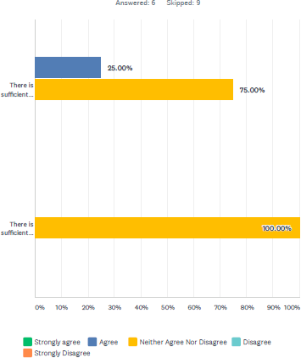

Graph: strategic level meetings: health practitioners’ views

## Hospital Discharge Processes and Accessible Housing

There were clear recommendations coming from both health and housing practitioners identifying the need for more step-down accessible accommodation to enable safe and timely discharge from hospital. Health practitioners were strongly in favour of more

resources to be invested into ‘hospital to home’ discharge services which would support patients with applying for accessible housing and enable better links with housing options teams and social landlords.

It was evident that the issues related to Delayed Transfer of Care due to housing and/or care needs were not new. All too often this can lead to patients being discharged into unsuitable or unsafe accommodation, patients discharged into long-term residential care where this is not the right solution for the patient and patients staying in hospital much longer than needed. This of course entails significant costs to the NHS but also to housing, care and other services longer term as well as having a detrimental impact on people with access requirements.

A comprehensive hospital to home discharge service and more flexible step-down accommodation could contribute to solving this problem.

Availability of step-down accommodation was patchy. We were told that the availability is good in Blaenau Gwent through their Cariad scheme with 8 to 10 beds consisting of a

mixture of residential home beds, extra care facilities and other provision. The provision is flexible and can adapt to patients’ needs. We were also informed that that in Newport the picture was different – with some step-down beds available but all of them being in residential care with strict qualifying criteria. A September 2019 report into demand and capacity for step down beds carried out for the Gwent Regional Partnership Board outlined the provision in the following way:

* Caerphilly, Monmouthshire and Newport use in house facilities to provide the step- down beds.
* Blaenau Gwent commissions beds across four facilities and also spot purchases more beds if needed with a number of care homes in the area.
* Torfaen commission beds from local, private care home providers.

Out of 568 patients whose needs were analysed for the purposes of the report, 37 were assessed as experiencing DTOC due to housing related issues, as per table below:

|  |  |
| --- | --- |
| **Reason for DTOC** | **Number of People** |
| Housing Related Issues | 37 |
| Home Care Related Issues | 165 |
| Care Home Placement Issues | 70 |
| Healthcare Arrangement | 137 |
| Choice Related Issues: Person/Family/Care | 159 |
| **Total** | 568 |

The report highlighted that the current estimated demand outstrips the capacity, although some local authorities experienced more voids, with the commissioned block capacity being underutilised – this could be due to a number of reasons, including varying needs for care or support, patients’ choices etc.

It seems that the above report focused on step down facilities with some level of care available and it is difficult to say to what extent it considered the need for temporary step- down facility without a care element for those patients whose independence is restricted purely by lack of accessibility of their home. Flexible arrangements with varying levels or care/support, similar to the Cariad Blaenau Gwent model were clearly identified as good practice by healthcare practitioners interviewed. Cariad also demonstrates that partnership working with social housing providers can bring real benefits in terms of flexibility of provision.

Continuous mapping, development of more (in some places) and more flexible temporary step-down accommodation is therefore needed.

CARIAD scheme is one example of a step-up/step-down provision aimed at safer discharge from hospital as well as prevention of admission. Below is an extract from a Community

Housing Cymru and Welsh NHS Confederation report: *Why housing matters to health and care20*, which describes the CARIAD scheme.

**The CARIAD scheme** was started in June 2014 using Integrated Care Funding from Welsh Government. CARIAD is a collaboration between Linc Cymru, United Welsh, Aneurin Bevan University Health Board and Blaenau Gwent Social Services to deliver several step up / step down intermediate care units within residential care, sheltered and Extra Care schemes throughout Blaenau Gwent. CARIAD stands for Collaborative Assessment Reducing Interventions, Admissions and Delayed transfers of care.

The CARIAD project significantly contributes to the prevention of hospital admissions and reducing the length of stays of patients in both acute and community hospitals. Its reablement and rehabilitative focus promotes both prevention and early intervention. The CARIAD project is aligned to the wider strategic priority of prevention, rather than intervention.

There are several locations within Blaenau Gwent which host a CARIAD facility, one of which is Llys Nant y Mynydd, a United Welsh Extra Care Scheme. Within the building, two rooms have been converted to fully accessible, adapted flats.

While in the CARIAD scheme, individuals are provided with support and input from the Blaenau Gwent Community Resource Team. The team is made up of Social Workers, Intermediate Care Consultant, Occupational Therapists, Physiotherapists, Rapid Response Nurses and Health and Wellbeing Support Workers. The average length of stay within the scheme is between four-six weeks.

The report estimated that occupation of flats over a 12-month period in 2018 by 10 service users represented a notional saving of £179,850 to the NHS in terms of available bed space. The majority of those who make use of the service end up moving back into their homes where they can live comfortably and independently.

Further ICF funding has now been sought to create an additional Cariad facility at a United Welsh sheltered housing scheme to convert an under-utilised guest bedroom facility into a fully accessible adapted flat. This will enable the CARIAD service to increase its capacity to support individuals during their period of intermediate care, within a sheltered housing setting as opposed to a residential care home.

In terms of examples of ‘hospital to home’ support, practitioner participants from health, housing and social services highlighted the need for earlier engagement with patients to assess their housing need. There was a need for appropriate discharge planning on admission rather than at later stages, when the patients are medically fit to leave.

20 https://[www.nhsconfed.org/-/media/Confederation/Files/Wales-Confed/Joint-Briefing-Health-and-Housing-](http://www.nhsconfed.org/-/media/Confederation/Files/Wales-Confed/Joint-Briefing-Health-and-Housing-) November-2019.pdf

Two specific discharge services were mentioned: the Lighthouse Project and Care and Repair Hospital to a Healthy Home service, but it was clear that, despite good outcomes, their scope is limited with significant gaps in coverage.

## Care and Repair Hospital to a Healthy Home Service

Care and Repair Hospital to a Healthy Home service is an example of good practice in this area. Funded through ICF, the service works closely with hospital teams to find out where the greatest patient discharge pressures are and provide a casework service to help patients return home quicker. HTHH caseworker has early conversations with patients and clinicians, that can help plan whether their homes are suitable to return to when it comes to discharge planning.

Services provider by Care and Repair include:

* helping to provide quick adaptations
* moving beds from upstairs to downstairs
* carrying out essential repairs
* providing minor adaptations
* preventing falls by making properties safer or
* making the home warm by improving heating and insulation

The service includes:

* A healthy homes assessment of the home by our skilled, qualified caseworker
* Quick access to in-house Handyperson services
* Expertise for older patients with sight and hearing loss, and the particular help they need to return home and live there independently
* Direct access to grants for small and large repairs and adaptations
* Referral-on to statutory and third sector providers for assistance with care needs, loneliness, disabled rights, financial advice etc.

Care and Repair can arrange for minor adaptations to enable safer discharge, including:

* Key safes
* Grab rails
* Internal and external Handrails
* Small ramps and half steps
* Lock changes

Although the service is a great way to enable a more effective discharge of patients with access requirements, it is currently limited in its scope. Support is mostly provided to Newport residents in private housing and is focused on minor adaptations rather than

having a significant support role in re-housing. It also mostly focuses on older people due to the restricted amount of resources available. Care and Repair provided us with many examples of how the project enabled a safer discharge and it was evident that a regional, Gwent wide resource which focuses on older as well as younger disabled patients would bring considerable benefits to the health board, housing, social care and patients themselves – an argument strongly supported by the healthcare staff engaged in our research.

It is important to make the point that whereas the Hospital to a Healthy Home service helps to satisfy the criteria for safe discharge, what it adds value to is the wider needs of vulnerable patients that require far more to secure longer term independence, i.e. it helps reduce risks of readmission. In a more general sense, some adaptations providers highlighted that viewing safe discharge in terms of adaptations is limited in itself. There is therefore a need to view adaptations and other ‘safer discharge’ services more holistically, from the point of view of the needs of the service user and using a ‘whole-systems’ approach to meet this need. Our interviews showed that different services may have a different understanding of what constitutes a safe discharge, often dictated by silo approaches and/or budgetary constraints. Criteria for safe discharge can at times be narrow with a patient being medically fit to be discharged, but limited consideration of other needs and adaptations/other services or home improvements that facilitate independent living.

One practitioner highlighted a gap in considering adaptations that facilitate discharge, adaptations that facilitate independent living and wider access and safety issues:

*Criteria is often narrow, with 'grey areas' around bathing and dignity & respect, also wider access and safety issues, cold, damp homes, etc. all with associated health determinant issues are not always considered.*

Adaptations provider

Another example of a hospital to home support service was Lighthouse project. The project was also highlighted in the 2018 *Why housing matters to health and care21*report. Below is a summary of the service in the report:

**Lighthouse Project**

For the past 10 years, Taff Housing Association’s Lighthouse Project has a Support Worker based alongside the Hospital Social Work Team in the Royal Gwent Hospital. This member of staff, funded by Newport City Council through their Supporting People programme, is there to tackle directly the obstacles preventing patients who are medically fit from returning home. These can vary from something as simple as making sure the home is warm and safe for their return, through to obtaining purpose-designed adapted property, or accessing a specialist care facility in the community.

Helen Lloyd the Service Manager of Community Care and Adult Services stated:

21 Ibid.

*‘This service’s input to people with housing related problems gave them a safer discharge and helped them meet their desired outcomes. It also helped reduce the DTOC and the number of days that people were delayed in hospital. The Lighthouse Hospital Discharge Project is an excellent example of local authority, health and the third sector working together to produce a better service.’*

Healthcare practitioners highlighted that the Lighthouse project was particularly useful in helping patients navigate the housing system, with the managers also having a good knowledge of available stock and allocation system.

It is our understanding that Lighthouse Project was at one point extended to a regional support service as a pilot scheme. Under the pilot, all patients medically ready for discharge and with a housing need were assessed and, where needed, supported by the project – a service described by health participants as ‘invaluable’. It is our understanding however that the pilot was not extended beyond an initial period. It was clear that healthcare practitioners interviewed saw a need for a regional hospital to home support service focusing on accessible housing which would encompass: adaptations and support with re- housing.

Similar recommendations, albeit focusing on patients at risk of homelessness were made in the 2019 Housing and Mental Health Support Analysis22 report commissioned by Aneurin Bevan University Health Board. The report recommended commissioning a *Gwent wide hospital discharge service with the inclusion of Housing Advice Workers to identify suitable housing prior to discharge.*

This recommendation to some extent also reflected in the *Gwent Regional Homelessness Strategy Action Plan23* which includes an action: *to introduce a hospital discharge framework across Gwent by December 2020.*

It would be worthwhile to consider a more joined up approach to commissioning a holistic housing focused discharge service and pathways, focusing on accessible re-housing, adaptations, other housing support for disabled people/people with access needs, mental health support and prevention of homelessness.

In planning the above, consideration could also be given to the links and the potential for joint working with the Home First service. Home First is based on *admission avoidance teams which provide assessment of the functional ability and care needs of patients, with the aim of preventing admission by supporting recovery at home” largely the teams are based within Emergency Departments.* (Home First Presentation to Gwent HHSC partnership). It is understood that some of the patients supported through this service experience housing issues.

22 https://[www.cymorthcymru.org.uk/files/7015/6329/4532/Campbell_Tickell_-](http://www.cymorthcymru.org.uk/files/7015/6329/4532/Campbell_Tickell_-)

_Aneurin_Bevan_University_Health_Board Housing_and_Mental_Health_Support_Analysis.pdf

23

https://[www.blaenaugwenthomes.org.uk/Data/Pub/PublicWebsite/ImageLibrary/Regional%20Action%20Plan](http://www.blaenaugwenthomes.org.uk/Data/Pub/PublicWebsite/ImageLibrary/Regional%20Action%20Plan)

%20(English).pdf

Below is a description of the pilot regional discharge scheme given in the CHC/NHS report:

**Regional Hospital Housing Support Service – the extension of the DTOC project to Blaenau Gwent, Caerphilly, Monmouthshire and Torfaen**

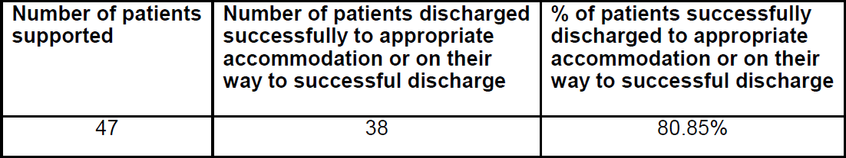

The Lighthouse approach significantly reduced the time medically fit patients remained in hospital and its success led to about extending the service to patients from outside of Newport. A pilot project was established with the help of the Intermediate Care Fund. This was as a result of the In One Place Programme instigating the extension of the Lighthouse Project through discussions with Aneurin Beban University Health Board, Newport Supporting People and Taff Housing. Its original purpose was to support patient discharge from the Royal Gwent and St Woolos Hospitals in Newport. However, early on in the project it was decided to expand the service to all the hospitals in the four other local authority areas of Gwent area, Blaenau Gwent, Caerphilly, Monmouthshire and Torfaen.

The Support Officer worked in partnership to create strong links with Health, Social Services, Housing and the third sector to develop effective ways of working to enable a safe and prompt discharge from hospital.

**Outcomes achieved:**

In the 12 months during which the pilot operated, the following outcomes were achieved:

The extended Regional Housing Hospital Support Service demonstrated that the model used to reduce DTOC time in the Royal Gwent Hospital, in combination with the services used in Newport, could be rolled out effectively across the region with positive outcomes achieved even for complex cases.

Healthcare practitioners highlighted that the key benefit of additional hospital to home resource is the extra capacity provided by professionals with knowledge and experience of housing systems. It was highlighted that these can be difficult to navigate and that housing options teams were not always responsive to the needs of patients. On the other hand, many housing practitioners also highlighted that, at least to some extent, this could be mitigated within existing resources, by clearer pathways and heightened awareness amongst health staff of the importance of early referrals.

## Adaptations and allocation

## The links between adaptations and allocation of accessible housing

Our interviews with practitioners and engagement with disabled people highlighted the importance of adaptations systems and their interplay with allocations. A number of themes have been identified through this engagement.

It was clear that there are instances where adaptations are taken out of properties due to a mixture of factors such as: quick void turnaround periods, lack of comprehensive information on adapted properties, lack of comprehensive information on the accessibility needs of applicants, lack of communication channels with social care and health or difficulties some people experience with bidding systems and more.

It seemed that some housing options teams and lettings teams were more proactive or had more resources to find the right applicants for adapted homes than others.

*We need HAs to stop taking adaptations out of properties when they are void because they are going to lose rent. I guarantee that there will be someone who needs it. People forget to bid or aren’t well or have busy lives. If people were phoned, we could find someone I’m sure. It would save money by not taking adaptations out and a suitable person would get an adapted property.*

Social care OT

*We have had occasions when we have had a property with a stair lift and a level access shower and we haven’t managed to let it to any applicant who will benefit from that property type – because we don’t know them. They may not have been banded properly or graded. And we have had to take the lift out – and we just don’t know who might have wanted it*

HA housing manager

*If we have a fully adapted property and no one on the list matches the property we will run the list again and ask OTs and social services if they know anyone would like to be registered to get the property. That happens a few times (a handful over the years – e.g. one a year out of about 30-40% of all of our properties).*

HA housing manager

In some cases, some adaptations had to be taken out of void properties as they were at the end of their useful life. Some participants highlighted that some adaptations, in particular stair lifts can also be bespoke to the person, although others stressed that having the right information on adaptations required by applicants can help in these situations, e.g.

*Stair lifts in properties can be an issue – knowing whether to leave it in a vacant property or not (as they can be bespoke to the person), it may need repair, parts*

*may be obsolete, it may be at the end of its useful life; we try to leave a stair lift in a property wherever possible but we must know it is safe.*

HA Housing Manager

*With stair lifts, 9 times out of 10 they will remain, as we will look for someone to move in who needs it. Stair lifts can be used by new people – it just depends on their weight. Most take people up to 19 stone and then you would need a sturdier one for people over 19 stone.*

Housing OT

In the course of interviews, we also considered what happened with removable adaptations or equipment once they were no longer needed or tenants moved out of the property with equipment in situ, and no tenants needing the particular equipment/adaptation in the property were found. Some housing providers highlighted that they use their own storage facilities as usable equipment/adaptations is regularly recycled back into use. Caerphilly Council for example have their own storage facilities and housing OT’s are regularly involved in decisions on whether adaptation/equipment such as stair lifts can be recycled. This is a good practice from the point of view of promoting sustainable environment and circular economy, i.e. reusing what is already there. Additionally, it contributes to a more sustainable use of public money and resources. This practice was not however widespread.

I some cases, the aids and adaptations equipment will be provided through health or social care service in social homes and will not be owned by the housing provided or tenant. We were told that much of this equipment, when no longer needed, will be recycled through the GWICES – Gwent Wide Integrated Community Equipment Service, however, once again this practice seemed patchy. One housing provider told us that until recently, if the equipment was not needed, it would be discarded (or could be left in empty homes).

Examples of equipment include: hoists, mattress elevators, rise and recline chairs and hospital beds. The housing provider is now registered with the GWICES service and equipment is collected, stored and reused. This is however not the case for other equipment which might be owned or leased by social housing providers rather than provided through social services or health. I would be worth exploring therefore, whether: a) more housing providers with social services or health equipment could link with GWICES service b) GWICES service could be used by housing providers without storage facilities for their own equipment or adaptations c) whether there is any other vehicle for pooling resources locally or regionally to facilitate better reuse of equipment and removable adaptations.

**The Gwent Wide Integrated Community Equipment Service (GWICES)** has been established to maintain service user’s independence in their own home, by providing equipment to assist with daily living.

Torfaen County Borough Council as lead commissioners for GWICES manage the pooled budget which was agreed through the signing of a Section 33 Agreement (National Health Services (Wales) Act 2006), which enables local authorities to exercise certain NHS functions and for local health boards to exercise certain local authority social care related functions.

This Section 33 Agreement covers the five “Greater Gwent” local authorities (Torfaen County Borough Council, Caerphilly County Borough Council, Monmouthshire County Council, Newport City Council, Blaenau Gwent County Borough Council) and Aneurin Bevan Health Board.

To ensure service users get the correct equipment, a health or social care worker will undertake a needs assessment. The range of equipment that is provided through GWICES includes:

* Equipment for disabled adults
* Mobility aids
* Equipment for disabled children

[https://www.torfaen.gov.uk/en/Related-Documents/Social-Services-General/Social-Care-](https://www.torfaen.gov.uk/en/Related-Documents/Social-Services-General/Social-Care-and-Housing-Team-Profiles.pdf) [and-Housing-Team-Profiles.pdf](https://www.torfaen.gov.uk/en/Related-Documents/Social-Services-General/Social-Care-and-Housing-Team-Profiles.pdf)

Issues were also identified with adapting properties in the course of or post move-in date.

We were told that some housing associations had a policy of no adaptations in the first 12 months post move-in date. This seemed to be the cases where the adaptations were not agreed in the course of allocation, e.g.

*OT: A lot of HAs won’t adapt a property for 12 months once someone accepts a property. This is their policy and I assume it is because they shouldn’t have accepted a property that isn’t suitable for them. They move in and we get a phone call saying this has a level access shower and I need a bath. It isn’t housing associations’ responsibility to adapt all of their properties – because the person shouldn’t have accepted the property.*

### *Researcher: That doesn’t seem right – the person may suffer for a year?*

*OT: We see it from both sides. Lots of people could have accepted that property who needed what that property had, and so those people go without a property with a bath because the person who actually needed a shower accepted the property with a bath. If someone needs a level access shower, they may bid for a 3-bed property with a bath, because 3 bed properties don’t come up very often with a level access shower – and then when they move in, they say that*

*they need a level access shower. So, the person who does need a 3-bed property with a bath does not get it.*

*So, I think that is where the policy has come from. We get that a lot – people move into a property and very quickly tell us they need adaptations. We see it all the time. If we had a list of properties that were already adapted those properties would be better linked to people who have those needs.*

Social care OT

The above issue is clearly a difficult one to resolve. On the one hand, social landlords are trying to make the best use of their already adapted stock, with stock transfer associations in particular having a limited adaptations budget. On the other hand, some disabled people might be stuck in very difficult housing situations where bidding for a property which is otherwise suitable but for one specific feature, is a much better option than waiting for a long time, e.g.

*I have been turned down by otherwise suitable ground floor properties because they don’t have walk in showers, yet I am expected to carry on living in an upstairs flat and climb into a bath to take a shower.*

Disabled applicant

One housing manager told us that they come across many applicants who don’t state their accessibility needs at application stage and ask for adaptations once they move in. While we cannot make a direct link, it is possible that situations like the one described above might be a reason for this.

It was clear that the differing grant regimes sometimes dictated whether an adaptation could be made pre moving in date or whether a tenant will need to move in first and await adaptation in their new home. Many providers highlighted that PAG funded adaptations cannot be made before moving in date, whilst others mentioned that they found solutions to this problem. The availability of adaptations before and after moving in was confusing for tenants and some non-housing professionals.

In some cases, however, adaptations will be agreed as part of the letting process. Housing OT’s told us that having a good understanding of the applicant’s current housing situation as well as a good understanding of the availability of properties which match the particular applicant’s need is key to making this decision. Applicants can be given a higher priority banding to enable a quicker allocation or, knowing how often specific properties do or don’t come up on the register, a decision can be made to adapt an available and otherwise accessible property pre or post moving date. Adaptations budgets and availability of grants might also influence this practice.

It would be our recommendation that policies clearly state how decisions on installing adaptations pre or post moving date are made and what the deciding factors are e.g. the

impact of current housing situation, the availability of specific accessible properties, the waiting time the applicant has already spent on the list, budgets and types of adaptations, or differences between funding regimes etc. This would help to clarify the situation to applicants and non-housing professionals.

There was another issue which can also affect applicant’s chances of being allocated a suitable property and which is clearly difficult to manage. We were made aware of cases where applicants live in extremely inaccessible housing which poses a safety risk but are also applying for a more suitable housing (and are in clear need of that). Fitting an adaptation in current home would usually ‘downgrade’ the applicant’s priority banding, as the current housing is deemed more suitable. These situations can be obviously difficult for applicants who may need to struggle or live in very unsafe housing for a long period before they find a suitable property. It seemed that some providers/housing options allowed more flexibility in these situations than others. For example, one housing professional told us that in such situations they would allow to e.g. fit a stair lift as it can be recycled. This is an example where the facility to be able to recycle adaptations can have a great impact on applicants’ quality of life.

In general, however, we were told that, often once an adaptation is fitted in current housing, applicants decide to stay in their home.

Conversely, practitioners also told us of multiple situations where adaptations have been fitted in housing which is otherwise inaccessible. In many cases those adaptations had to be later taken out upon re-letting. Some housing policies will stipulate therefore that properties which are otherwise inaccessible, will not be eligible for adaptations and re- housing is recommended.

These can obviously be difficult to manage, as many tenants will be keen to stay in their homes, especially if that is where their support networks are. There is an obvious shortage of accessible properties and re-housing may mean moving away from e.g. special needs school catchment areas or support networks which can often be a lifeline for disabled people. It would be our recommendation that there is some flexibility in such policies, depending on the situation that the tenant might be finding themselves in. This is one of the situations where individual’s needs must be weighed against business needs and difficult decisions have to be made.

*If someone wants to put in a level access shower in a house with 20 steps, I will argue it isn’t cost effective. Longer term if the person can’t climb in and out of a bath, they may have problems with steps and stairs. Why would you put a level access shower in costing £3,500 to £5,000, and 3 years later they can’t get in and out of the house…. we had one family who moved 5 times and had adaptations done each time on each property.*

Housing OT

*I went into one house that had a through floor lift and a wet room – but had 19 steps which could not be adapted. I said sell the property rather than taking everything out. They wouldn’t get the money back.*

HA Housing Manager

*Some tenants may have put a walk-in shower into their upper floor flat – however, it may have stairs to go up to the flat, and so we wouldn’t re-let that to somebody who had mobility issues who couldn’t go upstairs.*

HA Housing Manager

*One lady wanted a wet room in her house which had 20 steps. She didn’t want to move. There is a delay in getting funding for that – people can wait for up to 18 months. In the meantime, she isn’t on the list for re-housing. But I stopped the wet room going in, saying that the property was unadaptable – and so she is now on a high band. But if she had the wet room fitted, she would be on a lower band*

*OT*

*I have been waiting over 2 years. I have applied for properties on the system, but have not been accepted. I need to stay in my area as I’m disabled and rely heavily on my parents. I don’t seem to be getting anywhere!*

Disabled applicant

Finally, some stakeholders engaged in the course of the research, highlighted the need to

reflect the diversity of people’s needs in the delivery of adaptations:

*Often an off-the-shelf approach to adaptations doesn't work for people living with sensory loss or dementia, and adaptations by default can lead to unintended outcomes (i.e. maintained risk). RNIB's Visibly Better standards are crucial to this standard required for providing adaptations to clients with diverse needs.*

Adaptations provider

**Care and Repair Managing Better** service supports home safety and independent services, cross-tenure, for older people 50+ that have a sensory loss, living with dementia or have survived a stroke. The service, funded from the Welsh Government’s Sustainable Social Services Third Sector Grant, is led by Care & Repair Cymru in partnership with RNIB Cymru, Action on Hearing Loss Cymru, Stroke Association, the Alzheimer Society and Care & Repair Agencies across Wales. Through relatively small-scale investments in housing adaptations and improvements, Managing Better helps to reduce easily preventable falls and poor

health, increasing people’s personal safety, confidence, independence and well-being at home. Taking such a prudent and preventative approach helps to reduce people’s visits to the GP, admissions to hospital and their reliance on Social Care.

The numbers of people with sight loss and/or hearing loss are set to grow as the population ages, and housing services must consider the needs of older people. The success of the Managing Better project is based on collaboration between large Welsh charities, and this in turn has created new partnerships with hospitals, clinics, GP surgeries and social services

teams to focus on the wellbeing of older people as a ‘shared patient-client journey’. Integrating the impact of sight and hearing loss into home improvement and in support of independent living, the service has had a crucial impact on the lives of older people.

<https://www.careandrepair.org.uk/en/news/service-ensures-people-are-managing-better/>

**RNIB Visibly Better Cymru** standard supports organisations to develop and maintain accessible environments so that many more people can feel more confident in getting in and around the places they visit, work or live. Having accessible environments means that people with sensory loss such as sight loss, can also benefit from inclusive design as well as other disabled people.

The design principles support partners to meet best practice and legislative obligations that include The Equality Act 2010; BS8300; Part M; Welsh Housing Quality Standard (WHQS); Development Quality Requirements (DQR) and Lifetime Homes. The Visibly Better design principles include fundamental considerations to help prevent falls and promote confidence by establishing appropriate lighting level requirements. Lighting has to then be complimented by colour and tonal contrast of surfaces, fixtures and fittings to aid identification, task work and wayfinding.

## Environments that have benefited from Visibly Better Cymru principles:

* Hospital wards, surgeries and clinics
* Community buildings
* Offices
* Domestic new build projects for General Needs
* Domestic new build projects for Learning Disabilities and Dementia (RNIB publication

‘Building Sight’ is referred to in DQR Part 1.1.1)

* Refurbishment projects for supported living schemes
* Refurbishment for General Needs housing

(RNIB publication ‘Building Sight’ is referred to in WHQS Part 7d)

[https://www.rnib.org.uk/wales-cymru-how-we-can-help/designing-accessible-housing-and-](https://www.rnib.org.uk/wales-cymru-how-we-can-help/designing-accessible-housing-and-buildings) [buildings](https://www.rnib.org.uk/wales-cymru-how-we-can-help/designing-accessible-housing-and-buildings)

## Equity of adaptations systems

Numerous Wales and UK wide reports have highlighted issues related to the inequitable experiences of adaptations systems depending on tenure (e.g. most recently Wales Audit Office report on adaptations24). We will not therefore be covering this topic in extensive detail. Evidence from practitioners and many disabled people confirmed the lack of equity between different tenures and the impact of this on allocation of accessible housing.

There were big differences in the timescales within which adaptations of similar size were installed, including assessment times: in some cases, the process took weeks from the identification of need to installation, in others tenants experienced months-long waiting periods for what seemed to be similar type adaptations. Some processes seemed quicker where housing OTs were available to carry out assessments and where they had good links with adaptations staff or they were part of the same team, however this wasn’t always the case. The Wales Audit Office report demonstrated that delays and different timescales can be caused by a huge variety of factors, including budget streams and multiple pathways into adaptations.

*Some of the items I needed for my disability were considered before they direct matched me for a more suitable property, however there are some things put in place in my old property which were not put into place for my new property. I moved in August and am still awaiting an OT assessment regarding further adaptations I require for my conditions*

*Disabled tenant, survey completed 10 January 2020*

*There are 3 different funding streams for adaptations, and so people are potentially getting different decisions – DFGs (for homeowners/private properties), PAGs (for RSLs) and LSVT’s budget to fund adaptations. We need to look at consistency in how adaptations are agreed, irrespective of funding source. So, people will then get a consistent decision about whether properties will be adapted – this probably doesn’t happen at present.*

*Housing options manager*

Budgets within some LSVT’s (stock transfer housing associations) were an issue compared to those providers who could access PAG’s (Physical Adaptation Grants – available for non- stock transfer housing associations). Issues were also experienced by tenants potentially eligible for DFG’s (Disabled Facilities Grants) although we could not establish whether they were budgetary or due to e.g. terms and conditions of grants, suitability of properties etc.

24 <https://www.audit.wales/publication/housing-adaptations>

(Disabled Facilities Grant are usually for owners, local authority and private sector tenants).

LSVT’s cannot usually access grants and adaptations are funded through their own budgets.

*The other three housing associations here can get PAGS – and so the service you get from them is different to the service you get from the LSVT. The LSVT have to be savvy – they can’t do 2 or 3 large extensions, because that takes away 10 or 12 shower adaptations. Also, the LSVT stock is built to old standards - most new stock has wider doors and wheelchair turning spaces.*

*Housing OT*

*It would have needed a ramp to be installed and there was no available budget to do this.*

Disabled applicant on being offered different HA properties

*I would like to get up to my grass area but I would need a ramp that the council won’t do. I also had to pay again for the new drop curb for my wheelchair, we had already had a driveway put into the property they gave us by mistake costing us thousands of pounds*

Disabled council tenant on moving into accessible home

In summary, it was evident that the effectiveness of adaptations systems impacted on applicants’ experiences as well as on the way accessible housing is allocated. It seemed that organisations with limited adaptations budgets would be more likely to recommend re- housing and, at least at a policy level – aim for a more ‘perfect’ match approach. Greater knowledge of available accessible stock, early and comprehensive OT assessments, together with clear categorisation system and a Housing OT resource facilitated better matching and could therefore help alleviate some of these pressures.

Notwithstanding the above, most practitioners agreed that one of the benefits of an effective accessible housing allocation system was a reduced need for removal of adaptations and increased re-use of already adapted homes – a finding which is further confirmed by the cost analysis study in section 5.13.2)

Welsh Government Adaptations Steering Board has been working on bringing improvements of the adaptations system since 2018 – the year of the publication of Wales Audit Office Report. One of the outcomes was the development of Housing Adaptations Standards of Service25. The Welsh Government Board is currently working with practitioners towards the development of a guide on Housing Adaptations Strategic Planning Frameworks which could be adopted locally and/or regionally across Wales.

It is envisaged that a development of Strategic Planning Frameworks would:

25 <https://gov.wales/housing-adaptations-standards-service>

* Provide a person-centred approach to planning and delivering services, facilitating a move away from services shaped by grant availability and towards a more person- centred approach
* Enable the scoping of future population need and demand for housing adaptations within each local authority area.
* Support a co-productive approach to deliver a coherent pattern of services across different housing tenures.
* Support coordinated use of funding.
* Simplify pathways into services (single route of entry).

In light of the above developments, it is certainly worth considering the need for a strategic analysis of population needs for adaptations and accessible/adapted housing and use this for joined up planning of adaptations delivery, accessible housing allocation and development – be it locally or regionally.

**North East Wales – regional approach to provision of adaptations**

During the research, we have spoken to a housing options manager in Conwy Council. Conwy are part of North East Wales Single Access Route to Housing – a common allocations system and policy operated by all major housing associations and councils including Flintshire, Denbighshire and Conwy. Conwy are currently part of a regional group working together on a consistent approach to provision of adaptations, addressing the recommendations of WAO report. The regional group consists of councils, housing associations, social services, health and other partners. The group is developing a consistent regional referral form and application process for adaptations.

## Monitoring and oversight

## Performance and outcome monitoring

Various forms of individual and organisational performance monitoring of accessible housing allocations are adopted across the region.

A range of methods is used by local authorities and housing associations to monitor the quality of individual allocation decisions. The practice however varies across the region:

* Some organisations/councils adopt extra checks on each accessible housing allocation, for example, each allocation of accessible/adapted property is signed off by housing options manager to ensure correct match in Monmouthshire. Similar

practice is adopted in some RSL’s. In Caerphilly, a housing OT will need to sign off each accessible housing allocation and the OT can challenge how the property has been categorised, suitability etc – this is again an added value of a housing OT.

* In some organisations no extra checks are carried out specifically on accessible housing allocations and lettings officers will make the decisions
* Some local authorities housing options teams do not sign allocations off
* All local authority housing options teams however monitor RSL allocation decisions to some extent, ensuring that the policy and process is followed and picking up on

e.g. overlooked applicants.

* Some housing associations told us that they use external agencies to undertake audit of their lettings practices. It would be useful if specific attention were paid to accessible housing allocations in the course of these audits.

In terms of wider performance of accessible allocations systems, we found that:

* Local authorities carry out equality monitoring, comparing the make-up of the local population, against waiting lists and against lettings to identify any disproportions. This is of course a statutory duty under the Equality Act 2010. We could not establish to what extent this is common practice across the region however, only two local authorities referred to this practice.
* All local authorities have common housing register management groups consisting of housing options managers, partner RSL’s and (in some cases) OT’s. A variety of other meetings, groups and panels takes place focusing on different issues (e.g. move-on from supported housing, housing delivery officers’ groups etc). These meetings are often used to review the performance of the allocations system, operational issues, gaps etc. Although we were given examples of accessible housing ‘coming up’ on the agendas of these and other similar meetings, we did not come across examples of regular monitoring of the performance of accessible housing allocation as a separate area (for example waiting times, appeals, need vs. lettings etc) or accessible housing being a standing agenda item. We would recommend that regular monitoring is undertaken.

*We don’t review accessibility in particular but it forms part of our wider monitoring of why people don’t take up tenancies. We can drill down into health reasons.*

*Housing Options Manager*

*We don’t have an Accessibility Panel – but people within the panels may have accessibility needs*

Housing Options Manager

* Generally, there seemed to be little involvement or analysis of feedback specifically from users with accessibility needs or analysis of allocation outcomes for people with accessibility needs. We discuss this in the forthcoming section on applicant/tenant engagement.
* We could not establish to what extent councils regularly monitor the waiting lists in terms of applicants who might have high accessibility needs and banding but who have been on the waiting lists for longer periods. This is important as it might highlight issues such as lack of availability of specific accessible housing types and the need to develop or look for other options, the need to assist applicants with

bidding, or the need to raise applicants’ awareness of their chances of securing properties and recommend e.g. widening their choice criteria or other options, such as adaptations. This seemed to be happening in Caerphilly, where the housing OT performs has a proactive oversight role. To some extent this might also be happening in some CBL systems, as several applicants/social care staff told us that applicants were encouraged to regularly bid so as not to lose their priority. Where this proactive monitoring of applicants with accessibility needs is not taking place – it would be our recommendation to undertake it or a regular basis due to the specific needs of this population and possible health and wellbeing implications.

## Strategic oversight

Accessible housing allocation is just one piece of a housing and support puzzle which contributes to the housing outcomes and therefore the health and wellbeing of disabled and other people with accessibility needs. Effective accessible housing allocation is focused on making the best use of existing resources but it is also inextricably linked to and impacted by:

* the way the adaptations system operates and
* the number of specific types of accessible homes available in the area and their quality
* housing support and advice available to disabled and other people with access needs

Housing and Health, a Case for Investment report26 estimated that that poor quality housing in Wales cost the NHS more than £95m per year in first year treatment costs and the cost to Welsh society was over £1bn. Key factors contributing to these costs were housing quality, homelessness and unsuitable homes. Adaptations will of course help reduce the number of homes which are unsuitable for the specific population we are considering. Effective allocation of accessible homes, i.e. how effectively we make use of suitable homes, is also a key element of making housing ‘suitable’.

The added value of an effective accessible housing allocation system is the information and analysis which can be gained from key elements of such system (e.g. property and applicant information, accessible housing need and availability, gaps and pressures on the system,

effectiveness of assessment/matching processes and applicants’ outcomes) should therefore form part of a much wider strategic analysis of housing, health and care needs of the population and feed into strategic work between these three services.

26 https://phw.nhs.wales/news/poor-housing-costs-health-service-95m-per-year-new-report/

There is of course a long and commendable tradition of housing, health and social care working strategically together across Gwent – locally and regionally. Much work is put into local and regional joint strategic planning of housing support, delivering joint strategic

initiatives such as ‘In One Place’, the work programmes under Health, Housing and Social

Care Partnership, CARIAD programme mentioned above and so on.

*Work is going on with health and social care regarding people who are in residential care outside of Monmouthshire to try to provide 1, 2 or 3 properties per year for those people. They need bespoke housing, kits and technology to live as independently as possible. It could be on a new development of properties being built by one HA – and we ask for one property to be built in a bespoke way. It could be we ask a HA to buy a property or through a Section 106 on a new build. The people getting those properties would probably never hit the Home Search waiting list. Overall cost savings come into this as well for health and social care*

Housing Association Manager

Nevertheless, strategic and joint analysis of accessible housing allocations across the board, accessible housing need (within general, not specialist housing), housing development and adaptations and the extent to which these could work better to contribute to a healthier population seems to be patchy.

## Applicant communication, engagement, and transparency

## Awareness of the process

The majority of respondents – 76% per cent, were not aware of the allocation system for accessible housing before submitting their application. Additionally, 63% told us that they, were not made aware of what the process entails during their application process. Some respondents noted that the lack of transparency in the allocation process left them feeling frustrated and confused.

*I have been misinformed and feel let down*

Disabled applicant

## Application process & accessibility

Majority of the respondents to the survey applied for housing online (63.5%) with the second biggest group applying in person at council/housing provider office etc. (16%)

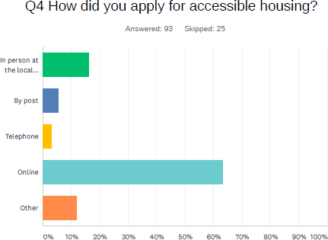

In term of the ease of application ca 25% of applicants found the process easy of very easy, while 38% found the process difficult or very difficult – a significant proportion of applicants.

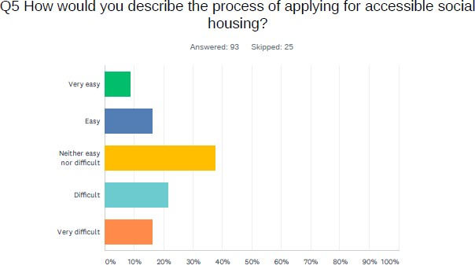

Interestingly, our survey showed that ca. 18% of applicants in choice-based systems said their application process was very difficult compared to no applicants in needs-based systems. Conversely, ca. 11% of applicants in CBL systems also said that the process for very easy for them compared to no applicants in the NB systems.

*The online registration system was easy to use but hard to speak to someone in person*

Disabled applicant

This indicates that the experience in NB systems might be more uniform while in CBL systems, there are big disparities between applicants which might indicate a need for support for ca 1/5th of the applicants. This was certainly supported by comments received from support workers, social care staff and some applicants.

*The term 'BID' is still confusing for a lot of older people, many are put off and struggle on in accommodation that is no longer suitable or appropriate for their needs simply because they cannot don't understand the processes and can't face the thought of moving/uprooting. I would like to see a wider role for Allocation Teams to support disabled and older people through the process through to rehousing, because like or not, they and only they know and understand the process as it needs to be understood. Support workers rarely do and all too often don't follow up or monitor that bids are being placed, or the system updated of changes*

Social services practitioner

Accessibility of the online systems was an issue for some applicants with sight impairments and we would recommend that accessibility audits are carried out on the websites.

For example, we spoke to an applicant who is registered blind and who has been on the waiting list for 10 years.

*I have to renew my application annually online to say I still require an accessible home. The online system is not accessible to me. I have a carer to complete the form. I use screen reading software, website is time restricted, pages log out after certain time. This is not accessible for me.*

*Disabled applicant*

Disappointingly, 38 out of 54 respondents who needed accessible formats did not receive information in their preferred format (e.g. Large Print, BSL or Easy Read).

As previously mentioned, several applicants in focus groups and in the survey made comments about the difficulties with the requirement to be actively bidding as priority points can be lost otherwise. Those applicants generally found this requirement difficult as accessible homes can be scarce or not entirely suitable.

In general, many of the respondents who applied online, said they would have liked an option to apply in person, which they thought would have given them an opportunity to ask questions about the process and system of allocation. In the course of interviews, staff made us aware of a variety of accessible methods available for application in each area, including physical hubs, offices and home visits. Our recommendation would be to raise further awareness of these options to applicants.

Disappointingly, only 16 per cent of respondents felt that they had a choice in the type or location of home they were allocated. Respondents noted that the lack of accessible social housing meant that felt forced to accept homes away from their social networks.

*The process was ok, I found it difficult, as although we required a ground floor property or bungalow. I was being told I had to bid every week, most of the properties advertised were not suitable*

*I would have liked to be near my family, it takes longer to get the children to school now, which is difficult for me. I just wish my social needs could have been met in a better way*

*Disabled applicants*

When asked to rate their overall experience of applying for an accessible home, just over 17% described the experience as good or very good, 44% of respondents described their experience as average, with 39% survey respondents describing their experience as either bad or terrible. Comments made here mainly focused on: lack of support, the wait time for an accessible home, lack of suitable accessible homes in the area.

Monmouthshire and Caerphilly had the higher number of respondents with a good or very good experience.

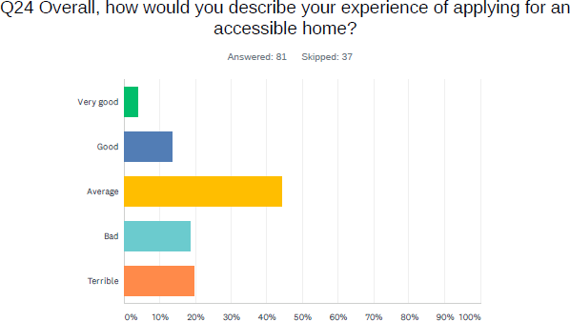

## Assessment process

In terms of assessment of accessibility needs, ca 65% of applicants stated that those needs were assessed when they applied. The 35% might reflect the proportion of applicants in areas where assessments are not carried out routinely – an element of allocation process that most staff thought would be extremely helpful (see assessments section).

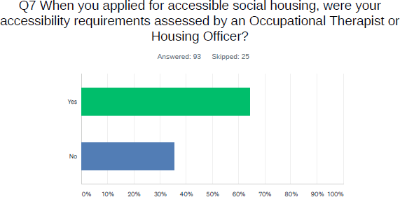

We received mixed views on the experience of the assessments. Many applicants clearly had a good experience of the assessment and found it useful. Others were rather critical of the process. The two key issues identified were:

* The length of time waiting for the assessment
* The extent to which the applicants thought the assessment was translated into a suitable home on allocation and/or was reflected in priority banding (many still waited for small adaptations or some homes weren’t suitable)

*A really nice lady came to see me and within few months I was offered a place.*

*When I met the Occupational Health Therapist, she listened to me and told me what type of property I would need*

*The OT came out to assess my husband only after we had been on the waiting list for 3+ years and only after we had chased up the housing dept a number of times.*

Disabled applicants

## Communication

The research results highlighted inconsistencies across the five council areas in how applicants were kept informed of their application for accessible social housing.

Only 17% of respondents felt that their housing options were fully explained to them. 32% felt that the housing staff took time to understand their accessibility requirements.

*I feel that my housing needs are being ignored when I contact the council, I get abrupt emails*

Disabled applicant

Only 28% of respondents thought they were regularly kept informed of the progress of their application progress. Of those, majority stated they initiated the contact or that contact was made when necessary.

*The staff were great, they worked hard to process my application quickly*

Disabled applicant

Of those respondents that were not kept informed, the majority stated that they would have liked to have received monthly updates on their application. Whilst regular updates on the status of applicants housing application could help to reduce some of the stress and anxiety that applicants experience whilst on the waiting list and increase transparency, it is understood that a monthly proactive update would probably be difficult to achieve due to capacity.

Nevertheless, it would be worth considering whether there are any other methods of meeting this need.

Although, as highlighted, many applicants had positive experiences, a significant proportion of applicants in focus groups and those who provided comments in the survey also highlighted their negative perceptions around attitudes and general disability awareness.

*For people to listen to me as a person and not a box to fit into and tick and understand my needs correctly and not make life worse*

*I want to be treated as a person, not a number*

*I’d like the Housing Officers to be more empathetic of my needs as a disabled person*

*More care and assistance should be given to disabled tenants. This house was in an appalling state, dirty by the repair team, needed a complete deep clean from top to bottom and repaint from top to bottom, which the housing association would not do. The words used when we viewed this house by the housing officer were WELCOME TO THE WORLD OF SOCIAL HOUSING (emphasis by respondent)*

Disabled applicant.

We asked all practitioner interviewees whether they raised awareness of housing options available to people with access requirements and the allocation system directly with disabled people’s community groups etc. The only organisation which provided us with examples of doing this regularly was Monmouthshire Housing Association.

In terms of the website information available to applicants, our quick review found that more information specific to people with access requirements could be provided on the various housing options websites. Key gaps identified include:

* Information on support organisations specific to disabled people, people with access requirements or for specific conditions
* Separate and easy to find section on accessible housing which describes the allocation process specific to applicants with access needs, e.g. categorisation of applicants and properties, OT assessment process (and timescales), whether age restricted properties can be applied for, the matching/shortlisting process, the link between adaptations and re-housing, adaptation policies,

We would recommend reviewing the information available on the websites to take account of the above.

## Support for applicants

In relation of support services offered to applicants whilst on the waiting list, just under 40% thought that support was offered to them. 17% were offered support to view properties, 10% had advice and support to apply and 10% support to understand the process. Only 3.5% were offered support to move home. Out of those who stated other, only 3 applicants through support wasn’t required, other key comments can be seen below.

There were no real differences in the experiences of disabled people between different local authority areas here.

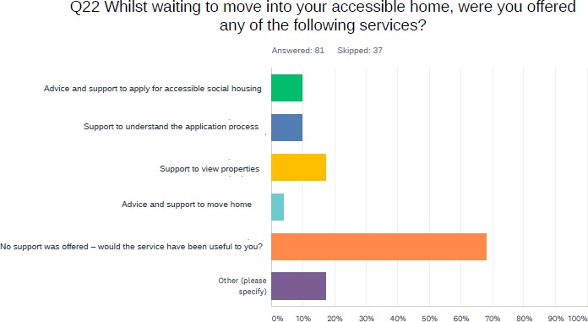

*I have had very little help in finding a property and my health is getting worse*

*Support services would have been useful to me as I’ve never been through this process before*

*Yes, physical support to move would be very beneficial*

*We had no support offered even after they had made the mistake of giving us the incorrect house and only 1 wks. notice to move*

*Would have been useful to have been offered assistance with moving processes,*

*it’s very scary as a vulnerable person*

Disabled applicants

We also asked practitioners whether they referred disabled applicants to other agencies/support groups which could help with housing and/or other issues. Ca 86% of housing practitioners confirmed this is done, compared to 75% of social care staff and under 60% of health staff. Key support organisations mentioned were housing support organisations and charities/third sector organisations such as Mind, Shelter Cymru, Age Concern, Care and Repair, Platfform. Applicants also mentioned having been assisted by the Disability Advice Project – a service specific to disabled people, certainly worth raising awareness of and making links with. Many applicants highlighted that they struggled to access any support or advice or found it challenging not to have a face to face contact therefore making referrals or simply providing information about the support and advice services available to disabled people is worth investing in. This could be provided on the websites as a list.

In summary, these finding evidence the need for more support or increased awareness of support with the application process for some applicants. Support in moving home is

certainly something that should be further considered by providers as most of this population may experience difficulties in managing this often-physical process. Partnering with third sector support providers could also be an option here.

## User engagement and awareness

Engagement with applicants or former applicants with accessibility needs seemed to be rather patchy.

* Many organisations mentioned that they carry out satisfaction surveys but none of them disaggregated their data to analyse experiences of this specific group
* Some consultation work was carried out by councils when e.g. common housing register was being developed or major policy reviews carried out, e.g.

*We have recently consulted on updates to the allocations policy. A high percent age ofpeople confirmed the updates regarding medical, adaptable and accessibl e properties (80% agreed with proposed changes to the process when allocating adapted/accessible properties).*

*Housing options officer*

* Some housing associations had disabled tenant groups although these often mainly fed into the landlord services and adaptation processes
* There seemed to be very little analysis of the wider experiences of allocation process and applicant outcomes which could provide a meaningful insight into processes and any improvements needed

It would be our recommendation to improve engagement and data analysis from this specific group to provide insight into services from the service user perspective and constructively feed into further development of allocation systems.

## Accessible housing shortage

There was a widespread agreement that accessible housing is in short supply. The Equality and Human Rights Commission *Housing and Disabled People Toolkit states that in Wales, 23% of the population (and 39% of social tenants) report that their day-to-day activities are ‘limited due to a long-term health problem or disability’ (Census, 2011). Most people (83%) acquire their impairment rather than being disabled from birth.*

*The demand for accessible housing will increase significantly in the near future. The Welsh Government projects that the ‘number of people who will struggle with domestic tasks aged over 65 will increase by roughly 34% and those with mobility difficulties will rise by 58% by*

*2035’ (Wales Audit Office, 2018, p.56).*

The above average increases can of course be more or less pronounce is different areas in Gwent but there is no denying that this poses a substantial challenge to local authorities, housing providers, health and social care system and the need to develop more homes which are accessible and/or adaptable is urgent.

Both disabled people and practitioners highlighted the impact of the shortage on the ability of housing providers to meet the needs of people with accessibility requirements and the strain this puts on the allocation systems and the outcomes for disabled people.

*There is not enough accessible housing of the type I require i.e. local to me and not in a block of flats.*

*There needs to be more accessible housing in Rogerstone / Bassaleg.*

*Despite there being lots of new housing building built, there doesn't seem to be any social housing in the new developments that met my needs. I have therefore had to move.*

*The time factor is the major ‘unsatisfactory element’. However, I do understand that there is a lack of housing stock in this area, making swift re-housing impossible.*

Disabled applicants

Some participants highlighted the need to address accessible housing shortage across all tenures. E.g.

*There needs to be more private sector accessible housing built. At present house builders don't see it as a priority & when local planners have been contacted, they are not interested & don't feel it is needed. There is a particular gap in provision for younger people with families who need private sector accessible housing - they want to live near schools & require larger properties due to the size of their families. They would prefer to move rather than having costly adaptations but often cannot find suitable properties. I am also aware of older people who have wanted to move to a smaller, accessible property rather than their privately owned house but unable to find a suitable property. They have then sold up, given the funds to family members & moved into social housing, claiming housing benefit to pay for the rent.*

Health practitioner

## Feeding into housing strategy and development

Effective accessible housing allocation systems have the added value of improved information on the needs of people with access requirements and the extent to which these are being met – this can and should feed into housing strategy and development.

Comprehensive and granular information on the accessibility and other housing needs of disabled people and granular information on the categories of accessible housing available can help determine the need for the different types of accessible homes. Data on the operation of common housing registers, including waiting times, pressure points and allocation outcomes is also invaluable in shaping future strategies on adaptations and developments.

Although many practitioners highlighted how data and knowledge of accessible housing needs feeds into housing strategy, it is clear that a strategic approach to increasing the stock of accessible housing through a mixture of adaptations and development remains a challenge.

*Something else that could be improved is what housing need is out there – I feel that in a big organisation accessibility needs may not filter through enough, so when we are considering new developments that we haven’t got all the data.*

*HA housing manager*

*I link with the Housing Strategy Officer and look at plans for new developments. The Technical Team also work as part of this. I work directly with the Technical Officers.*

*If I want to know if a property can be adapted, I am next door to technical officers and can ask them very quickly to look at the property with me – that is really useful. It is brilliant. Has a property got the potential to be ramped, can a wet room be fitted etc.? If it can then I can offer an applicant to visit the property knowing that it can be adapted.*

*ENABLE funding is WG funding for adaptations where the normal funding routes can’t cover the adaptation. I have got funding to increase the number of A Category properties. We changed a bungalow that needed major works so that when the building work was undertaken it was done to include wheelchair accessibility, wet room etc. A young man with physical disabilities moved in after the work had been completed which I don’t think would have happened without my knowledge that the bungalow was being worked on, and my knowledge of 3 potential people needing an adapted bungalow.*

*There have been new developments in 2 areas. The A category person has been matched to properties. We did the viewing of the property with the applicant. We knew it would be life time homes standard – level access, wet room, wider doors etc. – but to get upstairs he would need a stair lift. So, we put in a PAG for a stair lift. That meant he got the property. If we hadn’t been involved that property would have gone to someone from general needs. The RSL allow us to*

*do viewings, we make a recommendation which allows a person to be matched to the property.*

Housing OT

Housing options and/or housing and social care OT’s input into new developments is crucial to ensure that the properties are built to the need in the area and identify people to match them but it was clear that it doesn’t always happen.

*It is happening in the Housing Delivery Group but also happening outside of this group. Anything that comes through in a new development I would work closely with the Housing Officer to identify demand. For every new development we are looking at everyone who wants this area.*

*Researcher: Would it lead to new accessible/adaptable properties?*

*Housing Options Officer: We would need to get it through planning – we were finding it was difficult before and that if we had to get it through PAG it would take a lot longer. We are getting better at that now, and for bespoke properties too.*

Housing options officer

It was also evident that there are planning constraints and that the need for accessible housing is often met with reluctance from private developers.

*So, the LA will have more information on need, but I am not sure how much pressure is put on developers when doing Section 106 work regarding accessible housing. Some may have small adaptations (e.g. a walk-in shower) but if there is need for a significant adaptation, I don’t know how much that happens or how many properties are built specifically for people with disabilities*

HA housing manager

We were also told that although properties are built to DQR standard (Welsh Government development standard which includes the Lifetime Homes housing accessibility standard) with widened doorways, large hallway level access etc, they might only have bath, not a shower. This can result in the properties being categorised as accessible so viewed by someone who then accepts the property and asks for the bath to be removed and a shower fitted. We were also told about instances where the housing provider in new developments have to take out brand new baths and put showers in or take out brand new kitchens to add an adapted ones in. Good links with housing options and early engagement of housing and/or social care OT’s with a knowledge of need in the specific areas could prevent this from happening and save the constrained public funds.

In terms of data feeding into longer term housing strategies and development plans, the picture was patchy. There is certainly a need for more strategic future proofing of properties

to be accessible and adaptable and to have specific targets for specific types of accessible housing based on the need (e.g. wheelchair accessible).

*Housing Strategy access the same computer system. They produce reports based on housing need and area. This feeds into the local housing market assessment as well.*

Housing Options Manager

*At present we don’t have proper insight into what people need and where they want it. Our Housing Register information feeds into the Housing Needs Assessment. We don’t have the stock information and we don’t know what type of housing that the 250 people with accessibility issues need. We don’t fully know how many people need wheelchair accessible housing and where they want to live.*

*The current information on the register alone isn’t good enough to properly inform housing strategy and new developments. The work I am doing should improve this.*

Housing Options Manager

Our survey seems to confirm that future strategic planning in terms of accessible housing need can be more limited in comparison to current housing developments. This is even more limited, when it comes to joint working with health and social care to inform their strategies and vice versa.

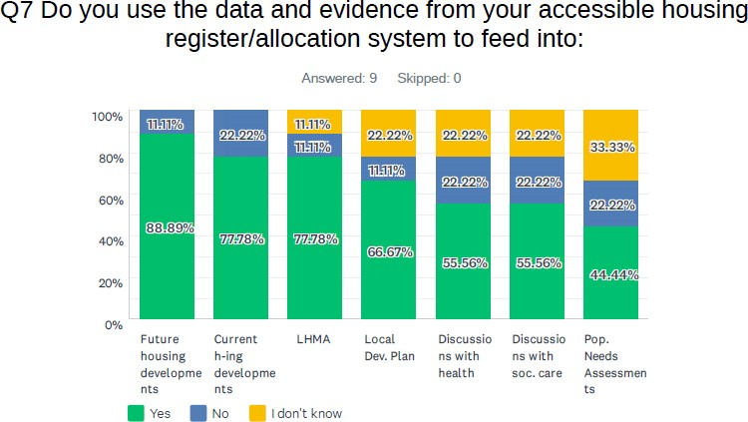

Graph: Local Authorities views on feeding into housing developments, housing and other plans

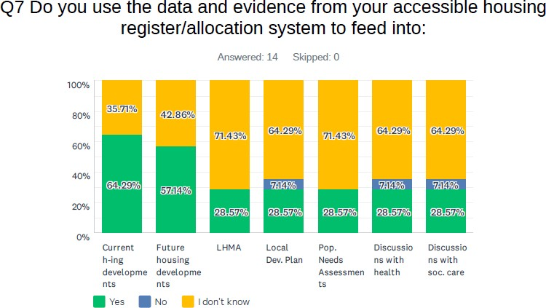

Graph: Housing Association views on feeding into housing developments, housing and other plans

*We need closer working relationship and having all stakeholders sat round a table from the beginning the properly plan a development rather than doing it piecemeal as the process drives it along*

HA staff member

We asked housing professionals from both local authorities and housing associations to rate the extent to which accessible housing needs data from the register feeds into various plans. The table below illustrates the answers, showing that there is still some work to be done in this area.

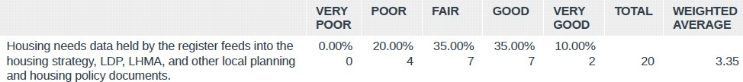

We also asked social care and health practitioners to indicate whether they had opportunities to feed into housing strategy or development. 41% of social care practitioners and 40% of healthcare practitioners thought they had such opportunities. Of those who answered yes, the comments mentioned vehicles such as: Regional Partnership Boards and Accessible Housing Groups, Integrated Care Funding, Housing OT linking up with social care team to feed into developments, joint management structures of social care and housing in the council and ‘feeding in only in the form of re-housing support letter’.

In general health and social care practitioners we interviewed indicated that they would like to be more involved in housing strategy and development. Some housing professionals indicated that social care in their area were invited to feed in to strategies and meetings but at times did not engage.

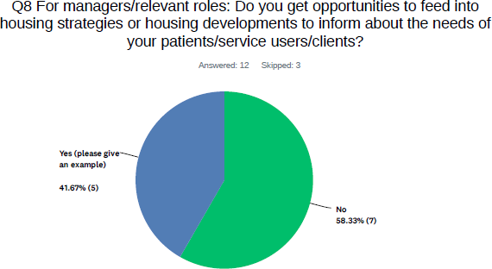

Graph: Social care practitioners on feeding into housing strategies/developments

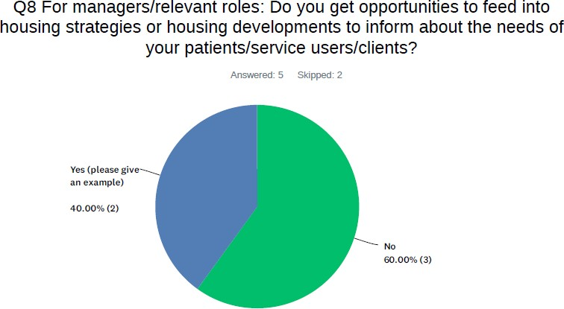

Graph: Health practitioners on feeding into housing strategies/developments

## The role of Private Rented Sector

It is worth considering whether, in the context of shortage of accessible social housing, more could be done with a private rented sector to increase the provision and options for tenants.

It is generally acknowledged that private landlords are reluctant to adapt their properties due to the lack of assurance that the tenant will stay in the property. Some tenants we interviewed indicated that they had to move out of their privately rented properties for this reason.

*We can offer private rented accommodation through Home Options, through the Affordable Housing Register – incorporating low cost Home Ownership, owned properties, shared ownership properties, intermediate rental properties, social housing and, in the past, private rented accommodation. But accessible private rented accommodation is very hard to come by. We have looked at trying to provide temporary accommodation that is accessible – working with RSLs and private landlords for this. We have just developed 2 properties completely refurbished, completely accessible, family homes with wet room and additional bedroom downstairs – this is for temporary accommodation for a family that is struggling in the private rented sector with accessibility. We are developing a private rented housing strategy. We have some examples of private landlords allowing tenants to adapt properties, but very few. People approach us because their private landlord won’t let them adapt their home. One of our pressures is finding temporary accommodation for households who need adaptations.*

Housing Options Manager

Nevertheless, as some local authorities and housing associations are widening their work with the private rented sector, it is worth considering to what extent arrangements such as social lettings or longer-term leasing of PRS properties could help source accessible/adapted housing. Several organisations mentioned to us that they were moving in the direction of offering more than just social housing. Some organisations also have separate registers for intermediate rent arrangements and rent-to-own arrangements etc. It would be worth to include accessible housing offer within these arrangements. Below are examples of how PRS could be used or is being used to house people from the register.

*We have a programme run by Housing Options. They work with the private rented sector to assist homeless people - this could expand to be used for accessible housing. I could use ENABLE funding to put in a shower etc. to increase accessible/adapted housing. This can increase options for people. Housing Options are approaching private landlords about this. Some people will consider private rented and prefer it to social housing.*

Housing OT

*If anyone offers us an adapted private property, I will look through our lists to see if it would suit anyone. We have had a 2-bed adapted private bungalow recently and are seeing 2 more soon – one with a through floor lift.*

Housing Options Officer

In our survey, just over 50% of housing practitioners agreed or strongly agreed that PRS should be part of an accessible housing allocation system.

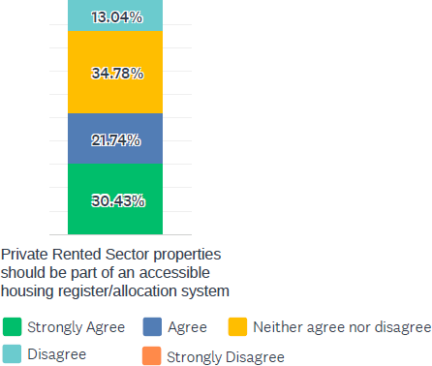

## Age restrictions

Several disabled people highlighted that age restrictions on some of the accessible properties limited their housing options and access to housing.

*We tried to explain that we were trying to get a bungalow... but they said even though we are disabled because of our age 55 me and 53 my wife we are not allowed*

Disabled applicant

*Feel that it’s unfair that the only properties we can apply for are usually for over 60's then we are turned down because we are too young. And very rarely does a property come up that has all the requirements needed.*

Disabled applicant

Many housing practitioners highlighted that they will consider younger disabled people for age restricted properties. These are often exceptions to the rule although in some councils disabled people are allowed to bid for age restricted properties as a matter of course, e.g.

*Generally, our bungalows, sheltered and extra care housing have an age criterion of 55 plus. However, if an applicant has a very specific need that can only be met through that accommodation, we will consider younger people. There has to be very clear evidence of the need.*

Housing association manager

*on our housing register if a person has been assessed as needing adapted or accessible housing and is under 60 the system allows them to bid on properties that may only be for over 60s (so a 35-year-old with a need for adaptations could apply for a bungalow designated for over 60s).*

Housing options manager

One organisation indicated that they lifted age restrictions on their bungalows, which widened choices for younger disabled people and relieved some of the pressure on allocations, speeding some allocations up. Another local authority has a system of automatic eligibility for age restricted properties for their Category A applicants (with highest accessibility requirements) whilst other disabled people are also considered depending on area and availability of properties and consequently allocation chances. One organisation also mentioned that widening edibility in this way positively promotes more mixed communities.

It is certainly worth considering whether there is scope for widening eligibility for age restricted properties based on the analysis of needs of disabled people on the waiting list and the extent to which these can be met.

## The benefits of an effective accessible housing allocation system

Throughout this report we have highlighted the multiple advantages of having a comprehensive and effective accessible housing allocation system. It is evident that these benefits stretch far beyond the immediate outcomes of a suitable allocation for the individual and the provider. Effective allocation and accompanying operational and strategic processes will no doubt have a substantial impact on long term population health, preventing hospital admissions and enabling better and speedier discharge.

Good use of already adapted and accessible properties can also reduce the strain on public resources, by reducing wastage in the adaptations systems.

Elements of a comprehensive accessible housing allocation approach and the information which can be gleaned from those, can be invaluable in feeding into the immediate and longer-term housing, health and social care strategies.

Finally, a good allocation system will undoubtedly have a substantial impact on the quality of life, physical and mental wellbeing of people with accessibility requirements, by removing barriers that all too often reduce disabled people’s independence. It enables disabled people to exercise the voice, choice and control over their own lives.

In our survey, we asked practitioners about the original rationale behind developing their approaches to accessible housing allocation and the actual benefits that they thought the systems brought. The graphs below clearly illustrate the initial perceptions are matched by reality and in some cases the actual benefits exceed initial expectations.

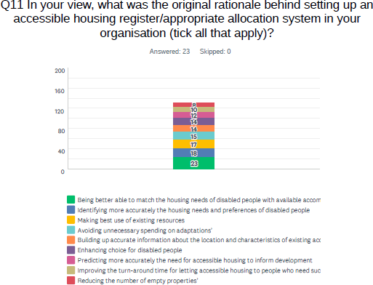

Graph: rationale behind accessible housing allocation system

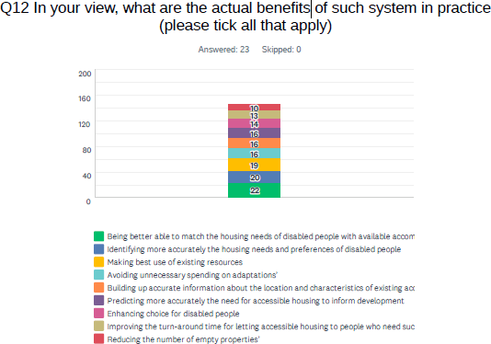

Graph: actual benefits of accessible housing allocation system.

## Costs and benefits of a good accessible housing allocation system

As outlined above an effective accessible housing allocation approach can bring about cost savings. We asked housing practitioners whether they thought this was the case. The graph below demonstrates that this is the perception of most of the practitioners who responded.

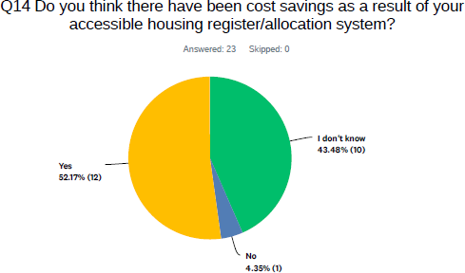

This was also clearly the case with a vast majority of practitioners we interviewed, with the following costs savings reported

* Reduction in voids and additional costs linked to homelessness/temporary accommodation
* Reduction in costs associated with putting in and removing adaptations
* If adaptations are taken out and recycled – there is an obvious cost saving
* Reduction in costs associated with unsustainable tenancies (if a suitable allocation made which reflects all or most of the needs).
* Reductions to health and social care costs where the need for care is reduced, falls prevented, quicker discharge and prevention of admission

Only one organisation, a housing association, indicated that they have carried out a cost savings or cost-benefit analysis, however we were not able to access this.

A 2011 Herriot-Watt University study, *Costs and effectiveness of accessible housing registers in a choice-based lettings context*27, commissioned by the UK Department for Communities and Local Government provides some analysis of costs savings which can be achieved by an efficient accessible housing allocation system (see Section 3.3. for benefits and efficiency factors analysis from this study).

The study compares the costs of two models of accessible housing allocation systems (referred to as registers):

* The full accessible housing register (London Borough) is where a significant proportion of properties have been categorised by their accessibility level (98% council owned and 46% RSL owned) and a comprehensive database of these properties is available.
* The partial register (mixed urban authority) is where properties are categorised at void stage although in the case below this is not yet fully operationalised and some properties are not categorised appropriately.

Below is an extract from the report which assesses cost savings and return on investment for both registers.

*The set-up costs in the London borough of the accessible housing register were £150k (over a number of years) which is equivalent to approximately £6 for each housing unit covered. This cost can alternatively be expressed in terms of per letting. There were 2,146 general needs lets made via the choice-based letting service in 2008/09 of which 598 were to council stock and 1,548 to registered social landlord stock. Given that more than half the registered social landlord stock, 54%, has not been classified and applying this proportion to the annual lettings this broadly equates to £115 for each letting of assessed stock. The alternative approach of the partial accessible housing register by the mixed urban authority is cheaper*

27 <http://www.housingcare.org/downloads/kbase/3134.pdf>

*certainly in the short term, costed at approximately £14 per void (not per letting). However, the full accessible housing register cost figure will of course reduce with each year of additional lettings so that after ten years of lettings it would equate to a crude average of*

*£11.50 over the period.*

*The cost of the construction of the accessible housing register is equivalent to 60 adaptations so the key question is how long it will take for this expenditure to reduce this number of adaptations (subject to the discounting over time of expenditure on adaptations).*

*The cost effectiveness of a full accessible housing register centres around the reduction in the expenditure requirement to adapt stock and the financial analysis of the London case study suggests that an efficient full accessible housing register could pay back its costs over five years if it could remove the need for 15% of adaptations. The financial case will vary with local circumstances in terms of the percentage of accessible stock, current household mismatches, and existing knowledge/databases on the characteristics of the stock.*

*There are other financial benefits to in the long term through freeing of occupational therapy resources and the use of the accessible housing register to support strategic housing needs assessment.*

*The partial accessible housing register approach is financially attractive in the short term as it has no initial capital costs (costs of assessing stock) and from the tenant’s perspective it provides the same choice-based letting service. This approach offers the possibility through the incremental inputting of the information collected on to a register of building up to a full accessible housing register, with its long-term strategic benefits. The annual running costs can be supported by utilising savings from the adaptations’ budget. It is possible that a partial accessible housing register represents the optimum solution for at least small local authorities given limited financial circumstances and that it can also be built up to a full version.*

# Recommendations

|  |  |  |  |  |
| --- | --- | --- | --- | --- |
|  | **Recommendation** | **Timeframe** | **Resources** | **Scope** |
|  | OVERARCHING | | | |
| 1 | Development of regional accessible housing allocation framework and guidance. The framework could help establish common ground and work towards more standardised and improved practice based on an agreement between partners. The framework could potentially encompass joint work on some of the below recommendations. | Medium term | Staff time | Regional |
| CAPACITY, SKILLS AND TRAINING | | | | |
| 2 | Focus on increase and exchange of practice and skills amongst housing, health and social care staff. This could be achieved through:   * Peer to peer skills and practice exchange * Training, in particular of non-specialist staff (e.g. social model of disability, inclusive design, functional ability, specific health conditions, housing   systems) | Medium term | Staff time Financial where sourced externally | Regional |
| 3 | Invest in Housing Occupational Therapists in housing options teams | Long term | Financial | Local |
| ALLOCATION PROCESSES | | | | |
| 4 | Explore opportunities for providing early OT assessments at housing application stage in all local authorities. Consider the content of assessments to focus on access barriers as per social model of disability | Long term | Staff time if within existing housing/soc ial care teams Financial additional OT’s  needed | Local with potential for regional co- operation |
| 5 | Ensure robust processes are in place for prioritising applicants with accessibility needs for accessible properties, especially where banding-based quota systems are in place. | Medium to long term | Staff time | Local with potential for regional co- operation |
| 6 | Work towards common regional categorisation of accessibility levels of properties and applicants’ accessibility requirements. Invest in proactive assessments, classification and mapping of accessible  properties (potential for pooling resources to carry this out). | Medium to long term | Staff time Financial resources | Regional |
| 7 | Ensure there is a balance between meeting business needs and individual accessibility needs in decisions on  void turnaround times. | Medium | Staff time | Local |
| SERVICE ACCESSIBILITY AND SUPPORT | | | | |

|  |  |  |  |  |
| --- | --- | --- | --- | --- |
| 8 | Review website information and accessibility including:   * Provision of more comprehensive information specifically on accessible housing allocation process and support available to disabled people * Website accessibility audit | Short to medium term | Staff time Financial (if new regional website developed) | Local although a regional website/app with information & support could  be considered |
| 9 | Consider reviewing current support arrangements and commissioning a pan-Gwent accessible housing support service for disabled people/people with access  requirements including support with house-moves | Medium to long term | Financial | Regional |
| 10 | Provide clear information and policies on adaptations in the context of allocations for applicants and non- housing professionals including:   * Availability of adaptations pre and post moving-in date * Adaptations to current housing for applicants in extreme need * Decisions on whether adaptation or move is the best option for service users | Short to medium term | Staff time | Local with potential for regional co- operation |
| ADAPTATIONS | | | | |
| 11 | Jointly consider how to address the findings of WAO Housing Adaptations report28 including the need for joint strategic planning and delivery of adaptations to make the system more equitable across tenures (including common pathways and single points of  contact) | Medium to long term | Staff time | Regional |
| 12 | Consider carrying out a review of equipment and adaptation storage and recycling facilities/processes, including potential for using pooled resources or extended use of Gwent Wide Integrated Community  Equipment Service by all partners | Medium to long term | Staff time Financial | Regional |
| HOSPITAL DISCHARGE | | | | |
| 13 | Review and investment in a variety of step down and  temporary accessible housing facilities | Medium to  long term | Financial | Regional |
| 14 | Commission a housing focused hospital discharge service (align and address gaps in existing housing and social care discharge and admission prevention  services) | Long term | Financial | Regional |
| 15 | Develop clear hospital discharge pathways including increased focus on early referrals to and  communication with housing | Medium to long term | Staff time | Regional |
| PERFORMANCE AND APPLICANT ENGAGEMENT | | | | |
| 16 | Increase engagement with and analysis of data on  experiences and outcomes of disabled | Medium  term to | Staff time | Local with  potential for |

28 <https://www.audit.wales/publication/housing-adaptations>

|  |  |  |  |  |
| --- | --- | --- | --- | --- |
|  | applicants/tenants. This can include disaggregation of  existing survey data. | long term |  | regional co-  operation |
| 17 | Undertake regular monitoring and analysis of the performance of accessible housing allocation systems | Medium to long term | Staff time | Local with potential for regional co- operation (e.g. common  indicators) |
| 18 | Increase activity on raising awareness of accessible housing options and processes directly with people affected (build on online engagement methods and  tools developed in the lockdown period) | Medium term | Staff time | Local and Regional |
| STRATEGY AND STOCK | | | | |
| 19 | Consider investing in mapping of accessible housing stock onto centrally held database(s) | Long term | Financial | Local with  potential for regional |
| 20 | Maximise the development of accessible housing through:   * Increased focus on early engagement of key relevant partners with the knowledge of accessible housing needs in housing development * Increased utilisation of the planning system (including Section 106) and available funding (including ICF and SHG) | Long term | Staff time Financial | Local and regional |
| 21 | Improve the strategic focus on increasing provision of accessible housing, including:   * Granular analysis of accessible housing need with specific development targets feeding into housing, health and social care strategies * Joint consideration of accessible housing allocations, adaptations, housing development as well as increasing stock via purchase & re- development through social housing partners | Long term | Staff time Financial | Local and Regional |
| 22 | Consider widening eligibility for age restricted housing based on needs, area and availability. | Medium to long term | Staff time | Local with potential for more regional  co-operation |
| 23 | Build on and learn from existing work of housing options teams with Private Rented Sector (e.g. social lettings, leasing schemes) to acquire accessible stock which can be used to address the needs of some  applicants | Medium term | Staff time | Local with potential for regional learning |

# APPENDICES

**Appendix 1A – Caerphilly Accessibility Classification System – Properties**

The Council uses the criteria below to identify accessible housing and match disabled applicants with suitable accommodation based on their specific requirements:

|  |  |  |
| --- | --- | --- |
|  | Criteria | Examples |
| A1 | A highly adapted or purpose-built property, providing wheel chair access throughout. Access to alternative levels will need to be achieved by a stair lift or vertical lift and access to the property would need to be level or ramped to a maximum of 1:12 gradient. All doorways to be a minimum of 780mm clear opening. | A wheelchair accessible highly adapted or purpose-built property, allowing wheelchair access internally and externally.  Bungalow, Ground floor flat, first floor flat with vertical access or 2 storied house with vertical lift allowing access to first floor |
| A2 | A property allowing wheelchair access to main facilities, i.e. bathing, living and sleeping facilities. Access to alternative floors will need to be achieved by a stair lift or vertical lift Access to the property will need to be level or ramped to a maximum gradient of 1:12. |
| B1 | A ground floor property, first floor property with lift access or a two-storied property allowing either a stair lift or vertical lift access to the first floor.  Access to the property should be level or ramped to a maximum gradient of 1:12. | A property not wheelchair accessible internally but affords good graded access and when necessary is suitable for provision of vertical lift or stair lift.  Bungalow, Ground floor flat, first floor flat with vertical/stair lift access or 2 storied house with vertical/stair lift allowing access to first floor |
| B2 | A ground floor property, first floor property with lift access or a two-storied property allowing stair lift access to the first floor. Access to the property should have a maximum of three steps. |
| C1 | A first-floor property so facilities are on one level. Lift access to first floor not essential. Access to the property should have a maximum of six steps. | A property that facilitates limited use of stairs and steps. A property in which lift |

|  |  |  |
| --- | --- | --- |
| C2 | A two storied property with WC facilities on both levels. Lift access to first floor not essential. Access to the property should have a maximum of six steps. | provision is not possible and has maximum of 5 steps to main external access. |
| C3 | Ground floor property with maximum 6 steps. |
| D | Suitable for general needs In excess of 5 steps.  Not suitable for allocation to a person with physical disabilities.  Property not suitable for adaptations. |  |

**Appendix 1B - Caerphilly Accessibility Classification System – Applicants**

|  |  |
| --- | --- |
|  | Criteria |
| A1 | Independent wheelchair user. Will require ground floor accommodation or vertical lift access to alternative floors. Access to property must be level or ramped to a maximum of 1:12. The accommodation will need to be entirely wheelchair accessible i.e. door widths to a minimum of 780mm. |
| A2 | Dependant wheelchair user. Will require ground floor accommodation or vertical lift access to alternate floors. Access to the property must be level or ramped to a maximum of 1:12. Internally full access to the property may not be necessary but essential rooms will need to have minimum door widths of 780mm. |
| B1 | Semi ambulant person who is unable to negotiate steps or stairs, or who is dependent on a wheelchair out of doors. The property will need to be ground floor or have either stair lift or vertical lift access to alternate floors. Access to the property will need to be level or ramped to a minimum of 1:12. |
| B2 | Semi ambulant person who is able to negotiate a limited number of steps. The property may be ground floor or have either stair lift or vertical lift access to alternate floors. Access to the property does not need to be level but should have a limited number of steps with handrail provision. |
| C | An ambulant person who is able to negotiate steps and stairs on a limited basis. |
| D | A non-disabled person |
| U | An applicant who has indicated health issues but is waiting for assessment. This ensures applicant does not miss out on an opportunity |

**Appendix 1c Caerphilly Accessible/Adapted Housing Best Match Shortlisting Criteria/Prioritisation Process**

If an A1 property becomes void then the process will be:

|  |  |
| --- | --- |
| **Stage** | **Action** |
| **1.** | Shortlist category A1 applicants in band 1. If no suitable applicants found then go to next stage. |
| **2.** | Shortlist A1 applicants in band 2. If no suitable applicants found then go to next stage. |
| **3.** | Shortlist A2 applicants in band 1. If no suitable applicants found then go to next stage. |
| **4.** | Shortlist A2 applicants in band 2. If no suitable applicants found then go to next stage. |
| **5.** | Consider A1 applicants in band 3. If no suitable applicants found then go to next stage. |
| **6.** | Consider A2 applicants in band 3. If no suitable applicants found then allocate from main list. |

If an A2 property becomes void then the process will be:

|  |  |
| --- | --- |
| **Stage** | **Action** |
| 1. | Shortlist A2 applicants in band 1. If no suitable applicants found then go to next stage. |
| 2. | Shortlist A2 applicants in band 2. If no suitable applicants found then go to next stage. |
| 3. | Consider A2 applicants in band 3. If no suitable applicants found then allocate from main list. |

If a B2 property becomes void then the process will be:

|  |  |
| --- | --- |
| **Stage** | **Action** |
| 1. | Shortlist category B1 applicants in band 1. If no suitable applicants found then go to next stage. |

|  |  |
| --- | --- |
| 2. | Shortlist B1 applicants in band 2. If no suitable applicants found then go to next stage. |
| 3. | Consider B1 applicants in band 3. If no suitable applicants found then allocate from main list. |

If a property becomes void with usable adaptations (major) in situ, the process would be:

|  |  |
| --- | --- |
| **Stage** | **Action** |
| 1. | Shortlist category B1 applicants in band 1. If no suitable applicants found then go to next stage. |
| 2. | Shortlist B1 applicants in band 2. If no suitable applicants found then go to next stage. |
| 3. | Consider B1 applicants in band 3. If no suitable applicants found then allocate from main list. |

Appendix 3

London Accessible Housing Register – Property Categories

