**Back the Bill: A route for the right to adequate housing in Wales**

**Introduction**

Since 2019, the [Back the Bill](https://www.taipawb.org/policy-influencing/backthebill/) coalition has campaigned for the incorporation of the right to adequate housing in Wales. Comprising of [Shelter Cymru](https://sheltercymru.org.uk/), [Tai Pawb](https://www.taipawb.org/) and [The Chartered Institute of Housing Cymru](https://www.cih.org/), we believe the only way to resolve our housing emergency is to fundamentally change how we think about homes, starting with seeing them as a right. We want to increase the importance of homes on the political agenda, delivering a long-term strategy for housing, and turbocharging the changes (including funding) to ensure everyone has a safe, suitable home they can afford.

What is the right to adequate housing?

The right to adequate housing means **everyone** has the right to live somewhere in security, peace, and dignity. Originating as part of the broader right to an adequate standard of living through the UN [International Covenant on Economic, Social and Cultural Rights](https://www.google.co.uk/url?sa=t&rct=j&q=&esrc=s&source=web&cd=&cad=rja&uact=8&ved=2ahUKEwi8xuSbiKj6AhUWWcAKHV7BBoUQFnoECBwQAQ&url=https%3A%2F%2Ftreaties.un.org%2Fpages%2FViewDetails.aspx%3Fsrc%3DIND%26mtdsg_no%3DIV-3%26chapter%3D4%26clang%3D_en&usg=AOvVaw29OZivF-J6NGPz2gKKKF8T), countries across the world are increasingly exploring it to drive action to end homelessness and improve the quality of people’s homes.

There are seven components to the right to adequate housing. These are:

* Legal security of tenure
* Affordability
* Habitability
* Availability of services, materials, facilities, and infrastructure
* Accessibility
* Location
* Cultural adequacy

Alongside these components are freedoms and entitlements –

***Freedoms***

* Protection against forced evictions and the arbitrary destruction and demolition of one’s home.
* The right to be free from arbitrary interference with one’s home, privacy, and family.
* The right to choose one’s residence, to determine where to live and to freedom of movement.

***Entitlements***

* Security of tenure
* Housing, land, and property restitution
* Equal and non-discriminatory access to adequate housing
* Participation in housing-related decision-making at the national and community levels.

**About this guide**

The Back the Bill campaign has sought to build the evidence base for incorporation of the right to adequate housing in Wales through the following research:

* [Feasibility study into the right to adequate housing](https://www.taipawb.org/wp-content/uploads/2019/06/RightToHousing-Full-ENG.pdf)
* [Draft bill](https://www.taipawb.org/wp-content/uploads/2020/09/Back-the-bill-right-to-adequate-housing.pdf)
* [The right to adequate housing in Wales: The evidence base](https://www.taipawb.org/wp-content/uploads/2022/01/Alma-Economics-Back-the-Bill-Phase-1-Full-Report.pdf)
* [The right to adequate housing in Wales: cost-benefit analysis](https://www.taipawb.org/wp-content/uploads/2022/09/Alma-Economics-Back-the-Bill-Final-Phase-2-report.pdf)

We wanted to combine these pieces of research into a practical and accessible guide, highlighting how the right to adequate housing can be introduced in Wales and crucially, **what it could look like**.

The summer of 2024 will see a White Paper on introducing a right to adequate housing and fair rents in Wales. Ahead of this consultation, we hope this guide can act as a useful tool for those wanting to learn more about what a right to adequate housing could look like in Wales.

**Part 1 – The case for the right to adequate housing**

Reducing inequality

We know the people most affected by poor housing are amongst the most disadvantaged in in society:

* Black, Asian, and Minority Ethnic people are disproportionately likely to live in an overcrowded house and have a higher risk of homelessness.
* Refugees, asylum seekers and migrants also face housing inequalities, due to racism, discrimination, or structural factors.
* Research has indicated that one of the main barriers for individuals who have experienced domestic abuse face in order to escape abusive situations is the lack of access to secure and affordable homes.
* Individuals from the LGBTQ+ community also face housing inequalities, with evidence suggesting the LGBTQ+ community are four times more likely to be homeless compared to their peers.

Improving supply and standards

18% of tenants reporting that they did not live in accommodation that met their needs due to a disability. A right to adequate housing will boost supply and ensure the homes built meet communities needs now and in the future. Crucially, this will mean high quality standards across the private as well as the social sector.

Ending homelessness

Recent proposals to homelessness legislation are progressive, but questions remain over funding and the lack of urgency and sufficient investment into increasing supply. A right to adequate housing can strengthen these reforms, including providing levers to ensure the necessary funding for implementation and delivery. A right to adequate housing would also prioritise the elimination of homelessness in the shortest possible time.

Supporting our climate change goals

Sustainability is recognised by the UN Special Rapporteur on the right to adequate housing meaning new homes should be low or zero emissions, built with sustainable materials and adequately protect and against climate-related disasters and weather. The Welsh Government is committed to achieving net-zero emissions by 2050, with housing is one of the biggest emitters, responsible for [up to 21%](https://www.gov.wales/sites/default/files/publications/2019-07/decarbonising-welsh-homes-stage-1-summary.pdf) of all greenhouse gas emissions. We believe a right to adequate housing and decarbonisation can work together, driving the investment and political will for change. Achieving one without the other may not be possible.

**Part 2 – A cost-effective approach**

In a 2019 report, Public Health Wales estimated that poor housing costs the health service in Wales £95m per year. Staggeringly, the cost of poor housing across the Welsh economy is estimated at **£1bn per annum**. We all know poor housing costs, but we now know a right to adequate housing will save us money:



**Costs and benefits**

The costs associated with incorporating the right to adequate housing in Wales include:

* Homebuilding
* Securing suitable accommodation for homeless households, such as through deposit payments or rent arrears payments, as well as rents paid.
* Households support
* Housing adaptations

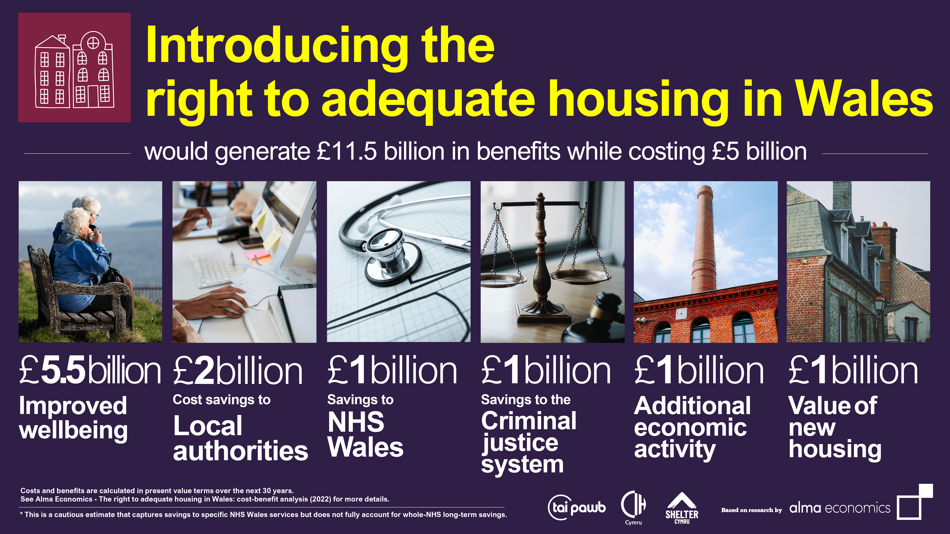

Financing a right to adequate housing

No country has the finances to deliver the right to adequate housing overnight. Equally, the supply of good homes needed **cannot be built or modified overnight**. This does not mean a right to adequate housing is unobtainable. Instead, it is achieved through **progressive realisation. Progressive realisation** is a process that legally requires government to commit the maximum available resources, including land, technology, staff, and finance, over time towards the realisation of a the right. And crucially, to take no measures that could contradict that right. This means that a right to adequate housing is a long-term, achievable policy goal. We believe introducing the right in law will act as a lever to drive the investment needed.

**Part 3 – What could it look like?**

**Guidelines for implementation of the right to adequate housing**

The UN has produced guidelines for implementation of the right to adequate housing. Highlighted in the legislative, policy and strategic changes below:

• Incorporation of housing as a right – recognition of legal changes needed to reflect this.

• Taking immediate steps to ensure the progressive realisation of the right to housing, in line with the standard of reasonableness – concrete steps including actions and timelines that target sufficient resources at those most in need.

• Ensure meaningful participation in the design, implementation and monitoring of housing policies and decisions.

• Implement comprehensive strategies for the realisation of the right to housing – Housing strategies must identify clear goals, outcomes, coordination and identify how obstacles can be overcome.

• Eliminate homelessness in the shortest possible time and stop the criminalisation of homelessness.

• Address discrimination and ensure equality – including positive measures to ensure access to housing, eliminate housing discrimination, and tackle issues around accessible homes.

• Ensure gender equality in housing – particular focus on inequality in relation to domestic abuse and housing, supply and participation in housing design and community planning.

• Ensure the capacity and accountability of local government – coordination of plans, local human rights-based housing strategies, and adequate funding to enact these changes.

• Ensure the right to housing informs and is responsive to climate change and address the effects of the climate crisis.

• Ensure effective monitoring.

• Ensure access to justice for all aspects of the right to housing.

We appreciate these are quite high-level principles of the changes that could be expected to take place in Wales.

The next section attempts to flesh out what this could look like in Wales in practice. Recognising no one owns the right to adequate housing, these ideas are presented for discussion and to generate further ideas and debate; recognising the approach, funding and timescale will be down to the political choices of the Government (s) of the day.

The Draft Bill

Our Back the Bill [feasibility study](https://www.taipawb.org/wp-content/uploads/2019/06/RightToHousing-ExecSummary-ENG.pdf) considers three options of incorporation – indirect via due regard duty, direct via enforceable compliance duty or the adoption of a dual approach. We believe combining both offer options ensures a strong proactive framework for policy making and strong enforcement if the right to housing is breached. Our [Draft Bill](https://www.taipawb.org/wp-content/uploads/2020/09/Back-the-bill-right-to-adequate-housing.pdf) demonstrates what could be achieved in legislation.

Our Due regard duty in the Bill ensures policymakers actively consider right to housing when making policy or decisions (like budgets). This is supported by a range of mechanisms such as housing rights impact assessments, and a housing rights strategy. Compliance duty & enforcement– where due regard is insufficient to ensure right-compliant implementation of housing policy there are opportunities for redress for individuals or groups adversely affected.

**What could change and how?**

As outlined in our draft bill, we believe the following changes would take place:

**Legally grounded shift in attitudes –** talk about how this shift is needed to move away from deserving vs. non-deserving and how this understanding was the key to change in Finland which can be seen here [Ara > Homelessness in Finland 2022](https://www.ara.fi/en-US/Materials/Homelessness_reports/Homelessness_in_Finland_2022(65349#:~:text=At%20the%20end%20of%202022,a%20decrease%20of%20185%20people.)

**Change through a deliverable and fully monitored whole system strategy**– right to adequate housing requires governments to produce a fully costed strategy and plan on how, over time, right to housing will be realised in Wales through changes to the **whole housing system** includinghomelessness, supply, ~~private rented sector~~, quality and standards and owner-occupied housing. Welsh Government would need to report on progress through published **compliance reports** to the Senedd. The duty to consider the whole system would mean that the government cannot produce a plan which focuses solely on homelessness without considering other elements.

**Increasing supply** – right to housing offers extra levers to help boost supply of housing through a range of tools. The duty to use **maximum available resources** in the delivery of the above plan for example, does not only pertain to budget but also availability of **land, workforce, technology** and other resources necessary to realise the right. Welsh Government would need to evidence how it plans to use such resources and remove any barriers. Accountability for such decisions would be increased, since WG would be bound by legal duties relating to decision making.

**Impact on housing and cross governmental budgets** – a right to housing would offer extra levers to truly invest in housing and homelessness. Welsh Government would be duty bound to evidence how they have considered the impact of any budgetary decisions on the right to housing. This includes the duty to use maximum available resources, progressive realisation, no retrogression, and impact on any plans. In short, the cabinet would be more accountable for the decision it takes on housing.

Currently on average since 2006, only 2.2 % of our budget has been spent on housing, despite the housing and homelessness emergency and despite evidence that investment in housing produces big savings in other areas.  A Housing Impact Assessment on any proposal for legislation or policy or budgetary allocation which is likely to have a direct or indirect impact on housing in Wales would also be required.

**Greater accountability** – increased accountability for housing decisions would offer more opportunity for scrutiny, public debate and housing advocacy. Right to housing legislation could include mechanisms such as published housing rights impact assessments of key decisions, 3 yearly progress and compliance reporting against published indicators to the Senedd for scrutiny, requirements to fully involve those with lived experience of housing issues and, as an absolute last resort – the right to legal challenge and redress.

**Litigation** - Evidence from [Wales](https://www.equalityhumanrights.com/sites/default/files/the_impact_of_legal_integration_of_the_un_convention_on_the_rights_of_the_child_in_wales_eng.pdf) and [Scotland](https://core.ac.uk/download/427554014.pdf) shows that there is little risk of human rights legislation leading to a ‘floodgate’ of legal cases; but providing people with mechanisms to exercise their rights influences policy changes and ultimately delivers better outcomes for people. Our proposals suggest the introduction of a so-called ‘sunrise clause’ in right to housing legislation, enabling the government and authorities to focus on progress and delivery through policy-making in the initial years.

**~~E~~mpowered housing sector and communities –** Changes required by the Welsh Government as well as improving the priority of housing, enhance the sectors’ and communities' ability to challenge the Welsh Government on meeting its commitments.

International approaches to incorporation

Understanding changes that have happened elsewhere can help explain what options for incorporation could be implemented in Wales:

Finland

Introduced in 2000, The Finnish constitution includes economic, social and cultural rights (including the right to housing), ensuring that public authorities will be responsible for protecting those rights. These rights are enacted through ordinary legislation and are considered justiciable by the courts. Every law is reviewed by the Constitutional Law Committee of Parliament, before enacted to assess whether the law is consistent with the Constitution. The courts protect ESC rights by either providing compensation in cases of proven violation of those rights committed by the government or local authorities, or by judicially reviewing public bodies’ decisions related to constitutionally protected rights. The right to housing made a significant step in the Housing First showing how policy and legal change can work together.

New Zealand

In New Zealand the State’s duty is not to build housing units, but to ensure the right is upheld in the country. Aspects of it are reflected in national acts and policies, rather than individual legislation. Since 2013, the Healthy Homes Initiative (HHI) has supported families with specific health conditions or pregnant women to access warm, dry, and healthy housing.

Canada

The Federal Housing Advocate is an independent, nonpartisan watchdog, empowered to drive meaningful action to address housing need and homelessness in Canada. The goal of the Advocate’s work is to drive change on key systemic housing issues and advance the right to housing for all in Canada.

The Advocate is responsible for making recommendations to improve Canada’s housing laws, policies, and programs so that they enable people and families in Canada to have access to adequate, affordable, and safe housing that meets their needs. The Advocate’s mandate is guided by a human rights-based approach, which values participation, accountability, non-discrimination, equity, transparency, empowerment, and respect for human rights laws and obligations.

**Part 4 – Conclusion**

We believe there is a clear moral and financial imperative for the right to adequate housing in Wales. For too long, the lack of a long-term plan and investment, alongside unexpected short-term crises, have left us with a housing emergency in Wales which without transformational action will get worse. A right to adequate housing will be the change that kicks off this transformation.

This summer will see a White Paper consultation by the Welsh Government on options for incorporating a right to adequate housing. We hope the ideas presented in this guide can act as starting point for some of the conversations.

While we know there are lots of opportunities for the right to adequate housing, there are also areas where more investigation or research would be beneficial. These include how lived experience can be best incorporated and how best to balance enforcement with support for providers and benefits for traditional Welsh language communities.

As we move forward and look to resolve the housing emergency, Back the Bill partners welcome discussion around the ideas presented in this guide and look forward to engaging positively with partners.